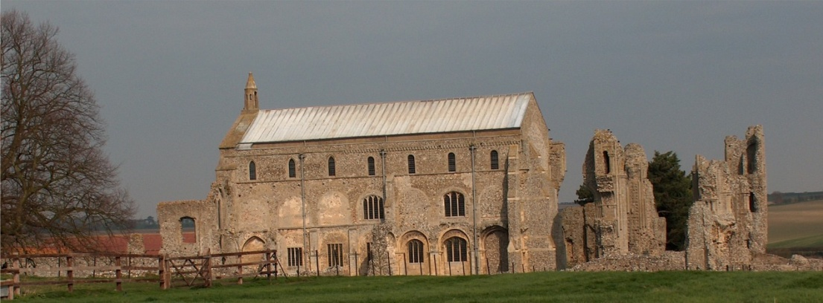
BINHAM with COCKTHORPE PARISH COUNCIL
Parish Clerk – Sarah Hayden
53 Cromer Road, Lower Gresham
NR11 8RH
Tel: 01263 570223
Email: clerk@binhampc.norfolkparishes.gov.uk
https://binhampc.norfolkparishes.gov.uk

2026/6
DRAFT
MINUTES OF BINHAM WITH COCKTHORPE ANNUAL PARISH COUNCIL MEETING
13th July 2026 AT THE MEMORIAL HALL, BINHAM

Those Present Cllr. E. Brady (Chair), Cllr. P. Alford (Vice-Chair), Cllr. J. Aldridge and Cllr. L. Wynder
In Attendance Mrs. S. Hayden (Clerk)
County Cllr. Dr. V. Holliday

The Chair opened the meeting at 7.40pm and welcomed everyone

1. To receive apologies for absence
Apologies were received from Cllr. W. Keesom
It was confirmed that Cllr. A. Wordingham had resigned but had offered help if required.
County Cllr Dr. V. Holliday had sent apologies for late arrival
District Councillor S Bütikofer had sent apologies
2. To elect a Vice-Chairman of the Council
Proposed and resolved to appoint Cllr. P. Alford as Vice-Chair
3. Declarations of Interest and any dispensations of disclosable pecuniary interests
None.
4. Approval of Minutes of Parish Council Meeting held on 11th May 2026
The draft minutes were amended for minor typing errors, then approved and then signed by the Chair
5. Matters Arising
1. It was confirmed that the drains on Langham Road had been cleared.
2. Cllr. Aldridge had attended the webinar with Anglian Water. It was largely a promotion for Anglian Water although they had been challenged by attendees. The focus had been on water use including the requirements of data centres, etc., with confirmation that their proposed solutions were being fed back to Government. Cllr. Aldridge took away useful information from it and would circulate a précis to parish councillors for information.
The Chair reported that she hadn’t been able to attend the NALC AGM.

6. Reports
6.1 Norfolk County Council
County Cllr. Dr. Holliday had sent a June report, a July update and a July report. From her July report, the fire prevention posters were discussed and it was agreed which one would be posted on the noticeboards. The reports are annexed to these minutes.
6.2 North Norfolk District Council
District Councillor Sarah Bütikofer had sent a report in June. The information on NIDA raised a question of whether the Parish Council should have a safeguarding policy. Agreed that the Chair and Cllr. Aldridge would prepare a draft. The Clerk would provide them with the NALC template.
6.3 Chair’s report
The Chair handed around the latest SAM2 data taken from Cockthorpe. She went through the figures, which were discussed.

2026/7

County Cllr. Dr. V. Holliday arrived and the Chair asked if she would like to give her report at that point. She expanded on her written reports highlighting the Community Resilience funding, the resumption of acceptance of electrical items, the new SEND provision, the reading challenge, workshops for older drivers (she was trying to get workshops in North Norfolk as well as Norwich) and fire prevention posters. There would be a social worker attending Glaven Caring on 7th August next. Cllr. Holliday outlined the work being done by NCC on Broadband connectivity in the North Norfolk area and a proposed future webinar on the subject. Coverage for mobile ‘phones was discussed. She advised that would be carrying out a survey on bus services. Traffic and speeding issues were discussed. Cllr. Holliday then made her apologies and left the meeting.

The Chair continued her report. A 30mph sign had disappeared from Langham Road by the bridge. On dog waste bins, she felt that a large bin should be ordered for the Priory now, rather than following he work on the Green as planned. All agreed. The Church’s Flower Festival would be held next year on 28th to 30th May in the Church.

7. Planning
7.1 To receive report from Planning Committee
Cllr. Alford reported that it had been a quiet year so far for planning applications
LA/26/1228 Internal and External works to include the removal of fireplace and wall between kitchen and dining room at ground floor level and removal of chimney breast at first floor level, internal alterations to create ensuite bath/shower rooms to each bedroom, removal of existing internal central heating boiler and replacement with external oil fired boiler together with plastic bunded oil storage tank and redecoration of external joinery – Primrose Cottage, 4 Chapel Yard, Front Street, Binham, NR21 0AN – The Parish Council had submitted their comments in support and the application was pending a decision by NNDC
PF/26/0891 Extension and alterations to existing cart lodge associated with conversion to annexe accommodation and store, construction of sauna structure and associated works – the Reading Rooms Langham Rod, Binham, NR21 0AN – The Parish Council had submitted comments in support and the application was pending a decision by NNDC
PF/26/0813 and LA/26/0814 Works associated with installation of a charging point and installation of a single domestic electric vehicle charging point on wall of dwelling – Old School House, Warham Road, Binham – Approved by NNDC
7.2 To discuss and agree observations on any applications received after the date of Agenda
PF/26/1Retention of 24 secure self-storage containers – land south of Cockthorpe Road, Langham – Discussed and agreed that the Parish Council considered the application site to be in Langham parish and not Cockthorpe.

8 Finance and Regulatory
8.1 To receive budget against actuals, cash account and bank reconciliation
A copy of the up-to-date budget was given out. That and the cash account were received with no comments. As Cllr. Keesom was not present, the bank reconciliation was offered to councillors for checking if they wished.
8.2 To approve the List of Payments
The List was approved and then signed by the Chair and Clerk
At this point it was agreed to ask the contractor to cut the verge outside the Priory. The Chair to liaise, concerning cuttings to be taken away.

9. To discuss implementing an annual rights of way audit
Discussed and agreed to carry out two audits, one in mid-summer (July) and one in winter (January). Cllrs. Alford and Aldridge offered to draft a footpath list for the parish and carry out the audits.

2026/8
10. S. 106 funding – to discuss and agree progress on projects using s.106 funding
It was agreed that the purchase of the two new dog bins, one 50 litre @ £244 + VAT, plus post and one 35 litre bin for The Green, with the Priory bin being moved to Walsingham Road end of footpath, would be funded from the maintenance budget in order to leave the s. 106 funds unused, to pay for the kerbing of the Green. In connection with kerbing, it had been agreed by NCC that s. 106 funds could be used in a Parish Partnership application, where NCC would pay 50% of the cost if the application was successful. It was not known yet whether the new administration at NCC would continue with the Parish Partnership scheme. Agreed to wait until that information was forthcoming.

11. To deal with any correspondence
Email request to carry out BTO survey. Agreed not to take part.

Cllr. Wynder made her apologies and left the meeting.

12. Items for information only or next Agenda
Cllr Aldridge confirmed she continued to receive interesting and informative information from Neighbourhood Watch.
The telephone box door was sticking and the box was getting overgrown. Agreed the door would be checked and vegetation cleared, after consent was obtained from the landowner.

There being no further business the meeting closed at 10.15pm and the approved cheque signed

