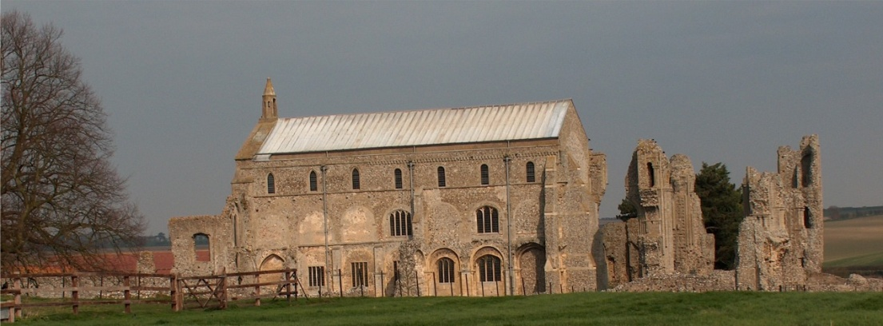
BINHAM WITH COCKTHORPE PARISH COUNCIL
Parish Clerk – Sarah Hayden CiLCA
53 Cromer Road, Lower Gresham
NR11 8RH
Tel: 01263 570223
Email: clerk@binhampc.norfolkparishes.gov.uk
Website: https://binhampc.norfolkparishes.gov.uk

Notice & Summons of Parish Council Meeting
Notice is given to the public and Members of the Council are summoned to attend a Meeting of Binham and Cockthorpe Parish Council at the Memorial Hall, Binham
On Monday 13th July 2026 at 7.30pm
S. H. Hayden
Parish Clerk
6th July 2026

The Public are welcome to attend this Parish Council meeting

AGENDA

1. To receive apologies for absence

2. To elect a Vice Chair of the Council

3. Declarations of Interest and any dispensations of disclosable pecuniary interests

4. Approval of the Minutes of Parish Council Meeting held on 11th May 2026

5. Matters Arising from those Minutes

6. Reports
6.1 Norfolk County Council
6.2 North Norfolk District Council
6.3 Chair’s Report

7. Planning
7.1 To receive report from Planning Committee
7.2 To discuss and agree observations on any applications after the date of this Agenda

8. Finance and Regulatory
8.1 To receive budget with actuals, cash account and report on bank reconciliation
8.2 To approve list of payments

9. To discuss implementing an annual rights of way audit

10. To discuss and agree progress on projects using s. 106 funding

11. Correspondence

12. Items for Information Only or next Agenda

