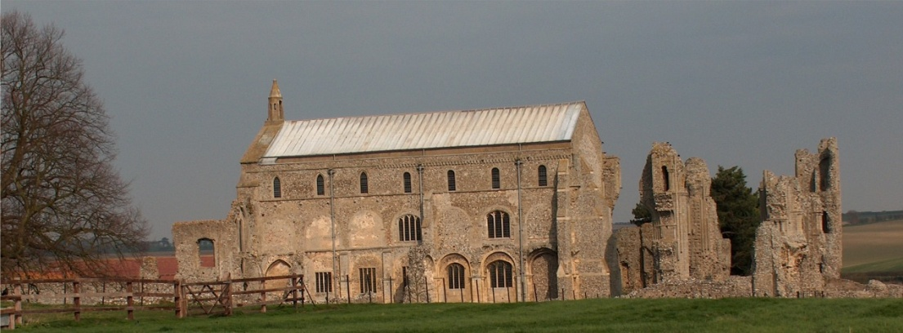
BINHAM with COCKTHORPE PARISH COUNCIL
Parish Clerk – Sarah Hayden
53 Cromer Road, Lower Gresham
NR11 8RH
Tel: 01263 570223
Email: clerk@binhampc.norfolkparishes.gov.uk
https://binhampc.norfolkparishes.gov.uk

2026/3
DRAFT
MINUTES OF BINHAM WITH COCKTHORPE ANNUAL PARISH COUNCIL MEETING
9th MARCH 2026 AT THE MEMORIAL HALL, BINHAM

Those Present Cllr. E. Brady (Chair), Cllr. J. Aldridge, Cllr. P. Alford, Cllr. W. Keesom and Cllr. L. Wynder
In Attendance Mrs. S. Hayden (Clerk)

The Chair opened the meeting at 7.30pm and welcomed everyone

1. To receive apologies for absence
Apologies were received from Cllr. A. Wordingham
District Councillor Sarah Bütikofer had sent apologies
2. To co-opt parish councillor followed by signing of Acceptance of Office
Mrs. J. Aldridge was welcomed by the Chair and she introduced herself and spoke about her background in the village and why she wished to join the Parish Council. It was proposed, seconded and resolved to co-opt her to the Parish Council. The Acceptance of Office was then signed and witnessed by the Clerk.
3. Declarations of Interest and any dispensations of disclosable pecuniary interests
None.
4. Approval of Minutes of Parish Council Meeting held on 11th January 2026
The draft minutes were approved and then signed by the Chair
5. Matters Arising
None

6. Reports
6.1 Norfolk County Council
A report had been received and circulated.
6.2 North Norfolk District Council
District Councillor Sarah Bütikofer would be sending a report shortly, which would be circulated
6.3 Chair’s report
It had been a quiet time for the Parish Council. The Chair had commented on the problems at Warham Road and Front Street junction in the Local Lynx. Item 7 was dealt with at this point, as below.
The Chair further reported that the shop would be closing on 3rd April and discussion followed on possible options for the future. The latest SAM2 data showed that speeding is by a small proportion of drivers and during Dec – Feb the maximum speed was 51mph going out of the village at Langham Road. This was similar to the past 5/6 years’ results and the average speed was 40mph.

7. Update on Warham Road and Front Street junction
Regarding the safety of the junction, The Chair commented that she hoped the new signs would slow traffic at the junction. She explained the requirements for 20mph limits. The Clerk had communicated with the Highways Engineer and explained that to impose a 20mph limit in the village would entail a feasibility study to be done at a cost of approximately £4,000 and if this recommended a lower limit, the work entailed would cost approximately £12,000, which the Parish Council would have to pay for. Further, a 20mph limit had to be self-enforcing with road alterations being made, such as zig-zag islands, etc. being

2026/4

built. The Highways Engineer had recently dealt with such a scheme which had cost in the region of £35,000. Agreed that the Parish Council did not have the funding required.

8. Planning
8.1 To receive report from Planning Committee
Cllr. Alford reported that it had remained quiet on the planning front. One application had been received since the last meeting and she outlined this to the meeting, i.e. PF/26/0169 Erection of single-storey extension covered entrance porch, modifications to two windows and reconstruction of the rear courtyard wall – 8 The Green, Binham, R21 0DD. The Parish Council had submitted comments in support and the application had been approved by NNDC.
A planning application in Hindringham on the border of Binham was briefly discussed, with no objections raised.
8.2 To discuss and agree observations on any applications received after the date of Agenda
None

9 Finance and Regulatory
9.1 To receive cash account and report on bank reconciliation
The cash account was received with no comments. Cllr. Keesom reported that the bank reconciliation was correct.
9.2 To approve the List of Payments
A bill for grounds maintenance was expected, but had not been received. The Clerk had prepared salary and tax payment cheques to be signed, due at the end of March, as one cheque signatory would not be available at that time. Those cheques had been dated 31st March 2026. The List was approved and signed by the Chair and Clerk.

10. Update on S. 106 funding
Consent was still awaited for using the funds as agreed at the November meeting. The required form had been completed and submitted to NNDC on 11th February 2026.

11. To deal with any correspondence
None other than emailed newsletters, etc.

12. Items for information only or next Agenda
For information, the Annual Parish Meeting would be held on 21st April 2026

There being no further business the meeting closed at 8.55pm and the approved cheques were signed

