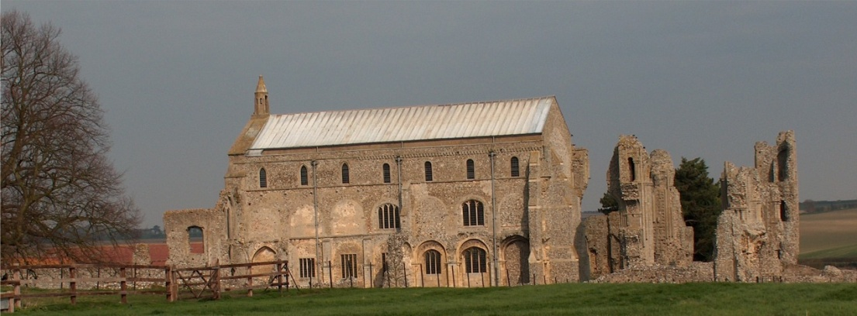
BINHAM with COCKTHORPE PARISH COUNCIL
Parish Clerk – Sarah Hayden
53 Cromer Road, Lower Gresham
NR11 8RH
Tel: 01263 570223
Email: clerk@binhampc.norfolkparishes.gov.uk
https://binhampc.norfolkparishes.gov.uk

2026/1
DRAFT
MINUTES OF BINHAM WITH COCKTHORPE ANNUAL PARISH COUNCIL MEETING
12th JANUARY 2026 AT THE MEMORIAL HALL, BINHAM

Those Present Cllr. E. Brady (Chair), Cllr. P. Alford, Cllr. W. Keesom and Cllr. A. Wordingham
In Attendance Mrs. S. Hayden (Clerk)
District Councillor Sarah Bütikofer

The Chair opened the meeting at 7.33pm and welcomed everyone

1. To receive apologies for absence
Apologies were received from Cllr. L. Wynder.
2. Declarations of Interest and any dispensations of disclosable pecuniary interests
None. Cllrs. Keesom and Wordingham confirmed they had completed their declaration of interests with NNDC
3. Approval of Minutes of Parish Council Meeting held on 10th November 2025
The draft minutes were approved and then signed by the Chair
4. Matters Arising
1. Cllr. Alford had looked into the Neighbourhood Watch scheme. This was discussed in detail and it was agreed that a new village scheme would not be set up at present.
2. New gov.uk addresses for parish councillors had not yet been used. The Clerk confirm this was not currently mandatory.
3. The new Local Plan had been adopted by full council at NNDC

5. Reports
5.1 Norfolk County Council
A report had been received and circulated. The Chair outlined the contents of the report and the NNDC reply to the Government consultation on unitary councils in Norfolk.
[District Councillor Sarah Bütikofer arrived during this item]
5.2 North Norfolk District Council
District Cllr. Bütikofer had sent a report, which the Clerk would circulate and annexe to these minutes. She confirmed that NNDC preferred the option of three councils for Norfolk and outlined some reasons why. NNDC were hoping to hear from the Government during March although she felt that date might be put back. The mayoral election had been put off and would not take place in May and that would result in a loss of funding for Norfolk. Cllr. Bütikofer then went through h.er report for the meeting.
5.3 Chair’s report
The Chair had nothing to add to the above, other than SAM2 data. She had not been able to access the data for the past months, but had been able to take graphs which she circulated and explained. These showed that 93% of traffic on Front Street had been under 30mph and of the small proportion over 30mph there had been a few over 50mph. The percentile figure worked out at 28mph, which as the same as it had been for some years. The graphs showing numbers of vehicles were discussed, but no firm conclusion could be made.

2026/2

6. To discuss Warham Road and Front Street junction and agree any further action
Following copy correspondence received on behalf of a resident, the County Councillor and the Highways Engineer, the Chair noted that there was a new “Give Way” sign 150 yards before the junction with Front Street on the Warham Road and the white lines had been re-painted. It was agreed the Clerk and Chair would check details and requirements for a change to a “Stop” sign.

7. Planning
7.1 To receive report from Planning Committee
Cllr. Alford reported that it had been quiet on the planning front and no new applications had been received. She explained the history of the application remaining from the last meeting i.e. PF/25/1946 Proposed extensions and alterations – 79 and 81 Warham Road, Binham, NR21 0DQ This had been approved by NNDC with strict conditions regarding lighting.
7.2 To discuss and agree observations on any applications received after the date of Agenda
None

8 Finance and Regulatory
8.1 To receive cash account and report on bank reconciliation
The cash account was received with no comments. Cllr. Keesom reported that the bank reconciliation was correct.
8.2 To approve the List of Payments
A sum of £170 to C & S Hudson for December grounds maintenance was added to the List, which was then approved and signed by the Chair and Clerk
8.3 To review the agreed precept for 2026-27 and following receipt of the tax base figure
Due to an increase in the tax base from 2025-26 it was proposed and resolved to increase the precept to £12,000 from the precept agreed at the November meeting.
8.4 To appoint auditor for 2025-26 accounts
Proposed and resolved to appoint Mrs. B. Flood as auditor
8.5 To review and approve updated draft Cemetery Rules
The draft had been approved by the PCC. Discussed and agreed that the Chair and Cllr. Alford would visit the cemetery and consider further amendments to the draft.

9. Update on S. 106 funding
The officer previously dealing with S. 106 funding had left NNDC and the new officer had recently made contact. Consent for using the funds as agreed at the November meeting was awaited.

10. To discuss management of footpath/nature area on Warham Road
NCC had recently cut the path. The Chair reported that she had recently had difficulties liaising with English Heritage, but a meeting had been arranged.
11. To deal with any correspondence
None other than emailed newsletters, etc.
12. Items for information only or next Agenda
The bin rota was discussed and re-arranged.

There being no further business the meeting closed at 10pm and the approved cheque was signed

