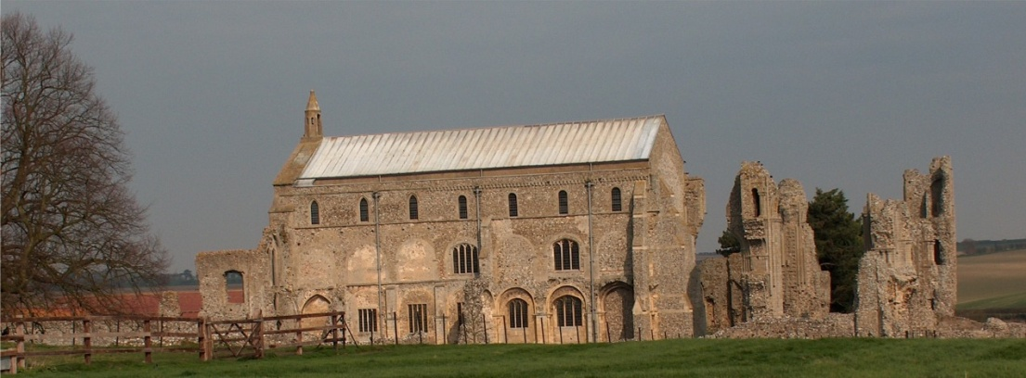
BINHAM WITH COCKTHORPE PARISH COUNCIL
Parish Clerk – Sarah Hayden CiLCA
53 Cromer Road, Lower Gresham
NR11 8RH
Tel: 01263 570223
Email: clerk@binhampc.norfolkparishes.gov.uk
Website: https://binhampc.norfolkparishes.gov.uk

Notice & Summons of Parish Council Meeting
Notice is given to the public and Members of the Council are summoned to attend a Meeting of Binham and Cockthorpe Parish Council at the Memorial Hall, Binham
On Monday 12th January 2026 at 7.30pm
S. H. Hayden
Parish Clerk
5th January 2026

The Public are welcome to attend this Parish Council meeting

AGENDA

1. To receive apologies for absence

2. Declarations of Interest and any dispensations of disclosable pecuniary interests

3. Approval of the Minutes of Parish Council Meeting held on 10th November 2025

4. Matters Arising from those Minutes

5. Reports
5.1 Norfolk County Council
5.2 North Norfolk District Council
5.3 Chair’s Report

6. To discuss Warham Road and Front Street junction and agree any further action

7. Planning
7.1 To receive report from Planning Committee
7.2 To discuss and agree observations on any applications after the date of this Agenda

8. Finance and Regulatory
8.1 To receive cash account and report on bank reconciliation
8.2 To approve list of payments
8.3 To review agreed precept for 2026-27 following receipt of tax base figure
8.4 To appoint auditor for 2025-26 accounts
8.3 To review and approve updated draft Cemetery Rules

9. Update on s. 106 funding

10. Update on management of footpath/nature area on Warham Road

11. Correspondence

12. Items for Information Only or next Agenda

