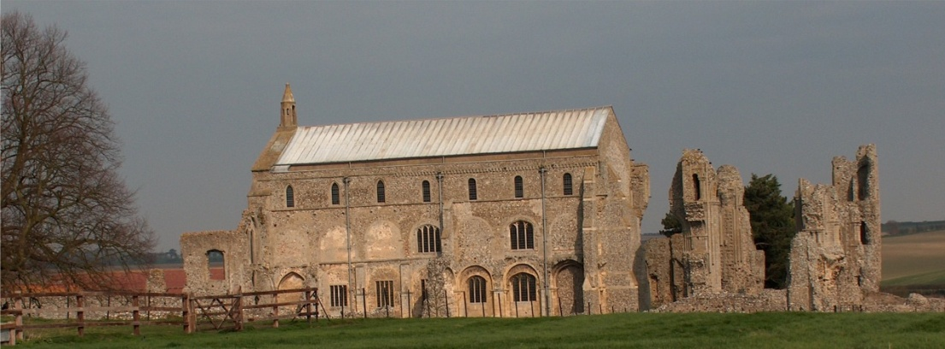
BINHAM with COCKTHORPE PARISH COUNCIL
Parish Clerk – Sarah Hayden
53 Cromer Road, Lower Gresham
NR11 8RH
Tel: 01263 570223
Email: clerk@binhampc.norfolkparishes.gov.uk
https://binhampc.norfolkparishes.gov.uk

2025/14
DRAFT
MINUTES OF BINHAM WITH COCKTHORPE ANNUAL PARISH COUNCIL MEETING
10th NOVEMBER 2025 AT THE MEMORIAL HALL, BINHAM

Those Present Cllr. E. Brady (Chair), Cllr. P. Alford, Cllr. W. Keesom, Cllr. L. Wynder and Cllr. A. Wordingham
In Attendance Mrs. S. Hayden (Clerk)

The Chair opened the meeting at 7.40pm and welcomed everyone

1. To receive apologies for absence
None
2. Declarations of Interest and any dispensations of disclosable pecuniary interests
None
3. Approval of Minutes of Parish Council Meeting held on 8th September 2025
The draft minutes were approved and then signed by the Chair
4. Matters Arising
1. It was noted that nothing had been heard (despite a reminder being sent) from Cllr. Dalby or the Highways Engineer on the problem of traffic emerging from the junction of Warham Road and Front Street. The Clerk was asked to remind the Highways Engineer.
2. Item 13 – Cllr. Alford would register for the new neighbourhood watch scheme.
3. Cllr. Wynder report that the paramedics were to continue to operate in Wells over winter.
4. Item 14 – Apologies that the safeguarding policy had not been drafted and draft Cemetery Regulations not completed.
5. New emails had been set up by NALC for Cllrs Brad and Alford, but were not yet in use on their devices.

5. Reports
5.1 Norfolk County Council
A report had been received and circulated.
5.2 North Norfolk District Council
An October report had been received and circulated.
5.3 Chair’s report
The Parish Council had achieved a lot over the past few years, with more to be done. The bus shelter was in place, but there was a hairline crack in the noticeboard glass and one door was stiff, which the Chair would report to Littlethorpe for them to rectify. Cllr. Wordingham felt the opportunity had been missed to centre it to the dropped kerb. There was no up-to-date data from the SAM2 but it was in position on Front Street. A query was raised as to whether it was recording every passing vehicle.

6. Planning - To receive report from Planning Committee
Cllr. Alford that it had been a quiet couple of months for planning with one pending application and no new applications.

2025/15

Pending Application
PF/25/1946 Proposed extensions and alterations – 79 and 81 Warham Road, Binham, NR21 0DQ – Cllr. Alford explained that this application replaced application PF/25/1622 which had been withdrawn. Cllr. Alford had contacted the planning officer and been advised that the comments on the original application
would be relevant and could be resubmitted. This had been done and the Parish Council had supported the application with comments on the large size of the extension and preference for wood cladding rather than Cedral for a conservation area. A new bat roost and emergence survey had been carried out, was on the planning portal and a decision was still pending.

Cllr. Alford then noted that the building work had commenced on plot 10 Walsingham Road with footings being laid. The Chair reported that she was continuing to monitor builders’ vehicles throughout the village to keep the roads as clear as possible.

7 Finance and Regulatory
7.1 To receive cash account and report on bank reconciliation
The cash account was received with no comments. Cllr. Keesom reported that the bank reconciliation was correct.
7.2 To approve the List of Payments
A sum of £20 was added to the List for the wreath although no request had yet been received. It was noted that the cheque for the bus shelter was signed and would be dated when the grant funding had been received. The List was then approved and signed by the Chair and Clerk.
7.3 To agree Budget for 2026-27 and set the precept
The Clerk informed the meeting that NNDC had been unable to give an accurate tax base figure due to problems with computer software and had suggested that parish councils use the 2025-26 figure. Councillors agreed that the tax base would be unlikely to change greatly and agreed to set the precept at the meeting. The Budget was discussed in detail. Proposed and resolved to set the precept at £11,400.
7.4 To approve IT Policy
The Clerk explained that due to changes in audit rules parish councils were now required to have an IT policy. A typing error was amended and the draft Policy approved, adopted and dated.

8. Update on new bus shelter
As item 5.3
9. To discuss use of s. 106 funding
The amount of funding was £7,522. Discussed and agreed that the funding would be used to kerb one side of the Green to help prevent parking and destruction of the edge, place a new larger dog bin at the Priory, move the existing dog bin and purchase one new bin for the footpath at Leeders Pightle and the Green and level the footpath from Front Street to the shop.
10. To discuss management of footpath/nature area on Warham Road
Discussed in detail and agreed this needed to be cut when overgrowing the path. English Heritage would be asked to contribute to the cost.
11. To deal with any correspondence
1. NNDC – The Local Plan was in its final stages and just had to be approved by full Council.
2. NNDC – Housing need figures for the parish
3. Local Lynx – thank you for donation
12. Items for information only or next Agenda
1. The Christmas lights were being organised by Mrs. E. Brown on behalf of the Parish Council. It was agreed that Cllr. Wordingham would liaise and shadow her with a view to taking over responsibility for them on behalf of the Parish Council for Christmas 2026
2. Cllr. Keesom confirmed she would complete her Declaration of Interests on-line with NNDC as they did not appear on the Register.
3. Cllr. Alford noted that notices on an empty property on Priory Crescent had been taken down and it appeared to be being cleared.

There being no further business the meeting closed at 9.25pm and the approved cheques were signed

