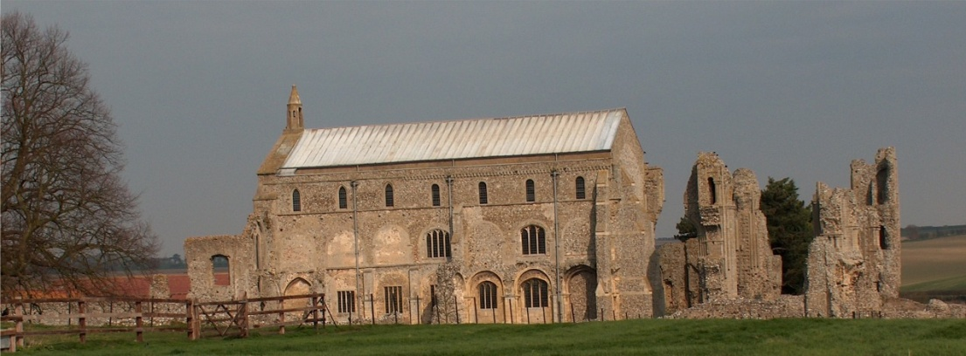
BINHAM with COCKTHORPE PARISH COUNCIL
Parish Clerk – Sarah Hayden
53 Cromer Road, Lower Gresham
NR11 8RH
Tel: 01263 570223
Email: clerk@binhampc.norfolkparishes.gov.uk
https://binhampc.norfolkparishes.gov.uk

2025/12
DRAFT
MINUTES OF BINHAM WITH COCKTHORPE ANNUAL PARISH COUNCIL MEETING
8th SEPTEMBER 2025 AT THE MEMORIAL HALL, BINHAM

Those Present Cllr. E. Brady (Chair), Cllr. P. Alford, Cllr. L. Wynder and Cllr. A. Wordingham
In Attendance Mrs. S. Hayden (Clerk)

The Chair opened the meeting at 7.30pm and welcomed everyone

1. To receive apologies for absence
Apologies were received from Cllr. W. Keesom
2. To co-opt parish councillor followed by signing of Acceptance of Office
The applicant spoke to the meeting about why he was interested in joining the Parish Council and how long he had lived in Binham. He was thanked by the Chair. It was then proposed and resolved that he be co-opted to the Parish Council, following which he signed the Acceptance of Office and was handed some information on governance of parish councils.

Cllr. Wynder then made her apologies and left the meeting.

3. Declarations of Interest and any dispensations of disclosable pecuniary interests
Cllr. Wordingham declared an interest in item 9 of the Agenda, being the appointed contractor for the groundworks for the proposed bus shelter. Proposed and resolved to grant a dispensation of disclosable pecuniary interests under s. 33(2)(a) of the Localism Act 2011 for the September and November meetings.
4. Approval of Minutes of Parish Council Meeting held on 28th July 2025
The draft minutes were approved and then signed by the Chair
5. Matters Arising
It was noted that nothing had been heard from Cllr. Dalby or the Highways Engineer on the problem of traffic emerging from the junction of Warham Road and Front Street as discussed at the July meeting. Discussion took place and the Clerk was asked to send a reminder to Cllr. Dalby.

6. Reports
6.1 Norfolk County Council
None received but the Clerk would circulate any received following the meeting
6.2 North Norfolk District Council
None received but the Clerk would circulate any received following the meeting
6.3 Chair’s report
A short discussion took place on the proposed unitary councils, noting that a forthcoming Forum was being held at Kings Lynn. The Chair also produced and explained the figures in an up-to-date SAM2 report, which is annexed to these minutes.

7. Planning - To receive report from Planning Committee
Cllr. Alford reported as follows:

2025/13
New Applications
PF/25/1946 Proposed extensions and alterations – 79 and 81 Warham Road, Binham, NR21 0DQ – Cllr. Alford explained that this application replaced application PF/25/1622 which had been withdrawn on 28.8.25. The Parish Council had supported the application and submitted agreed comments. The new application appeared to be exactly the same and it was agreed that Cllr. Alford would contact the planning officer and check if there were any updates or differences. If not, the original comments would be resubmitted.
PF/25/1185 Installation of arrays of 9 solar PV panels on the east and west facing roof slopes of dwelling (part retrospective) – 13 Leeders Pightle, Binham, NR21 0FA – This was a retrospective application and the Parish Council had supported it. It had been approved by NNDC.

8 Finance and Regulatory
8.1 To receive budget against actuals, balance sheet and report on bank reconciliation
The budget and balance sheet were received with no comments. As Cllr. Keesom was not in attendance, the report on the bank reconciliation would be held over until the next meeting. The Clerk offered the bank reconciliation to councillors if they wished to check the figures.
8.2 To approve a donation to the Local Lynx
A request for a donation had been received and was discussed. The budget provided for £100 and it was proposed and resolved to donate that sum.
8.3 To approve the List of Payments
The above donation was added to the List, which was approved and then signed by the Chair and Clerk.

9. Update on new bus shelter
A date was awaited from UK Power Networks for checking of power lines above the site. The Clerk would chase that. The proposed date for installation had been set as the half term week in October. Nearby residents would be informed once UK Power Networks had visited and the date for the work had been finalised with them.
10. To discuss use of s. 106 funding
Held over until the next meeting
11. To discuss management of footpath/nature area on Warham Road
Discussed briefly, but held over until the next meeting when more information was expected.
12. To receive annual Asset Safety Report and agree any action
The assets had been checked by the Clerk and Chair and circulated to parish councillors. The Clerk read out the items with none needing urgent attention. Due to the maintenance budget being used on the provision of the bus shelter it was agreed to carry out any work suggested in the next financial year. The noticeboard on Warham Road had been kindly repaired by Wells Men’s shed and a donation of £50 would be sent.
13. To deal with any correspondence
Police email re Neighbourhood Watch – Agreed that Cllr. Alford would register to receive information from the new Neighbourhood Watch scheme on behalf of the Parish Council.
Wells Town Council – notification of withdrawal of cycling paramedics during winter – to be discussed at their Sept. meeting
14. Items for information only or next Agenda
Next Agenda: S.106 funding, Management of footpath/nature area on Warham Road, Safeguarding Policy, Regulations for Cemetery.
For information: The Chair and Cllr. Alford had received their instructions for using their new gov.uk email addresses

There being no further business the meeting closed at 9.55pm.
The approved cheques were signed

