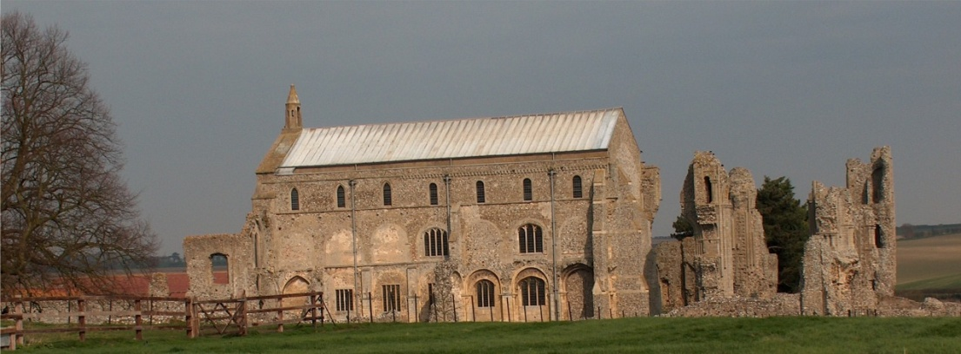
BINHAM WITH COCKTHORPE PARISH COUNCIL
Parish Clerk – Sarah Hayden
53 Cromer Road, Lower Gresham
NR11 8RH
Tel: 01263 570223
Email: sarah352hayden@btinternet.com

Notice & Summons of Parish Council Meeting
Notice is given to the public and Members of the Council are summoned to attend a Meeting of Binham and Cockthorpe Parish Council at the Memorial Hall, Binham
On Monday 8th September 2025 at 7.30pm
S. H. Hayden
Clerk
2nd September 2025
The Public are welcome to attend this Parish Council meeting

AGENDA

1. To receive apologies for absence
2. To co-opt parish councillor following by signing of Acceptance of Office
3. Declarations of Interest and any dispensations of disclosable pecuniary interests
4. Approval of the Minutes of Parish Council Meeting held on 28th July 2025
5. Matters Arising from those Minutes

6. Reports
6.1 Norfolk County Council
6.2 North Norfolk District Council
6.3 Chair’s Report

7. Planning
7.1 To receive report from Planning Committee
7.2 To discuss and agree observations on any applications after the date of this Agenda

8. Finance and Regulatory
8.1 To receive budget against actuals, balance sheet and report on bank reconciliation
8.2 To approve a donation to Local Lynx
8.3 To approve list of payments

9. Update on new bus shelter
10. To discuss use of s. 106 funding
11. Update on management of footpath/nature area on Warham Road
12. To receive annual Asset Safety Report and agree any action
13. Correspondence
14. Items for Information Only or next Agenda

