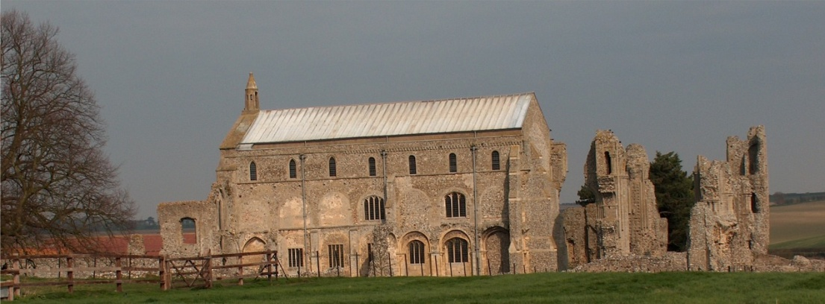
BINHAM with COCKTHORPE PARISH COUNCIL
Parish Clerk – Sarah Hayden
53 Cromer Road, Lower Gresham
NR11 8RH
Tel: 01263 570223
Email: sarah352hayden@btinternet.com
https://binhampc.norfolkparishes.gov.uk

2025/9
DRAFT
MINUTES OF BINHAM WITH COCKTHORPE ANNUAL PARISH COUNCIL MEETING
28th JULY 2025 AT THE MEMORIAL HALL, BINHAM

Those Present Cllr. E. Brady (Chair), Cllr. P. Alford, Cllr. W. Keesom and Cllr. L. Wynder
In Attendance Mrs. S. Hayden (Clerk)
County Councillor Michael Dalby

The Chair opened the meeting at 7.34pm and welcomed everyone

1. To receive apologies for absence
The Chair confirmed with regret that Cllr. Brown had resigned and expressed thanks for all her support during the time she had been a parish councillor
District Cllr. Sarah Butikofer had sent apologies
2. Declarations of Interest and any dispensations of disclosable pecuniary interests
None
3. Approval of Minutes of Parish Council Meeting held on 12th May 2025
The draft minutes were approved and then signed by the Chair
4. Matters Arising
It was noted that Blakeney Parish Council would not be charging for parking at the Village Hall following their consultation.
At this point Cllr. Alford reported that a resident has asked if there was anything the Parish Council could do about the dangerous driving at the Warham Road/Front Street junction, where drivers were emerging on to Front Street from Warham Road without stopping to check the traffic. Cllr. Dalby offered to contact to the Highways Engineer to see if there was anything that could be done regarding signs, etc. The Clerk was asked to also write in support.

5. Reports
5.1 Norfolk County Council
County Councillor Michael Dalby’s report had been received and circulated prior to the meeting and is annexed to these minutes. He further reported in connection with unitary councils that he supported one council but not in its current proposed form. He also felt that joint Suffolk and Norfolk unitary council with a Mayor, did not deal with scrutiny of the elected Mayor, in particular regarding the budget. Whatever was agreed would be put in place during May/June 2027. Two thirds of responders to the consultation in Suffolk did not wish to have a unitary authority. Regarding devolution, Norfolk County Council wished to have all local councils combined in to one authority. He felt that the report regarding one unitary council for Norfolk was not user friendly and was in communication with officers to try to resolve this issue. Regarding highway matters, he had that day had a meeting with the highways engineers regarding potholes, white and yellow lines, including problems with tarmac being laid over lines. He felt that potholes are not filled to a sufficiently high standard and would be looking into that problem. Parish Councillors supported that view and discussion followed. On a question being raised, he confirmed the LMF fund was still available and he would consider an application to fund a noticeboard in the new bus shelter if needed.

2025/10

5.2 North Norfolk District Council
District Councillor Bütikofer’s report had been circulated prior to the meeting and is annexed to these minutes.
5.3 Chair’s Report
The Chair reported that the SAM2 was working although there was no new data to report yet. The bin rota for the cemetery would be changed following new dates being received. The subject of new dog waste bins was raised, but the remaining budget for maintenance during the current financial year would be spent on the new bus shelter, so any purchase of bins would have to be held over.

6. Planning - To receive report from Planning Committee
Cllr. Alford reported as follows:
New Applications
PF/25/1185 Installation of arrays of 9 solar PV panels on the east and west facing roof slopes of dwelling (part retrospective) – 13 Leeders Pightle, Binham, NR21 0FA – This was a retrospective application and the Parish Council had supported it. The pros and cons of green power, the conservation area and previous applications in the village. The application was pending a decision by NNDC.
PF/25/1622 Proposed extensions and alterations – 79 and 81 Warham Road, Binham, NR21 0DQ – the application was discussed and it was agreed that Cllr. Alford would prepare comments and circulate them to the parish councillors for approval.

7 Finance and Regulatory
7.1 To receive budget against actuals, balance sheet and report on bank reconciliation
The budget, balance sheet and bank reconciliation were received with no comments. Cllr. Keesom confirmed the bank reconciliation was correct.
7.2 To approve the List of Payments
The List was approved and then signed by the Chair and Clerk.
7.3 To review and approve updates to the Parish Council Risk Assessment
The draft amendments were approved
7.4 To discuss requirements for gov.uk email address and agree provider
A short report on the new requirements for a Council owned email address had been circulated. Discussed, proposed and resolved that NALC would be asked to provide a gov.uk address.
7.5 To appoint new signatory and change bank mandate
Agreed to leave Cllrs Alford and Brady as main signatories and the Clerk as spare signatory for the time being. A new councillor signatory would be appointed in the future when more councillors are co-opted to fill the current vacancies.

8. Bus Shelter
8.1 Update on new bus shelter and grant application
The grant application had been successful and had been approved within a day of being submitted. There was a lead time of 6 – 8 weeks for the bus shelter and the grant had to be claimed by 31st March 2026.
8.2 To agree contractor for ground works
Three quotes had been received and were discussed in detail. Proposed and resolved to accept the local contractor Beechwood Landscapes’ quotation on condition that guttering and a water butt were included in the price and on condition that there would be no price increases. The Clerk would request the lead time required and confirm that an underground cable check would be made.
8.3 To agree final funding figures and timescale
The Clerk went through the figures and advised that the cost of the noticeboard would need to be covered from either the County Councillor allowance or S 106 funding. Agreed to request funding from Cllr. Dalby initially.

9. To discuss use of s. 106 funding
Enquiries to the Highways Engineer on the cost of kerbing for the Green resulted in the cost being circa £170 per linear metre. Agreed to hold a decision over until the September meeting when funding has been finalised for the bus shelter.

2025/11

10. To discuss management of footpath/nature area on Warham Road
The Chair reported that she understood the wall was owned by Norfolk Archaeological Trust but they had stated the verge is not their responsibility. English Heritage manage the area and she hoped to speak to them shortly. Agreed that further information would be sought on when the various plants seeded and the best time to cut the verge.

11. To deal with any correspondence
NNDC – link to consultation on the importance of cash – agreed the Clerk would answer it on behalf of the Parish Council.

12. Items for information only or next Agenda
Next Agenda: S.106 funding

There being no further business the meeting closed at 10.10pm.
The agreed cheques were signed

