June Priory Parish Council Report
Please find attached my report for the above period.
As always if you believe I can be of help or assistance as your District Councillor please do get in touch.
Email – sarah.butikofer@north-norfolk.gov.uk
Tel 07968 897235
Sarah

District Council General
Devolution and Local Government Reorganisation.
In terms of Devolution and the establishment of a Mayoral Combined County Authority (MCCA) some details are now available as to the detailed work programme and workstreams being set up and operated to support the safe and legal establishment of the MCCA by the end of this year / early next year to allow the necessary arrangements to be put in place for the election of a Mayor for Norfolk and Suffolk in May of next year. The two County Councils have also now agreed to establish a Sponsor Board for the programme with invitations extended to one District Leader from each County. A similar Chief Executive Group has been established, as well as each district council being asked to nominate a lead officer to support communications over the MCCA and to begin to propose priorities for any Investment Fund which might be operated by the Mayor. Details of these developments will be available soon.

With respect to the more significant issue for us - LGR, last week the Leaders and Chief Executives of the six Norfolk districts promoting a three unitary council model for Norfolk in the future attended a facilitated workshop to agree the boundaries or 'footprint' of the proposed councils. Consensus existed around the principles of a new three council model - ie a Greater Norwich authority based on the urban area of the city with some scope for further growth and East and West authorities of similar population and Tax Base size. Consideration was also given to the Government criteria of trying to use existing district boundaries (where possible) as building blocks and whether this might be achieved in Norfolk except for the Greater Norwich area impacting the Broadland and South Norfolk districts so as to limit issues of disaggregation of services. Balancing all of those competing criteria was not easy but subject to assessing the population and Tax Base issues in a couple of locations which are now subject to some further work, the geographies of the proposed authorities was broadly agreed and will be shared very soon.

As well as agreeing the likely geographies of the three new authorities, the process of engaging a consultant partner was also concluded last week and the Leaders and Chief Executives have had a first meeting with the consultant team to agree the detailed work programme required to develop a strong narrative around the three proposed authorities and begin to develop and 'test' new service operating models, costs and efficiencies considering the needs of our residents over large areas, and arrangements for community engagement through some form of area based structures referred to again by Government last week in confirming the allocation of (modest) capacity funding to support the business case process. Details of the work programme will be shared once available.

Again, related to the geographies of the proposed new councils, significant work has been progressed on a Communications and Engagement campaign to promote our thinking behind the three council model - based on the proposed councils being large enough to deliver but being close enough to our residents and communities to care and respond to their needs, which vary significantly across Norfolk. Thoughts have therefore been developed around engagement with Town and Parish Councils, briefing of MPs, an event at the Royal Norfolk Show and a dedicated website providing details of the proposals, FAQs and feedback so we can hear from our residents.

Two further briefings for Town and Parish Councils will be arranged very soon to update you further.

Housing Report
I have attached a report from our Housing portfolio holder which has some very interesting information regarding the housing challenges and statistics across our District.

Inland Dog Public Space Protection Orders
The Council is currently consulting to renew the existing orders for inland areas across North Norfolk – no new areas are proposed at this time, but the order has to be renewed periodically.

Local Plan
To keep you updated on next steps, please find an outline of the process moving forwards below
Just to be clear there are two components of the details below which are largely outside our control (part of Stage 2 and all of Stage 4) – i.e. that bring some uncertainty into the process - but our best guess at the moment is set out below:
Stage 1: We are already working from the Inspector’s letter with the aim of finalising the ‘Main Modification’ schedule (which we need to agree with the Inspector prior to finalising). Alongside that, we will produce an ‘Additional Modifications’ schedule consisting of consequential changes, factual updates and minor amendments that do not affect the soundness. We aim for all that work to be completed by the end of June.
Stage 2: The ‘Main Modifications’ need to be assessed from a ‘Sustainability Appraisal’ and a ‘Habitats Regulations Assessment’ perspective (the latter involving external consultants). While some of that can be done in parallel with Stage 1 it can’t be finished until after Stage 1 is completed. The outcomes also need to be reviewed with the Inspector before we can proceed to Stage 3 and the changes incorporated into the Plan. We hope all that can be completed by the end of July / mid August .
Stage 3: We will then need a 6 week period of public consultation on the Main Modifications, and forward the consultation responses to the Inspector for his consideration. We anticipate this taking place during August and September.
Stage 4: The Inspector then finalises his Report. We hope to receive that by the end of October.
Stage 5: Then we will move to the formal Council decision making (ultimately it is a Full Council decision to adopt). We anticipate this being either the November or December meeting of Council.
Stage 6: Legal advertising of Plan adoption. Hopefully before the end of 2025.
For the avoidance of doubt – when we adopt a new Plan – the existing one from 2008 (Core Strategy) and 2011 (Site Allocations) will cease to be part of the ‘development plan’ and will not be a relevant consideration in decision making from then on.
We are now in a position where we have greater confidence that the Plan will be found ‘sound’ and greater confidence as to the final wording of many of our policies and proposals.
Now that it has reached this advanced stage where those contested points have been resolved through the examination process this brings into play the question as to the ‘weight’ that Officers will give the emerging Plan in the Development Management decision making process – and within recommendations to Committee - and in pre application advice. Our view is that we should be transparent on that and transition to its use in line with paragraph 49 of the Government’s National Planning Policy Framework – so officers are aiming to take a report to Development Committee on 27th June 2025 that will set out the position and ‘weight’ that Officers will give to each draft policy and allocation prior to adoption. It is a matter for the decision maker in each case to decide the ‘weight’ to be given to different material considerations as is the case now.
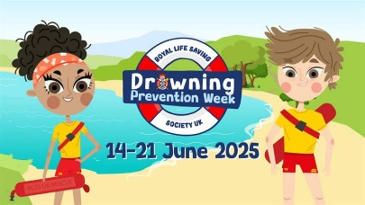
Drowning Prevention Week: 14-21 June
The RLSS launch their drowning prevention week for 2025 with a call to action to get as many schools and organisations behind the scheme delivering water safety messaging and lessons.
New campaign aims to help older people to drive safely for longer – information is available on the County Council Website
Norfolk County Council's Road Safety Team, in collaboration with Norfolk Police, Norfolk Fire and Rescue Service (NFRS) and East of England Ambulance Service, are supporting people to review their driving and get the support they need when they need it.
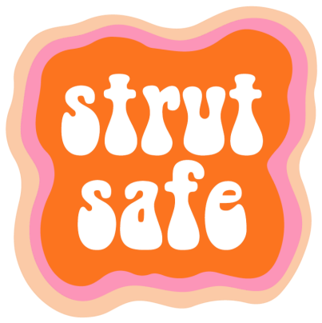
Strut Safe - 0333 335 0026 – Perhaps not one for our area but interesting for when visiting friends and family in other areas.
Strut Safe is a UK-wide phone line. If you're walking alone, our volunteers will be a friendly voice to keep you company and help you feel safe until you are through the door.
The phone line is open Fridays and Saturdays: 19:00 - 03:00 and Sundays: 19:00 - 01:00

