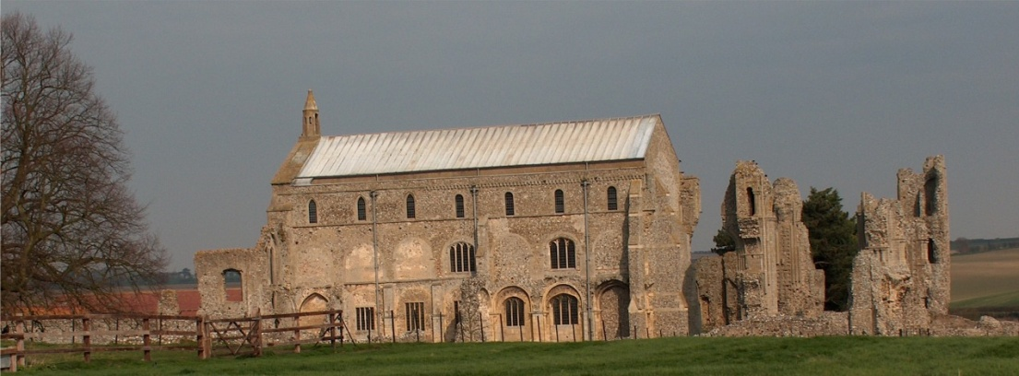
BINHAM with COCKTHORPE PARISH COUNCIL
Parish Clerk – Sarah Hayden
53 Cromer Road, Lower Gresham
NR11 8RH
Tel: 01263 570223
Email: sarah352hayden@btinternet.com
https://binhampc.norfolkparishes.gov.uk

2025/4
DRAFT
MINUTES OF BINHAM WITH COCKTHORPE PARISH COUNCIL MEETING
10th MARCH 2025
AT THE MEMORIAL HALL, BINHAM

Those Present Cllr. L. Brown (Vice Chair), Cllr. P. Alford and Cllr. W. Keesom
In Attendance Mrs. S. Hayden (Clerk)
District Councillor Sarah Bütikofer

In the absence of the Chair, the Vice-Chair opened the meeting at 7.34pm and welcomed everyone attending

1. To receive apologies for absence
Apologies were received from Cllr. L. Brady, Cllr. L. Wynder and Cllr. K. Cooke.
County Councillor M. Dalby had sent apologies
Due to Cllr. K. Cooke not attending a meeting of the Parish Council for six months, under the Local Government Act 1972 s. 85(1) he had ceased to be a member. It was therefore proposed and resolved to declare a vacancy on the Parish Council.
2. Declarations of Interest and any dispensations of disclosable pecuniary interests
None
3. Approval of Minutes of Parish Council Meeting held on 13th January 2025 and 3rd February 2025
The two sets of draft minutes were approved and then signed by the acting Chair
4. Matters Arising
The SAM2 had been serviced and would be put back in place in April.
The allotment hedge plants had been received and a date would be arranged for planting shortly.

5. Reports
5.1 Norfolk County Council
County Councillor Michael Dalby’s Report had been circulated prior to the meeting and is annexed to these minutes
5.2 North Norfolk District Council
District Councillor Bütikofer’s report had been circulated prior to the meeting and is annexed to these minutes.
5.3 Short report on briefing event by NNDC on the effects of devolution and unitary councils on town and parish councils in Norfolk
The Clerk, Cllrs. Brady and Cllr. Alford had attended the briefing at Thursford. District Councillor Bütikofer and Cllr. Alford outlined in general, the information provided at the briefing and the timetable set by the Government. Discussion followed.

6. Planning
6.1 To receive report from Planning Committee
Cllr. Alford reported as follows:

2025/5

Applications decided since last meeting
PF/24/1777 Installation of air source heat pump – 25 Front Street, Binham – Approved
PU/24/0753 Change of use of agricultural building to dwellinghouse (Class C3) and building operations necessary for the conversion -Barn to the rear of Abbott Farm Barn, Walsingham Road, Binham, NR21 0AW – The Planning Inspectorate had dismissed the Appeal
6.2 To discuss and agree observations on any applications after the date of this Agenda and application:
PF/25/0314 Formation of vehicle access and parking area – Nutwood Farm Bungalow, Binham Road, Wighton, NR23 1NX – Discussed and agreed there were no objections to this application and Cllr. Alford would draft comments for submission to NNDC
LA/25/0330 Repairs, upgrade and replacement of three sashes and a casement window on the east and north elevations – Old School House, Warham Road, Binham, NR21 0DQ – Discussed and agreed there was no objection and it should be supported as upgrading the property. Cllr. Alford would draft the comments for submission to NNDC.

7. Finance and Regulatory
7.1 To receive budget against actuals, balance sheet and report on bank reconciliation
The budget and balance sheet were received with no comments. Cllr. Keesom confirmed the bank reconciliation was correct.
7.2 To approve the List of Payments
The List was approved, then signed by the Acting Chair and Clerk

8. To discuss funding for the new bus shelter including agreement of earmarked reserve
Proposed and resolved to earmark £600 from the History Group donation and £400 from maintenance/contingency for this financial year for the new bus shelter. Fund raising was discussed and the possibility of further grants would be investigated.

9. Update on 80th anniversary of VE day celebrations and approval of any expenditure
Cllr. Brown outlined what had been agreed at the Memorial Hall committee meeting. It had been agreed that people would be invited to dress in 1940’s outfits and bring a savoury picnic, with teas and cakes to be provided by the Committee. Cllr. Alford offered to make up a display board as she had been researching the subject with particular regard to the village. There would be a standard bearer and Cllr. Brown was trying to find a school band to play. The day would be advertised in the Lynx.

10. Update on cost of path improvement Front Street to The Green
There had been no progress with this and Cllr. Brown offered to make enquiries with a builder

11. To discuss repairs to the Village Sign and noticeboard
A quote had been received from the person who had cleaned and oiled the outside of the sign on its last refurbishment, for filling the joints, cleaning and oiling the oak frame of the Village Sign at £275 and it was proposed and resolved to go ahead with that quote after the end of this financial year. The Wells Men’s Shed had kindly agreed to deal with the noticeboard at Warham Road when they had completed some existing jobs. They had asked for a donation to be made and any materials paid for.

12. To deal with any correspondence
Barclays – reduction in interest rates
Ron Bailey – support for increased safety legislation for lithium ion batteries

13. Items for information only or next Agenda
Cllr. Brown advised that the Annual Parish Meeting would take place on 22nd April 2025 with the Memorial Hall AGM

There being no further business the meeting closed at 9pm.
The next meeting would be the Parish Council Annual Meeting on Monday 12th May 2025

