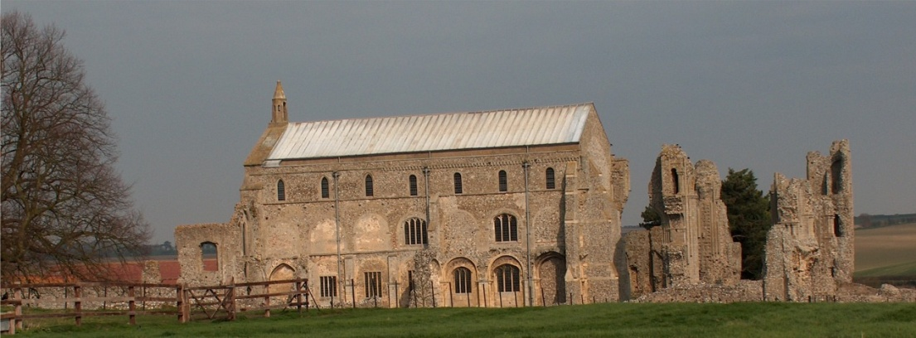
BINHAM with COCKTHORPE PARISH COUNCIL
Parish Clerk – Sarah Hayden
53 Cromer Road, Lower Gresham
NR11 8RH
Tel: 01263 570223
Email: sarah352hayden@btinternet.com
https://binhampc.norfolkparishes.gov.uk

2025/4
DRAFT
MINUTES OF BINHAM WITH COCKTHORPE
EXTRAORDINARY PARISH COUNCIL MEETING
3rd FEBRUARY 2025
AT THE MEMORIAL HALL, BINHAM

Those Present Cllr. E. Brady (Chair), Cllr. L. Brown, (Vice Chair), Cllr. P. Alford, Cllr. W. Keesom and
Cllr. L. Wynder
In Attendance Mrs. S. Hayden (Clerk)

The Chair opened the meeting at 7.30pm

1. To receive apologies for absence
None

2. Declarations of Interest and any dispensations of disclosable pecuniary interests
None

3. Public questions, comments or representations
(on matters connected with this Agenda – limited to four minutes per person and twenty minutes in total at discretion of the Chairman)
No public present

4. To reconsider the budget and precept for 2025-26 following notification of changes to North Norfolk District Council tax base on inclusion of a second homes Council Tax premium
The budget and new tax base was discussed in detail. It was proposed and resolved to re-set the precept at £11,170, which would give the Parish Council an increased amount of funds, but no increase on the 2024-25 Parish Council’s part of the council tax bill.

5. To deal with any correspondence
None

6. Items for information only or next Agenda
None

There being no further business the meeting closed at 8.15pm.
The next meeting would be on Monday 17th March 2025

