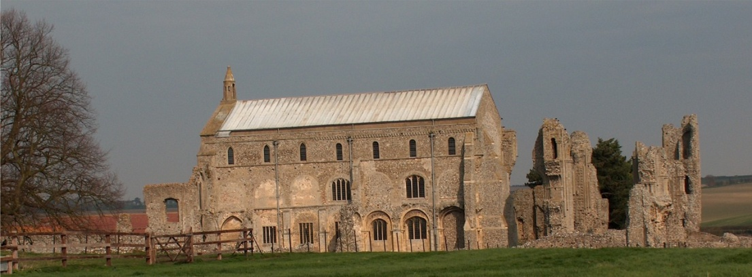
BINHAM WITH COCKTHORPE PARISH COUNCIL
Parish Clerk – Sarah Hayden
53 Cromer Road, Lower Gresham
NR11 8RH
Tel: 01263 570223
Email: sarah352hayden@btinternet.com

Notice & Summons of Extraordinary Parish Council Meeting
Notice is given to the public and Members of the Council are summoned to attend an Extraordinary Meeting of Binham and Cockthorpe Parish Council at the Memorial Hall, Binham
On Monday 3rd February 2025 at 7.30pm

S. H. Hayden
Parish Clerk
27th January 2025

The Public are welcome to attend this Parish Council meeting

AGENDA

1. To receive apologies for absence

2. Declarations of Interest and any dispensations of disclosable pecuniary interests

3. Public questions, comments or representations
(on matters connected with this Agenda – limited to four minutes per person and twenty minutes in total at discretion of the Chairman)

4. To reconsider the budget and precept for 2025-26 following notification of changes to North Norfolk District Council taxbase on inclusion of a second homes Council Tax premium

5. Items for information only or next Agenda

