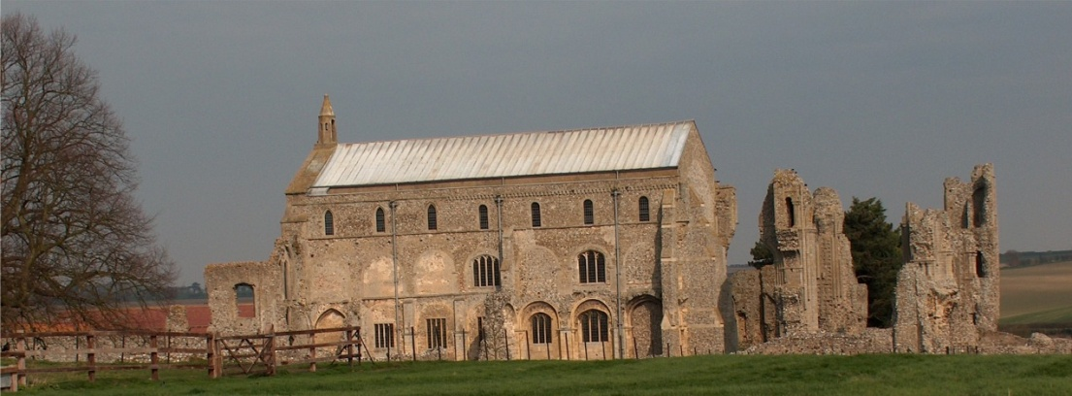
BINHAM with COCKTHORPE PARISH COUNCIL
Parish Clerk – Sarah Hayden
53 Cromer Road, Lower Gresham
NR11 8RH
Tel: 01263 570223
Email: sarah352hayden@btinternet.com
https://binhampc.norfolkparishes.gov.uk

2025/1
DRAFT
MINUTES OF BINHAM WITH COCKTHORPE PARISH COUNCIL MEETING
13th JANUARY 2025
AT THE MEMORIAL HALL, BINHAM

Those Present Cllr. E. Brady (Chair), Cllr. L. Brown, (Vice Chair), Cllr. P. Alford, Cllr. W. Keesom and Cllr. L. Wynder
In Attendance Mrs. S. Hayden (Clerk)
County Cllr M. Dalby

The Chair opened the meeting at 7.30pm and welcomed everyone attending

1. To receive apologies for absence
Apologies were received from Cllr. K. Cooke
2. Declarations of Interest and any dispensations of disclosable pecuniary interests
None
3. Approval of Minutes of Parish Council Meeting held on 11th November 2024
The draft minutes were approved and then signed by the Chair
4. Matters Arising
The Clerk confirmed that she had made an insurance claim for the damage to the SAM2 and it was in progress. The Chair had prepared the rota for the bins to be taken to the roadside from the cemetery and all confirmed it was working well.

5. Reports
5.1 Norfolk County Council
County Councillor Michael Dalby’s Report had been circulated prior to the meeting and is annexed to these minutes. He further reported that full Council had agreed to apply for the Priority Programme for a devolution/unitary deal and to request cancellation of the May elections until a deal was agreed. He reported that the Government would have powers to veto any agreement and also to force councils to form unitary councils. Details were not available currently and would be issued by the Government in due course. Discussion on this followed, followed by questions on Parish Partnership grants for 2025-26 and Cllr. Dalby’s available expenses for highways projects or the proposed bus shelter. It was agreed that the parish councillors would each walk around the village to check highway street furniture.
5.2 North Norfolk District Council
County Councillor Dalby confirmed that Cllr. Bütikofer was on compassionate leave. The Clerk confirmed she had attended her late husband’s funeral, which had been a memorable tribute to his life.
5.3 Chair’s Report and to receive SAM2 data
The Chair explained that it had been a quiet time over Christmas and New Year so there was nothing generally to report, but the SAM2 had been repaired and would be collected over the following week. Gritting had taken place in icy weather on Langham Road, Hindringham Road and Cockthorpe, but not Warham Road until the edge of Warham village. A message would be sent to Highways to request that Warham Road be gritted.

2025/2
County Cllr. Dalby made his apologies and left the meeting

6. Planning
To discuss and make observations on any application received after the date of this agenda and to receive report from Planning Committee
Cllr. Alford reported as follows:

New applications
None

Pending since last meeting
PF/24/1777 Installation of air source heat pump – 25 Front Street, Binham – New details for an acoustic fence had been submitted. The application was still pending. Cllr. Allford noted that this would be an interesting application as this type of heat pump was being promoted by the Government and more would no doubt be submitted as people updated their form of heating
LA/24/1830 Internal and external works to 4 Field Dalling Road and Bottle Cottage, Binham – Withdrawn

Other applications
PU/24/0753 Change of use of agricultural building to dwellinghouse (Class C3) and building operations necessary for the conversion -Barn to the rear of Abbott Farm Barn, Walsingham Road, Binham, NR21 0AW – This Appeal was with the Planning Inspectorate awaiting their decision.

Cllr. Alford had drafted a summary list of 2024 planning applications which had been circulated to parish councillors. 14 applications had been received during 2024, with 13 being decided. 8 had been approved, 1 permitted development, 2 refused, 2 withdrawn and 1 pending Planning Inspectorate appeal.

7. Finance and Regulatory
7.1 To receive budget against actuals, balance sheet and report on bank reconciliation
The Budget and balance sheet were received with no comments. Cllr. Keesom confirmed the bank reconciliation was correct.
7.2 To approve payment of training course for Cllr. Keesom
It was discussed and agreed that Cllr. Keesom would initially read through NALC’s “The Good Councillor” guide, together with any other documents for information on the NALC site, then consider courses at a later date.
7.3 To approve the List of Payments
The List was approved, then signed by the Chair and Clerk
7.4 To appoint internal auditor for 2024-25 accounts
The Clerk confirmed that Mrs. B. Flood was willing to carry out the audit. Proposed and resolved to appoint Mrs. Flood.

8. To discuss the purchase of new bus shelter
The Clerk confirmed that no planning permission was necessary for the new bus shelter. Prices of three different types of wooden bus shelter were discussed. It was agreed that the hardwood type of shelter for looks and longevity was preferred although the most expensive. Provision of windows each side, space for a noticeboard, seating, a pitched roof with guttering and waster butt added, to be used for watering flower boxes and the adjoining garden were all agreed. The Clerk was asked to try and obtain two more quotes from suppliers of hardwood shelters.

Cllr. L. Wynder make her apologies and left the meeting.

9. Update on cost of path improvement Front Street to The Green
Some type 1 had been laid on part of the path by persons unknown. In the absence of Cllr. Cooke the item was held over to the next meeting

2025/3

10. To discuss repairs to the Village Sign and noticeboard
Regarding the Village Sign the Clerk had asked the person who had originally refurbished the sign for the cost to deal with the surround again and this was awaited. The Chair had contacted the Wells Men’s Shed to ask if they would be prepared to repair the noticeboard on Warham Road and they had confirmed this was possible. They would ask for a donation to be made. This was therefore ongoing and being dealt with.

11. Update on hedge provision at allotments and discuss allocation policy for plots
The grant had been accepted and the hedge was on order to be delivered in March.

12. To deal with any correspondence
NNDC – request to answer survey on business waste. The email had been circulated and it was agreed that the Chair would answer the survey and relay any questions to the parish councillors to answer if she felt it necessary.
NALC – Request for vote on resolution to change structure and appoint solicitor. The email had been circulated to parish councillors. Agreed there was not enough information supplied to enable a vote. The Clerk was asked to draft a letter raising questions and circulate to parish councillors for approval.
Norfolk Screen CIC – Request to register parish council land on film register. Correspondence by email had taken place and English Heritage had confirmed they had their own film team to cover their sites. Discussed and agreed to register the Green.

13. Items for information only or next Agenda
Cllr. Brown asked if the parish councillors felt that the 80th anniversary of VE Day should be celebrated in the village. Agreed it should and help was offered. A date of 4th May was agreed as the most suitable for a commemorative event. Cllr. Brown would discuss this with the Memorial Hall Committee at their meeting the following evening and book the Hall.

There being no further business the meeting closed at 9.55pm.
The approved cheques were signed
The next meeting would be on Monday 17th March 2025

