October 2024 Priory Parish Council Report
Please find attached my report for October 2024 –
As always if you believe I can be of help or assistance as your District Councillor please do get in touch.
Email – sarah.butikofer@north-norfolk.gov.uk
Tel 07968 897235
Sarah

District Council General
The District Council is facing ever increasing pressure on our budget like many other Councils around the UK, much of which is created by increasing costs for emergency housing. We are undertaking a number of exercises at the moment to plug a budget gap that is emerging and as you will have no doubt heard in the press, we are reviewing our provision of Public Conveniences and the charges at our carparks amongst other measures.
No decisions will be taken lightly but we have a responsibility to you our residents to have a balanced budget no matter the financial challenges we are facing. I should emphasis there is no reason to be concerned that the District Council is in anything like the financial position of others but we cannot afford to be complacent or to do nothing if we are to protect and seek to enhance services in the longer term.
There is no plan to close all Public Conveniences and charges for resident car parking permits will be kept to a minimum. I would encourage anyone who doesn’t already have a District Parking permit to consider purchasing one from the Council if they use our carparks regularly as there are significant savings to be made.
Work has started on the Rocket House in Comer and we look forward to its reopening with the RNLI in due course.

Early Help Hub Support
There remains substantial concern for our residents impacted by the withdrawal of Winter Fuel Payments.
Here is the web address for our help hub team. A good point of call for those who need any support with a range of issues please do contact them if you have a query and if they cannot help directly I am sure they will seek to signpost in the right direction.
www.north-norfolk.gov.uk/tasks/projects/north-norfolk-help-hub/

Police
Please can I urge you and your local residents to respond to the Police and Crime Commissioners Consultation for Norfolk – all too often our Rural Villages voices aren’t heard strongly enough. Thank you
Norfolk’s PCC Sarah Taylor launches her Police and Crime Plan consultation | Norfolk PCC (norfolk-pcc.gov.uk)

EMERGING LOCAL PLAN - ELP
We have been asked by the planning inspectorate to look at specific villages suggested by him for further small growth across the District in the new Local Plan. The only village within Priory that he identified as part of this is Langham and I will be talking and working with them as we go forwards.

Supporting Vulnerable Residents and their Families
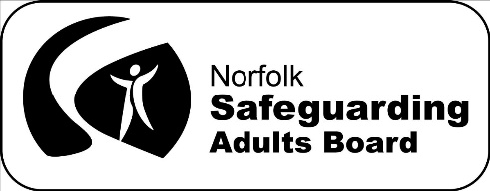

The Herbert Protocol
Norfolk Safeguarding Adults Board (NSAB) is delighted to present its latest animation, created in collaboration with the Suffolk Safeguarding Partnership and Norfolk & Suffolk Constabularies!



The Herbert Protocol
The Herbert Protocol, a scheme set up to protect and support vulnerable people and enable them to retain their independence, has been relaunched to link with World Alzheimer’s Day with a new animated video.
The scheme helps supports vulnerable people, including those with Alzheimer’s, aiding their independence and protecting them if they get lost or go missing.
This has been a fantastic collaboration, started by the Suffolk Safeguarding Partnership (SSP) and Suffolk police who then drew NSAB and police colleagues in, and we were able to bring out the story of the original ‘Herbert’, tracking down the manager of the care home where he lived in North Norfolk, back in 2010. This gave us a much more personalised view of how the idea for the protocol began and gave us rich material for our jointly funded animation, which not only aims to raise awareness but also ensure his legacy lives on.
While the original protocol was about supporting Herbert within his local community, the idea was recognised by Norfolk police as a way to help find people who may go missing much more quickly, by having quick reference information immediately at hand.
So the protocol evolved to what we have today. We are also keen to expand the usability of the protocol for anyone who would benefit from having this protocol in place, not just those with dementia, but can be used for those with mental health needs, learning disabilities, acquired brain injury or other situations where people may go missing or get lost.
CC Animations have helped us to create a very human and positive story about someone living with dementia who needed additional support from his community to keep safe. We also thank the various multi-agency colleagues who helped to ‘sense check’ the material as it was being developed – as well as Steve, the manager of the home without whom none of this would exist, and Gary, who was the local police Inspector whose ongoing promotion of the idea has led to it being adopted all across the country.
Herbert himself had no family and died a couple of years after the protocol had been developed. But with this animation we hope his memory will go on.
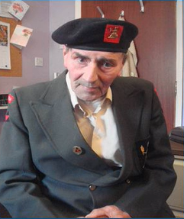

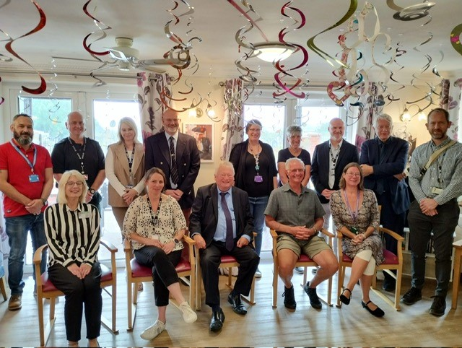
The relaunch took place on Friday 20 September at Dorrington House care home in Wells-next-the-Sea, Norfolk. It was attended by representatives from Norfolk and Suffolk Constabularies, NSAB, the Suffolk Safeguarding Partnership, Suffolk adult social care, Norfolk Trading Standards, Dorrington House staff and special guests Peter Berry and Deb Bunt who spoke very powerfully about living with dementia and using the Herbert Protocol as a safety net should he get ‘mislaid’.
The event took place ahead of World Alzheimer’s Day on 21 September. It is hoped the relaunch and new video will raise awareness and encourage more care homes, support services and other organisations to utilise the scheme to the benefit of vulnerable people across the country.
You can read more and follow links to Norfolk police on our NSAB website too.
Herbert Protocol | Norfolk Safeguarding Adults Board
Detective Sergeant Nicki Payne, who works as part of Norfolk’s Multi Agency Safeguarding Hub (MASH) and in the Missing Persons Team said: “Caring for vulnerable people, including those with dementia, Alzheimer's, brain injuries or learning disabilities can be challenging. There's a risk that they may get lost, even if taking a walk on a familiar route to a favourite place. Planning ahead to keep them safe is really important and makes such a difference in locating that person quickly and safely.”
Both constabularies are now exploring the possibly of a digital service to further improve the use and accessibility of the protocol documents.
DS Payne added: “We are extremely proud that the protocol originated here in Norfolk and that we were able to bring Herbert’s story to life in the animation.
“Working with our partners at Norfolk Safeguarding Adults Board and our Suffolk counterparts we created a product that can be used by other agencies and police forces across the country to promote the scheme.
“Herbert’s story is the essence of a community pulling together to look after each another and we hope that the scheme will be used more widely as a result.”

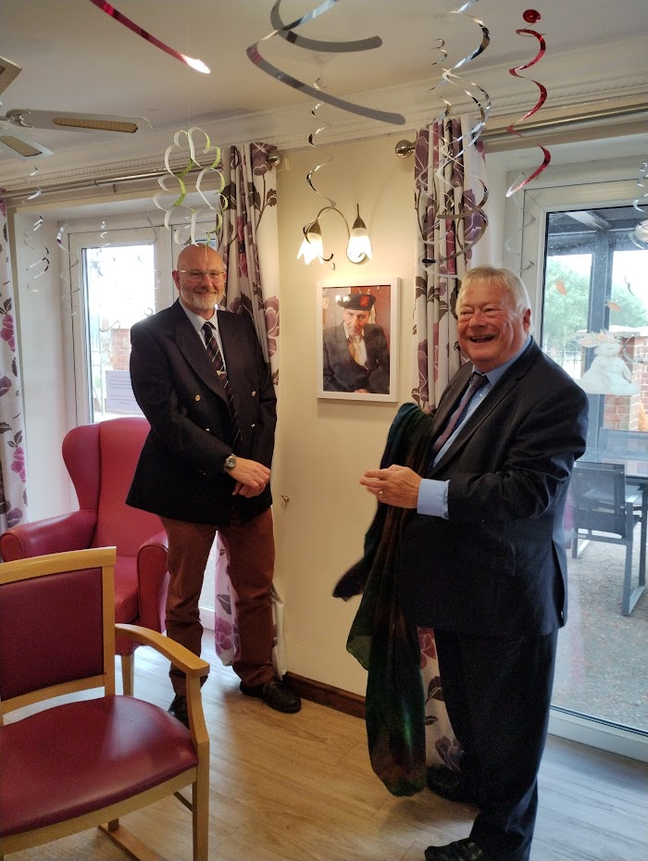
Steve Dorrington helped set up the Herbert Protocol and remains the owner of Dorrington House Care Homes. He said: “George was a very independent chap, he fought for our freedom, and fought us for his too.”
Gary Crowther, who now works as an operational trainer within Norfolk Constabulary, developed the scheme with a colleague in 2009 while working as an inspector in the force. As part of his duties, he was a trained missing person police search advisor.
He said: “In 2009, I had no idea that the protocol would be replicated across the country to such an extent.
“I find it heart-warming to see that virtually every police force in the country has adopted it and could not even guess how many lives it has potentially saved.”
NSAB independent chair, Heather Roach said: “I am delighted that the Norfolk Safeguarding Adults Board became involved in creating this wonderful animation to support the Herbert Protocol.
“Knowing much more about Herbert himself and that the idea for the protocol was developed here in Norfolk, makes it even more special. I would encourage anyone who cares for a person like Herbert or indeed anyone who might benefit from their information being readily available to the police, to visit the Norfolk police website to obtain the forms.
“Safeguarding at its best is about keeping people safe but allowing them to live their best lives.”
Anthony Douglas CBE, independent chair of the Suffolk Safeguarding Partnership, said: “Knowledgeable dementia care supports people with dementia and their carers who might otherwise easily be misunderstood. The Herbert Protocol is a civilising influence and encourages communities to fully accept people with dementia and to make adjustments to the local social fabric to take account of their needs. The protocol enables and liberates people with dementia to live as they wish in safer spaces when the protocol is followed.”

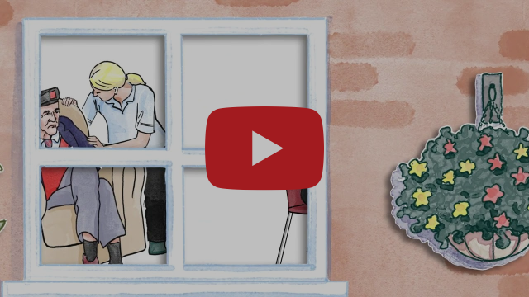
Watch the animation here

This animation has been created so that the last slide can be changed by the animation company to show the contact details for other forces / areas for a small charge - do contact us if you are interested.

