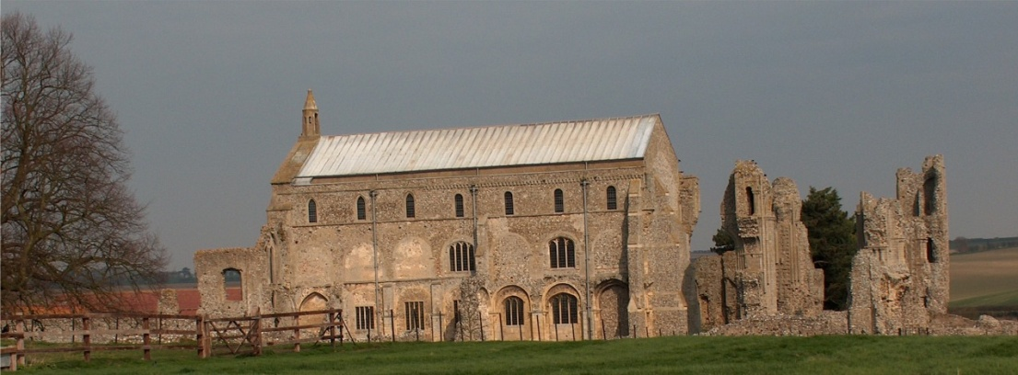
BINHAM WITH COCKTHORPE PARISH COUNCIL
Parish Clerk – Sarah Hayden
53 Cromer Road, Lower Gresham
NR11 8RH
Tel: 01263 570223
Email: sarah352hayden@btinternet.com

Notice & Summons of Parish Council Meeting
Notice is given to the public and Members of the Council are summoned to attend a Meeting of Binham and Cockthorpe Parish Council at the Memorial Hall, Binham
On Monday 11th November 2024 at 7.30pm
S. H. Hayden
Clerk
4th November 2024
The Public are welcome to attend this Parish Council meeting

AGENDA

1. To receive apologies for absence
2. Declarations of Interest and any dispensations of disclosable pecuniary interests
3. Approval of the Minutes of Parish Council Meeting held on 9th September 2024
4. Matters Arising from those Minutes

5. Reports
5.1 Norfolk County Council
5.2 North Norfolk District Council
5.3 Chair’s Report and SAM2

6. Planning
6.1 To discuss and make observations on any applications received after the date of this Agenda and report from Planning Committee
6.2 To discuss and agree any comments for the NNDC Local Plan consultation

7. Finance and Regulatory
7.1 To receive balance sheet and bank reconciliation
7.2 To approve list of payments
7.3 To appoint parish councillor to check bank reconciliations
7.4 To thank Binham History Group for their donation and confirm future use as earmarked reserves
7.5 To receive Budget for 2025-26 and agree precept
7.6 To approve redrafted Financial Regulations

8. To discuss purchase of new bus shelter

9. Update on cost of path improvement Front Street to The Green

10 To discuss repairs to Village Sign and noticeboard

11. Update on hedge provision at allotments and discuss allocation policy for plots

12. Correspondence

13. Items for Information Only or next Agenda

