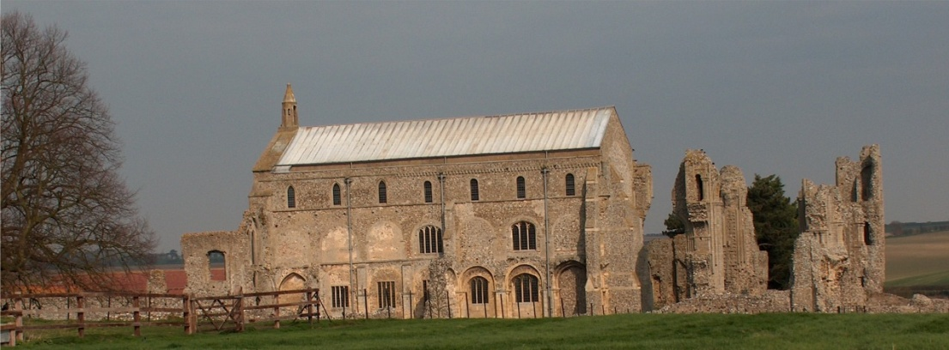
BINHAM with COCKTHORPE PARISH COUNCIL
Parish Clerk – Sarah Hayden
53 Cromer Road, Lower Gresham
NR11 8RH
Tel: 01263 570223
Email: sarah352hayden@btinternet.com
https://binhampc.norfolkparishes.gov.uk

2024/13
DRAFT
MINUTES OF BINHAM PARISH COUNCIL MEETING 9th SEPTEMBER 2024
AT THE MEMORIAL HALL, BINHAM

Those Present Cllr. E. Brady (Chair), Cllr. L. Brown, (Vice Chair), Cllr. P. Alford and Cllr. K. Cooke
In Attendance Mrs. S. Hayden (Clerk)
County Cllr M. Dalby
District Cllr. S. Bütikofer

The Chair opened the meeting at 7.31pm and welcomed everyone attending

1. To receive apologies for absence
Apologies were received from Cllrs W. Keesom and L. Wynder
2. Declarations of Interest and any dispensations of disclosable pecuniary interests
None
3. Approval of Minutes of Parish Council Meeting held on 8th July 2024
The draft minutes were approved and then signed by the Chair
4. Matters Arising
None

5. Reports
5.1 Norfolk County Council
County Councillor Michael Dalby’s Report had been circulated prior to the meeting and is annexed to these minutes. He further reported that his report was short, but the next full Council meeting would be at the end of the month. A short discussion followed on the Norwich Western Link.
5.2 North Norfolk District Council
District Councillor Bütikofer’s report had been circulated prior to the meeting and is annexed to these minutes. She arrived during item 6.
5.3 Chair’s Report and to receive SAM2 data
A resident had suggested that the Norfolk Wildlife Trust be asked to give a talk to the village. The clerk reminded the meeting that the Parish Council had a duty to consider biodiversity. Agreed the Chair would ask the resident to request a talk. The SAM data had been circulated and the relevant sites and results were discussed.

6. Planning
To discuss and make observations on any application received after the date of this agenda and to receive report from Planning Committee

New applications
PA/24/1526 Installation of solar panels to roof – Binham Village Hall, Warham Road, Binham – the Parish Council had supported the application and the NNDC decision was that prior approval was not required. Cllr. Brown advised that the panels were being installed on the following day.
PF/24/1381 Erection of shed to side of dwelling – The Reading Rooms, Langham Road, Binham – the Parish Council had supported the application and the NNDC had approved it.

2024/14

PF/24/1633 Conversion of attached garage to annexe accommodation; external alterations including recladding of garage to improve thermal insulation and provision of glazed doors in place of existing windows and garage doors – Mallards, Langham Road, Binham – The Parish Council had supported the application. Awaiting NNDC decision
PF/24/1779 Installation of French doors on south elevation to replace windows and enlargement of windows on north and east elevations – 2 Westgate Barns, Warham Road, Binham – Cllr. Alford reported that a previous similar application had been refused and this was an amended application. It was agreed to support this application and Cllr. Alford would draft comments and circulate to parish councillors for approval.
PF/24/1753 Change of use of land from agricultural to garden land (retrospective) and erection of summerhouse on the land – 39 Warham Road, Binham – Agreed to support this application. Cllr. Alford to draft comments and circulate to parish councillors for approval.

District Cllr. Bütikofer arrived at the meeting

PF/24/1777 Installation of air source heat pump – 25 Front Street, Binham – Agreed to support this application (retrospective). Cllr. Alford to draft comments and circulate to parish councillors for approval.

Pending since last meeting
PF/24/0841 Front and rear extensions to dwelling and external alterations – Bunkers Hill Barn, Bunkers Hill, Binham NR21 0DF – Cllr. Bütikofer was thanked for calling this application in to Committee. She explained that it had been agreed to hold the decision in order that a compromise could be reached in connection with the front extension that would be acceptable to the applicant and neighbour.
PF/24/1107 Erection of front porch and single storey front and side extensions – 8 The Green, Binham – this application had been withdrawn.

New Application
LA/24/1830 Internal and external works to 4 Field Dalling Road and Bottle Cottage – Bottle Cottage, 4 Field Dalling Road, Binham – As this was a recently received application, Cllr. Alford would consider it in more detail and circulate draft comments to parish councillors

Applications decided since last meeting
PA/24/1177 Installation of 1 no. trial temporary omni antenna and associated cables – Telecommunications Compound, Cockthorpe Airfield, The Street, Cockthorpe, Norfolk – Prior Approval given by NNDC

5.2 continued/..
At this point the Chair asked District Cllr. Bütikofer if she would like to add any comments to her written report. She explained that a report to cabinet for the recent meeting had advised that there was no statutory requirement for the Council to provide public toilets. Although it was agreed there was a need in North Norfolk as a tourism area, the Council needed to save money and that there should be cutbacks on this provision. The Council would be looking at closing toilets in winter where they were duplicated in towns such as Cromer. They would also be looking at gifting them where there were nearby businesses prepared to take on the maintenance. Weybourne beach toilets would be closed permanently as they had been misused by motorhomes emptying their waste tanks in them. As they were compost toilets the system became blocked, so had to be pumped out, the cost of which was unsustainable. On another topic there was a drive to promote pension credit claims and any publicity the Parish Council could give would be helpful. The Chair agreed to include a note in her article for the Lynx and put the flyers supplied on the noticeboards.

7. Finance and Regulatory
7.1 To receive budget with actuals, balance sheet and report on bank reconciliation
Received budget and balance sheet with no comments.

2024/14
7.2 To consider donation to the Local Lynx
Proposed and resolved to donate £100 to the Local Lynx
7.3 To approve the List of Payments
Discussed and agreed to raise a query on the grounds maintenance invoice. The List was amended, then approved and signed by the Chair and Clerk
7.4 To appoint a parish councillor to check bank reconciliations
Agreed to hold this over until the next meeting when more parish councillors would be in present.

8. To consider the Parish Council reverting to the title of “Binham with Cockthorpe Parish Council”
The Clerk advised that she couldn’t see any problems that would arise from the change of name and letterheads, etc., could be changed gradually. Proposed and resolved to revert to “Binham with Cockthorpe Parish Council”

9. To consider provision of a black bin in the cemetery
Discussed and agreed not to use sacks for collection, but to purchase a 140 litre bin for an approximate cost of £60 and arrange for collection once a month at a cost of £9.45 per collection. Agreed that if NNDC would not collect a purchased bin and sacks would be needed, the Parish Council would hire a bin from NNDC for direct emptying. The cost would be shared with the PCC.

10. To discuss and agree repair of bus shelter and approve any costs
Discussed and agreed not to repair the current shelter, but to aim to purchase a new shelter. Fundraising would be discussed at a working party meeting. The Clerk advised that Parish Partnership funding should be available for 50% of the cost.

12. Update on improvement of the surface of the path between Front Street and the Green
Discussed and agreed that Cllr. Cooke would obtain a price for type 1 for the pathway

13. Update on hedge provision at allotments
The Clerk had written to the Stody Estate office for consent for the hedge, but they had been unable to deal with the request at the current time. Clerk to send reminder.

14. To deal with any correspondence
None other than circular emails/newsletters

15. Items for information only or next Agenda
Cllr. Brown reported that a successful stall had been held on the Green and funds raised would go towards Christmas lights. It was hoped to have a second tree and the Clerk offered to donate a tree from surplus on her land. The “carols around the tree” would be held on 16th December this year.

There being no further business the meeting closed at 9.30pm.
The approved cheques were signed
The next meeting would be on Monday 11th November 2024

