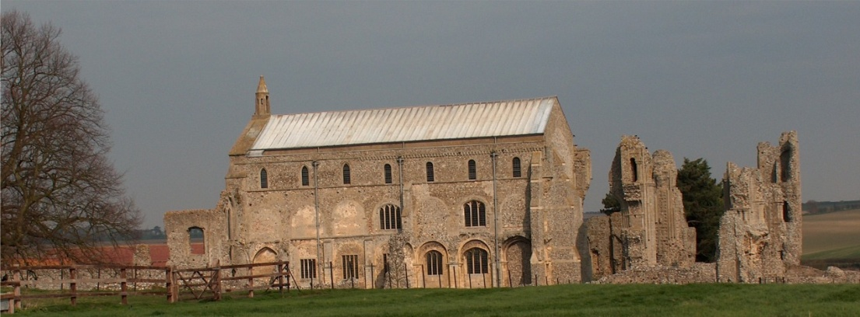
BINHAM PARISH COUNCIL
Parish Clerk – Sarah Hayden
53 Cromer Road, Lower Gresham
NR11 8RH
Tel: 01263 570223
Email: sarah352hayden@btinternet.com
https://binhampc.norfolkparishes.gov.uk

2024/10
DRAFT
MINUTES OF PARISH COUNCIL MEETING 8th JULY 2024
AT THE MEMORIAL HALL, BINHAM

Those Present Cllr. E. Brady (Chair), Cllr. L. Brown, (Vice Chair), Cllr. P. Alford and Cllr. W. Keesom
In Attendance Mrs. S. Hayden (Clerk)
PC Jon Kentfield

The Chair opened the meeting at 7.31pm and welcomed everyone attending

1. To receive apologies for absence
Apologies were received from Cllrs Cooke and Wynder
2. To co-opt parish councillor/s followed by signing of Acceptance of Office
Wendy Keesom was thanked for applying to be co-opted to the Parish Council and it was proposed and resolved that she be co-opted. She then signed the Acceptance of Office, witnessed by the Clerk.
3. Declarations of Interest and any dispensations of disclosable pecuniary interests
None
4. Approval of Minutes of Parish Council Meeting held on 3th May 2024
The draft minutes were amended at two points in item 7.1 and then approved and signed by the Chair.
5. Matters Arising
Item 7.1 Dental School - the Chair had contacted the Deputy Chief Dental Officer in London and Chief Dental Officer in East Anglia, neither of whom had news of any progress on that subject. The ICB had however, worked hard to come up with a plan for the area to improve matters. It should be noted that a school would take 5/6/7 years to make any difference to provision of dentists in the area. On other matters the Chair reminded councillors again, to be aware of data protection and be familiar with the Parish Council’s policy.

6. Reports
6.1 Norfolk County Council
County Councillor Michael Dalby’s Report was read out to the meeting and is annexed to these minutes
6.2 North Norfolk District Council
None
6.3 Chair’s Report and to receive SAM2 data
The Chair reported that the recent tea party for celebrating the postman’s 40 years delivering in the villages of Hindringham and Binham had been really well attended and a total surprise for him. The children from the School had created posters and the Youth Club wrote a note to him. A memory book had been set up and cards and messages left for him since the tea party. The balance of donations after expenses would be donated to a research facility following treatment he had received, as requested by him and his wife. Grateful thanks were due to the Chequers for use of their kitchen where the sandwiches and tray bakes had been made and to Abbey Farm for milk. Donations were received from the Open Circle, Parish Councils, Cosy Club, Howells and

2024/11

Memorial Hall who also provided the Hall at no cost. The Chair would be putting a report in the Lynx.

The SAM2 data had been circulated and is annexed to these minutes. Regarding the SAM2 data, it was reported that the last site was on the Warham Road facing east and had recorded 20,000 vehicles passing in five weeks. During April and May the average speed was 26.9mph, but with the 85% percentile this increased to 33-34 mph. Discussion followed.

Report from PC Jon Kentfield
PC Kentfield reported on the investigations in the village between 31st January and 30th June. There had been 14 investigations in total although 6 related to one person. There was 1 assault, 3 thefts/burglaries, 3 harassment/stalking, 2 bladed weapons, 2 domestic related (not criminal), 1 blackmail and 1 malicious communication (threatening/grossly offensive). Discussion followed and PC Kentfield asked if the Parish Council felt there was anything they were concerned about. It was agreed that the village was generally settled and people seemed to be more in touch with one another. PC Kentfield informed the meeting that there seemed to be a resurgence of interest in Neighbourhood Watch and this might be started again in the area. He then made his apologies, was thanked for attending and left the meeting.

7. Planning
To discuss and make observations on any application received after the date of this agenda and to receive report from Planning Committee
Cllr. Alford outlined to Cllr. Keesom how the Parish Council dealt with planning applications, including both the procedure and the policy of treating every application fairly and in accordance with the NNDC planning policies

New applications
PF/24/0973 Erection of single storey rear extension – 17 Leeders Pightle, Binham, NR21 0FA – The Parish Council supported this application with comments and it had been approved
PF/24/1107 Erection of front porch and single storey front and side extensions – 8 The Green, Binham, NR21 0DD – The Parish Council had objected to this application with comments. Cllr. Alford explained that they had commented that although they supported parts of the application, in its current form it had been objected to. Pending a decision from NNDC
PA/24/1177 Installation of 1 no. trial tempporary omni antenna and associated cables – Telecommunications Compound, Cockthorpe Airfield, The Street, Cockthorpe, Norfolk – the Parish Council had supported the application and it was waiting a decision from NNDC.

Pending since last meeting
PF/24/0841 Front and rear extensions to dwelling and external alterations – Bunkers Hill Barn, Bunkers Hill, Binham NR21 0DF –Cllr. Alford outlined the comments made in objecting to this application. Pending NNDC decision
PU/24/0753 Change of use agricultural building to dwellinghouse (class C3) and building operations necessary for the conversion – Barn to the rear of Abbott Farm Barn, Walsingham Road, Binham, NR21 0AW – The Parish Council objected to the application. It had been refused by NNDC, with a detailed report by the Planning Officer.

8. Finance and Regulatory
8.1 To receive budget with actuals, balance sheet and report on bank reconciliation
Received budget and balance sheet with no comments. Noted that the Parish Council has to appoint a councillor to check reconciliations, although the Clerk advised that the reconciliation had balanced and the bank statements and reconciliation were available at the meeting to inspect.
8.2 To agree rental rate for Memorial Hall
The Committee had discussed payment but had agreed not to charge the Parish Council for hire.

2024/12
8.3 To approve contribution of £78.76 for software for Clerk’s new laptop
The Clerk reported that as her old laptop could not be repaired, she had purchased a new one. There were three Parish Councils sharing this and she asked each to contribute to the cost of software necessary for their work, but not used personally. The other two parishes had agreed. Proposed and resolved to make the contribution.
8.4 To approve the List of Payments
The List was approved and signed by the Chair and Clerk
8.5 To appoint a parish councillor to check bank reconciliations
Agreed to hold this over until the next meeting when more parish councillors would be in present.
8.6 To review Financial Regulations
The Clerk apologised for sending these out the day before the meeting and it was agreed to hold this item over to the next meeting to allow councillors to read through them.

9. To consider the Parish Council reverting to the title of “Binham with Cockthorpe Parish Council”
Discussed and agreed in principle this should be adopted but a final decision would be held over until the next meeting to fully understand the governance implications of a change.

10. To consider provision of a black bin in the cemetery
This would be held over until the next meeting to further investigate the possibility of NNDC providing a bin rather than the Parish Council buying one. It was agreed to share the costs with the PCC

11. To discuss and agree repair of bus shelter and approve any costs
Estimated cost of repair was discussed. The Chair had asked the Wells Men’s Shed if they would be willing to help with repair and they had kindly agreed. Discussion followed and it was agreed to investigate the cost of new shelters further to compare against the cost of repair, before making a decision.

12. Update on improvement of the surface of the path between Front Street and the Green
Cllr. Cooke was not present and it was agreed to hold this over until the next meeting.

13. Update on hedge provision at allotments
The Clerk confirm that NCC had confirmed the Parish Council would be eligible for a grant, but would need to obtain consent from the landlord before an offer could be made. The Clerk had written to the Stody Estate office and was awaiting a reply.

14. To deal with any correspondence
NCC – grit bin audit – discussed and agreed there was only one bin at Priory Crescent

15. Items for information only or next Agenda
The Memorial Hall Committee were planning to install solar panels. The Chair understood the Parish Council were custodian trustees, although the Clerk stated she had no details, but which should be put on the Schedule of Assets if correct. The Chair would forward what details she had.
NCC Highways Engineer was leaving his post – Clerk to thank him on behalf of the Parish Council for all he had done for the village and wish him well.
The Clerk reported that NPTS would be holding a seminar in October that she wished to attend and asked the meeting to indicate whether or not they might contribute to the cost which would be put on the next Agenda for formal approval. Agreed informally to enable a booking to be made.
Dog Bin – was it emptied once per fortnight in summer – Clerk to check
Cllr. Alford had noted the new property on Priory Crescent that backed on to the footpath was progressing well and was unobtrusive and blended in well.

There being no further business the meeting closed at 10.06pm.
The approved cheques were signed
The next meeting would be on Monday 9th September 2024

