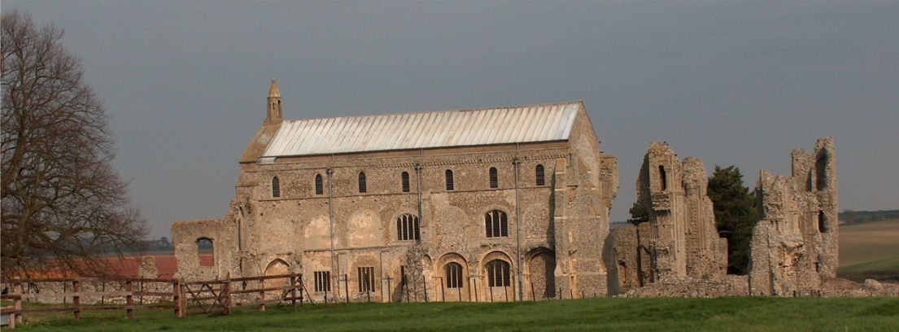
BINHAM PARISH COUNCIL
Parish Clerk – Sarah Hayden
53 Cromer Road, Lower Gresham
NR11 8RH
Tel: 01263 570223
Email: sarah352hayden@btinternet.com
https://binhampc.norfolkparishes.gov.uk

2024/04

DRAFT MINUTES OF PARISH COUNCIL MEETING 11th MARCH 2024
AT THE MEMORIAL HALL, BINHAM

Those Present Cllr. E. Brady (Chair), Cllr. E. Brown (Vice Chair) Cllr. P. Alford, Cllr P. Bailey, Cllr. K. Cooke,
In Attendance Mrs. S. Hayden (Clerk)
County Councillor Michael Dalby
District Councillor Sarah Bütikofer
One member of the public

The Chair opened the meeting at 7.30pm

1. To receive apologies for absence
Apologies were received from Cllr. Wynder
2. Declarations of Interest and any dispensations of disclosable pecuniary interests
None
3. Approval of Minutes of Parish Council Meeting held on 18th January 2024
The minutes were approved and signed by the Chair
4. Matters Arising
1. The Chair reported that the book ends had been fitted in the telephone box by her husband and were now successfully keeping the books away from the glass.
2. The yellow car had been removed from Priory Crescent
3. Flooding – all drains were clear although potholes were appearing.

5. Reports
5.1 Norfolk County Council
County Councillor Michael Dalby’s report had been circulated and is annexed to these minutes. He further reported that the Council had met with Westminster on the subject of Norfolk flood protection. The threat posed by flooding and coastal erosion had been laid out. A case had been made for building reservoirs to capture water in times of flooding to be used in times of drought. District Cllr. Bütikofer raised the subject of the NNDC budget for coastal erosion work commencing in Cromer and Mundesley and the success of the sandscaping work at Bacton, which broke the waves before they reached the shore. Discussion followed.
5.2 North Norfolk District Council
District Councillor Sarah Bütikofer’s report had been circulated and was annexed to these minutes. She apologised for being unable to attend the January meeting due to her husband’s ill health. Further news was that there would be a briefing the following Wednesday on changing the bin rounds (although she felt the changes appeared to be an improvement), which would then be voted upon. As soon as Cllr. Bütikofer had details of the changes, she would relay them to the Parish Council. She commented that the new Holt bank hub was good news. The large loads carrying cable for the windfarms was a concern locally. The reason for the increase in the NNDC budget and therefore Council Tax was explained as being mainly the greatly increased need for housing those made homeless.

County Cllr. Dalby made his apologies and left the meeting

2024/05

5.3 Chair’s Report and to receive SAM2 data
The SAM2 data had been circulated and is annexed to these minutes.
The Chair, as a member of the PCC, had been in discussion with them regarding new churchyard and cemetery regulations following a recent minor accident with a glass vase being broken. It was agreed that the Chair would produce a draft with the same regulations for both the churchyard and cemetery. When finally approved by the PCC and Parish Council, the regulations could be put on the Noticeboard on the side of the pathway to the Church. District Cllr. Bütikofer suggested that a good lead time be given for people to remove items they may wish to keep. The Chair thanked Cllr. Alford for supplying a bin at the cemetery for items not suitable for the brown bin. Parish councillors were currently removing that rubbish. She reported that someone had been driving on the Green again, despite the notices and a request not to do so would be part of the article for the Lynx. The Chair noted that Binham was one of the top tree planting areas reported in the NCC magazine although it was not known where they had been planted. Reporting on the SAM2 data, it was noted that it was the fifth year of having SAM2 in the village, with 600,000 vehicles recorded, which was a substantial database. The new roundels on the Langham/Warham/Hindringham Roads had reduced speeds by 50%. The peaks in traffic may be attributed to busy times for farms and when there are road closures and the Chair would try and note those in future.

6. Planning
6.1 To receive report from planning committee and 6.2 to discuss and make any observations on any applications received
PF/24/0248 and LA/24/0346 Single storey rear extension, fenestration alterations, erection of front garden boundary fence and wall. Removal of paintwork on front elevation of dwelling along with the removal of porch. Alterations to outbuildings, including addition of timber boarding and amended opening to car shed. Re-roofing of the west extension – The Pottery House, 41 Front Street, Binham, NR21 0AL - Cllr. Alford updated the meeting on the planning history of this property and outlined the current application, including the fact that at bat survey had been requested as the last one had been done in 2020. The application was discussed and it was agreed to recommend support. Cllr. Alford would draft comments for submission by the deadline on 13th March.
Applications decided since last meeting
PF/23/1513 Erection of two-storey detached dwelling (amendment to design of dwelling on plot 1 approved as part of planning permission PF/15/1221 and PF/19/0002 – 10 Walsingham Road, Binham – Cllr. Alford thanked District Cllr Bütikofer for calling this application in to Committee. The application had been approved. The question of traffic problems was raised and Cllr. Bütikofer confirmed that the planning department had no power to enforce traffic conditions whilst the building work took place.
Cllr. Bütikofer then made her apologies and left the meeting.
6.3 To discuss the possibility of a footpath extension at Walsingham Road
Enquiries had been made of the Highways Engineer and the Clerk read out his reply on highway rights. In this instance NCC had highway rights and it would be possible that the footpath could be extended and be the subject of a Parish Partnership grant. Discussed and the Clerk was asked to write to the agents/owners of number 10 to ask if they would be prepared to contribute towards the cost.

7. Finance and Regulatory
7.1 To receive Budget with actuals, balance sheet and report on bank reconciliation
The Budget and Balance Sheet were received with no comments. Cllr. Bailey reported that the bank reconciliation was correct. At this point the Budget was discussed in connection with the possibility of a new bus shelter and possible payment of rent by the Parish Council for the hire of the Memorial Hall for meetings. Agreed to put both subjects on the Agenda for the next meeting. Cllrs. Alford and Brown agreed to research costs for bus shelters.
7.2 To approve list of payments
The List of Payments was then approved and signed by the Chair and Clerk
7.3 To consider increase to clerk’s home working expenses
The Clerk reported that her home working expenses had not increased from £4/week since she began working for the Parish Council and HMRC now allowed £6 per week to be paid without incurring income tax. Proposed and resolved to increase expenses to £6/week

2024/06

8. Allotments – Update on replacing fence with hedge
The Clerk confirmed that NCC scheme for supplying tree and hedge plants would continue in the 2024-5 financial year. It was agreed to apply for hedge plants for the allotments.

9. To discuss dog fouling on footpaths
Discussed and agreed to check the footpaths in the parish again to gain an up-to-date picture and if there is still a problem either with fouling or full bags left, notices would be put up at the problem points reminding dog owners of their responsibilities. At this point, Cllr Brown raised a point that a resident had asked why the large rubbish bin had been placed in the bus shelter as she felt it was not pleasant if bagged dog waste was placed in it. The Chair reminded the meeting that the current bin had been moved from Priory Crescent where it was not being used and replaced the old small bin (regularly emptied by Cllr. Brown), so that NNDC would include in their collections. Discussed and agreed the land either side was privately owned so the bin would have to remain for the time being. The current cost of dog bins was discussed.

10. To discuss improvement of the surface of the path between Front Street and the Green
Discussed and agreed that Cllr. Cooke would investigate costs of type 1 and road planings.

11. To deal with any correspondence
Stop the Wensum Link – email asking for support. Agreed not to make comments

12. Items for information only or next Agenda
1. Cllr. Brown requested consent for a stall on the Green one day in August. Discussed and agreed
2. The Chairman thanked Cllr. Bailey for all his work litter picking, in particular in Sculthorpe where a photo of a huge amount of litter picked was shown to the meeting by Cllr Alford
3. A resident had complained about water being pumped from a field on to Long Lane and had reported it to the Highways Authority. This has ceased the following day.
4. A Blakeney Parish Council post on Facebook stated that Holt Medical Practice had formally applied to close the surgery and the final decision would be made by the Integrated Care Board on 23rd April 2024.
There being no further business the meeting closed at 9.50pm.
The approved cheques were signed

The next meeting would be on Monday 13th May 2024

