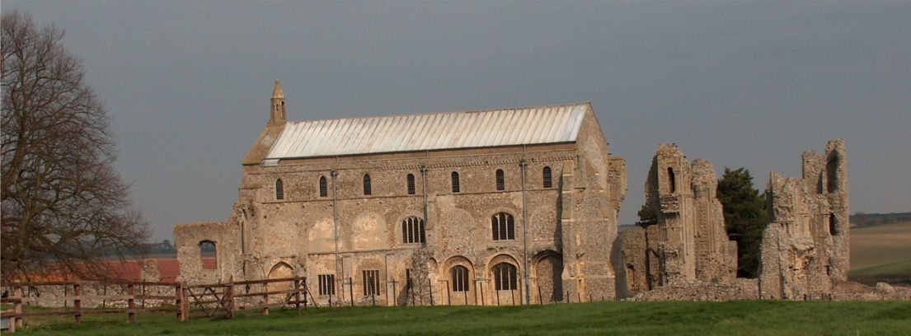
BINHAM PARISH COUNCIL
Parish Clerk – Sarah Hayden
53 Cromer Road, Lower Gresham
NR11 8RH
Tel: 01263 570223
Email: sarah352hayden@btinternet.com

Notice & Summons of Parish Council Meeting
Notice is given to the public and Members of the Council are summoned to attend a meeting of Binham Parish Council at the Memorial Hall, Binham
On Monday 11th March 2024 at 7.30pm
S. H. Hayden
Parish Clerk
4th March 2024

The Public are welcome to attend this Parish Council meeting

AGENDA

1. To receive apologies for absence

2. Declarations of Interest and any dispensations of disclosable pecuniary interests

3. Approval of the Minutes of Parish Council Meeting held on 8th January 2024

4. Matters Arising from those Minutes

5. Reports
5.1 Norfolk County Council
5.2 North Norfolk District Council
5.3 Chair’s Report with SAM2 update

6. Planning
6.1 To receive report from Planning Committee
6.2 To discuss and make observations on any applications received
6.3 To discuss the possibility of a footpath extension at Walsingham Road

7. Finance and Regulatory
7.1 To receive budget against actuals, balance sheet and report on bank reconciliation
7.2 To approve list of payments
7.3 To consider increase to clerk’s home working expenses

8. Allotments - Update on replacing fence with hedge

9. To discuss dog fouling on footpaths

10. To discuss improvement of the surface of the path between Front Street and the Green

11. To deal with any correspondence.

12. Items for Information only or next Agenda

