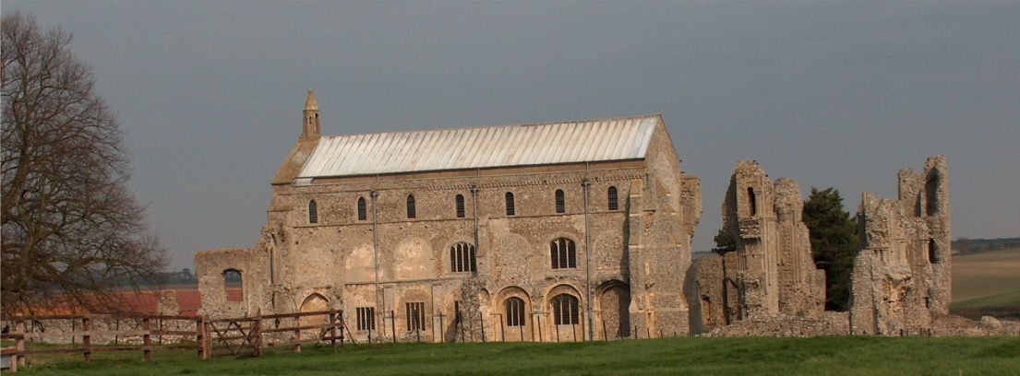
BINHAM PARISH COUNCIL
Parish Clerk – Sarah Hayden
53 Cromer Road, Lower Gresham
NR11 8RH
Tel: 01263 570223
Email: sarah352hayden@btinternet.com
https://binhampc.norfolkparishes.gov.uk

2024/01

DRAFT MINUTES OF PARISH COUNCIL MEETING 18th JANUARY 2024
AT THE MEMORIAL HALL, BINHAM

Those Present Cllr. E. Brady (Chair), Cllr. E. Brown (Vice Chair) Cllr. P. Alford, Cllr P. Bailey, Cllr. K. Cooke, Cllr. L. Wynder
In Attendance Mrs. S. Hayden (Clerk)
Councillor Michael Dalby

The Chair opened the meeting at 7.32pm

1. To receive apologies for absence
District Councillor Sarah Bütikofer had sent apologies
2. Declarations of Interest and any dispensations of disclosable pecuniary interests
None
3. Approval of Minutes of Parish Council Meeting held on 13th November 2023
The minutes were approved and signed by the Chair
4. Matters Arising
Red Telephone Box and Book Exchange
Cllr. Bailey reported that he had been able to seal the telephone box and it was 99% watertight. One more visit when the weather warmed a bit should finish the sealing (currently too cold for silicone!). Book ends were needed and the Chair promised to deal with those. There were a lot of books, so either a rota or a storage box was needed. The Chair offered to liaise on that.
Monitoring of Lighting
Cllr. Wynder reported that there had been no intrusive lighting since the last meeting. Agreed to take no action.
5. Reports
5.1 Norfolk County Council
County Councillor Michael Dalby’s report had been circulated and is annexed to these minutes
He had send apologies and would arrive late following another meeting.
5.2 North Norfolk District Council
District Councillor Sarah Bütikofer had been on leave.
5.3 Chair’s Report and to receive SAM2 data
The SAM2 data had been circulated and is annexed to these minutes. The Chair had asked PS Burton for the data results from the black box and was waiting a reply. She reported that the 30mph roundels had had an effect on speeding in Langham Road and Warham Road, reducing average speeds by at least 50%. The volume of traffic was similar year on year. The Hindringham Road data will be reviewed in mid-January. Cllr. Alford noted that there had been a post on “Next Door” asking for volunteers for Speedwatch in Hindringham. Regarding flooding and drains, the Chair had put a request in the Lynx asking people to check nearby drains were clear. Recent areas of flooding were discussed, together with the resultant potholes. The Parish Councillors would check potholes when the floods had receded.

County Councillor Michael Dalby arrived and was thanked by the Chair for attending

2024/02

County Cllr. Dalby was asked who was responsible for putting out signs for flooding and he confirmed it was NCC Highways. If the Parish Councillors reported floods to them could they copy him in and he would monitor progress. He confirmed to Cllr. Bailey, that he would reply to his email asking if rubbish bins could be placed in laybys, in particular he had found Brick Kiln Road to Melton Constable to be a problem when carrying out litter picking in that area. The Chair asked if Cllr. Dalby had any up to date information on the possible roundabout at Sheringham and he replied that he thought it was at the funding stage, but would send an update. The Chair mentioned that Duncan Baker MP had organised a public meeting at Hickling on flooding and she was hoping to attend. Cllr. Dalby confirmed the date and time and advised that it would be recorded and available on Duncan Baker’s Facebook live feed.

6. Planning
To discuss and make observations on any application received after the date of this agenda and to receive report from Planning Committee
Cllr. Alford reported as follows.

There were no new applications

Pending since last meeting
LA/23/2309 Replacement of existing front dormer window with two dormer windows, insertion of new roof light and replacement of existing roof light to the rear and internal alterations, and PF/23/2308 Replacement of existing front former window with two dormer windows, insertion of new roof light and replacement of existing roof light to the rear and internal alterations – 18 Front Street, Binham, NR21 0AL – Approved by NNDC
PF/23/1513 Erection of two-storey detached dwelling (amendment to design of dwelling on plot 1 approved as part of planning permission PF/15/1221 and PF/19/0002 – 10 Walsingham Road, Binham – The Parish Council had commented that they supported building of a house, but this was a complete redesign of the estate type of house originally proposed. The application had been called in by District Cllr. Bütikofer on a request by the Parish Council and was due to be discussed by the Development Committee on the following Thursday. The application was discussed in detail – most of the officer’s report (recommending approval) to the Development Committee was read out by the Clerk, as well as the Design and Conservation Officer’s report. It was agreed that there would be no further comments by the Parish Council and as Cllr. Alford was unavailable to attend, the Parish Council would not send a representative to the meeting. The Clerk was asked to thank District Cllr Bütikofer for calling this application in to Committee, confirming we had no further comments to make.

Applications decided since last meeting
PF/23/1686 External alterations and extensions to dwelling and new external swimming pool within courtyard – Abbey Farm, Warham Road, Binham, NR21 0DQ – Approved by NNDC

7. Finance and Regulatory
7.1 To receive Budget with actuals, balance sheet and report on bank reconciliation
The Budget and Balance Sheet were received with no comments. Cllr. Bailey reported that the bank reconciliation was correct.
7.2 To approve list of payments
A question was raised on the current budget for grass cutting and how much had been spent, which was answered by the Clerk. A short discussion followed on grass cutting and the Clerk was asked to write to a property owner on the Green asking if they could sow more grass seed as it was still bare following building work.
The List of Payments was then approved and signed by the Chair and Clerk
7.3 To appoint internal auditor for 2023-24 accounts
The current auditor Beryl Flood, was happy to continue for 2023-24 and it was proposed and resolved that she be appointed.

2024/03

8. Allotments - To discuss replacing fence with hedge
The current cost per hour for grounds maintenance was £20 and it would depend upon the age of the hedge how much it cost to cut. Discussed and agreed to plant a hedge next Autumn, as the deadline for applications to the County Council had passed and it would be better to plant in the Autumn to allow the plants to establish before summer arrived. Agreed to check whether Norfolk County Council would still be offering their reduced cost packs of hedge plants. Also agreed planting the hedge would contribute to the Parish Council’s biodiversity actions.

9. To deal with any correspondence
NNDC – Exception Housing call for help. Discussed the fact that there are 58 households currently on the Housing List for the Binham area, noting the recent development at Leeder’s Pightle. Agreed that the parish council did not know of any landowners who might be prepared to develop land, so could not help in that regard.
SEND – plans for improving services
10. Items for information only or next Agenda
1. A lot of rubbish dumping was being carried out on private land, but agreed no action could be taken.
2. There had been a yellow car parked for some time on Priory Crescent, which appeared to be taxed but uninsured. The Chair would raise the legalities of this at the SNAP meeting on the following Thursday.
3. Cllr. Brown thanked the Parish Council for being responsible for insuring the Christmas lights.

There being no further business the meeting closed at 9.17pm.
The approved cheques were signed

The next meeting would be on Monday 11th March 2024

