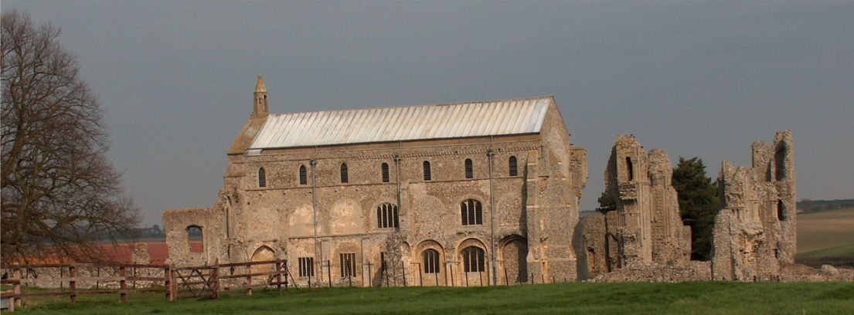
BINHAM PARISH COUNCIL
Parish Clerk – Sarah Hayden
53 Cromer Road, Lower Gresham
NR11 8RH
Tel: 01263 570223
Email: sarah352hayden@btinternet.com

Notice & Summons of Parish Council Meeting
Notice is given to the public and Members of the Council are summoned to attend a meeting of Binham Parish Council at the Memorial Hall, Binham
On Monday 13th November 2023 at 7.30pm
S. H. Hayden
Parish Clerk
7th November 2023

The Public are welcome to attend this Parish Council meeting

Claire Chapman of Community Connections at North Norfolk District Council will give a talk before the meeting

AGENDA

1. To receive apologies for absence

2. Declarations of Interest and any dispensations of disclosable pecuniary interests

3. Approval of the Minutes of Parish Council Meeting held on 11th September 2023

4. Matters Arising from those Minutes, including but not limited to:
Red telephone box and book exchange update

5. Reports
5.1 Norfolk County Council
5.2 North Norfolk District Council
5.3 Chair’s Report with SAM2 update

6. Planning
To discuss and make observations on any applications received after the date of this Agenda and receive report from Planning Committee

7. Finance and Regulatory
7.1 To receive budget, balance sheet and report on bank reconciliation
7.2 To approve list of payments
7.3 To discuss Budget and set precept for 2024-25

8. Allotments
8.1 To agree division of plots
8.2 To discuss and agree rents
8.3 To discuss replacing fence with hedge

9. To deal with any correspondence.

10. Items for Information Only or next Agenda

