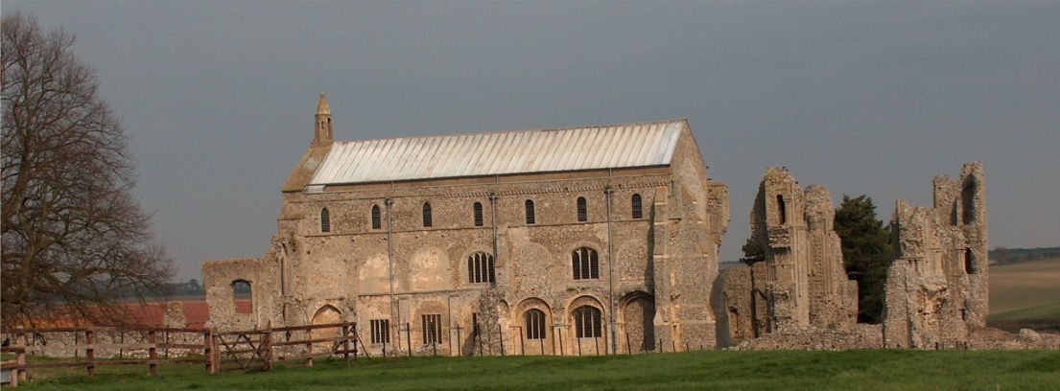
BINHAM PARISH COUNCIL
Parish Clerk – Sarah Hayden
53 Cromer Road, Lower Gresham
NR11 8RH
Tel: 01263 570223
Email: sarah352hayden@btinternet.com
https://binhampc.norfolkparishes.gov.uk

2023/13
DRAFT MINUTES OF PARISH COUNCIL MEETING 13thNOVEMBER 2023
AT THE MEMORIAL HALL, BINHAM

Those Present Cllr. E. Brady (Chair), Cllr. E. Brown (Vice Chair) Cllr. P. Alford, Cllr. K. Cooke, Cllr. L. Wynder
In Attendance Mrs. S. Hayden (Clerk)

The Chair opened the meeting at 7.35pm

1. To receive apologies for absence
Apologies were received from Cllr. P. Bailey
County Councillor Michael Dalby and District Councillor Sarah Bütikofer had sent apologies
2. Declarations of Interest and any dispensations of disclosable pecuniary interests
None
3. Approval of Minutes of Parish Council Meeting held on 11th September 2023
The minutes were approved and signed by the Chair
4. Matters Arising
Red Telephone Box and Book Exchange
It was thought that there had been no further leaks in the telephone box. The books seemed damp, although they had been kept away from the windows, but the situation would be monitored.
Blakeney Surgery Closure
In connection with Blakeney Surgery, the Chair noted that District Cllr. Bütikofer had reported on two motions at full Council meeting regarding the closure. The Chair read out the motions, which had been passed. It was noted that Melton Constable Surgery was out of action currently, due to roof repairs. The Chair also gave figures for those over 60 years of age living in Blakeney.

5. Reports
5.1 Norfolk County Council
County Councillor Michael Dalby’s report had been circulated and is annexed to these minutes
The Chair commented on County Councillor Dalby’s report, which she felt raised the question of whether any older person in the village needed any assistance in any way. This was discussed and it was thought that most had family or friends to help if needed.
5.2 North Norfolk District Council
Distrrict Councillor Sarah Bütikofer’s report had been circulated and is annexed to these minutes
5.3 Chair’s Report and to receive SAM2 data
There had been two cars parked on the Green recently despite the “no parking” signs. On speeding, there had been a meeting in the village with Steve White, the NCC Highways Engineer who was clear that what we were doing in the village was good and easily done to make a difference. He did not think any more signs would beneficial. Two “Slow” signs were faded on the Langham Road, but two were clear and he felt they were sufficient. Regarding the Langham Road exit from the village, he agreed that the SAM2 sign could be turned around and used on the existing site. Other sites looked at were either too close to the road or in the wrong place to be seen. Some road signs covered by vegetation were noted. Following the Chair’s chance encounter with a member of the Camera Safety Partnership, a black box had appeared on Warham Road, although she had not received any data gathered. She would make contact to enquire about the results. The Chair and her husband had attended the Rural Speeding Meeting organised by Duncan Baker MP, with the Chief Constable, NCC cabinet member for Transport, the Police and Crime Commissioner and Police Highways Officer attending and answering questions. She had noted the following: Interestingly
2023/14

there are 6000 miles of roadways in Norfolk; the Police were mindful of errors on speeds recorded with Speedwatch and SAM2 equipment; the decision making regarding prosecutions was dictated by primary legislation; there is a £4m highways budget; action was taken as a result of traffic trends such as speed, accidents, national speed limits; roadside furniture and the state of the roads. On the village SAM2, it has just been removed from the Warham Road and that data was not included in the latest figures. The data for Langham Road showed the percentage of traffic speeding had been down by one half since the roundels had been painted on the road. On the Warham Road the SAM2 had been turned around.

6. Planning
To discuss and make observations on any application received after the date of this agenda and to receive report from Planning Committee
Cllr. Alford had circulated her report prior to the meeting

New Applications
LA/23/2309 Replacement of existing front dormer window with two dormer windows, insertion of new roof light and replacement of existing roof light to the rear and internal alterations, and PF/23/2308 Replacement of existing front former window with two dormer windows, insertion of new roof light and replacement of existing roof light to the rear and internal alterations – 18 Front Street, Binham, NR21 0AL – Cllr. Alford outlined the application. The applications were discussed in detail, in particular the fireplace and dormer windows. Agreed there were no objections to the applications and Cllr. Alford would draft comments for circulating and submission to NNDC.

Pending since last meeting
PF/23/1513 Erection of two-storey detached dwelling (amendment to design of dwelling on plot 1 previously approved as part of planning permission PF/15/1221 and PF/19/0002 – 10 Walsingham Road, Binham – Revised plans had been submitted for this application, with repositioning of the property. The Parish Council had not been invited to comment further. It was noted there were solar panels on the roof. There had been an up to date response from the Conservation and Design Officer who had no objections.

PF/23/1686 External alterations and extensions to dwelling and new external swimming pool within courtyard – Abbey Farm, Warham Road, Binham, NR21 0DQ – Pending NNDC decision

Applications decided since last meeting
PF/23/1624 Erection of single-storey rear extension – Keppers House, 118 Warham Road, Binham, NR21 0DQ – The Parish Council had supported this application with some concerns over the flat roof extension against a cat slide roof, but had considered this against a previous application for a nearby property which had been granted permission. The extension would be in complimentary materials and was obscured from the roadside. Approved by NNDC

7. Finance and Regulatory
7.1 To receive Balance Sheet and report on Bank Reconciliation
The Budget and Balance Sheet were received with no comments. Cllr. Bailey was not in attendance and the bank reconciliation was held over until the January meeting.
7.2 To approve list of payments
The invoice for October grass cutting had not been received and was moved to “Payments anticipated”. The List was then approved and signed by the Chair and Clerk
7.3 To discuss Budget and set precept for 2024-25
The draft budget was discussed in detail, in particular the possible insurance premium. Proposed and resolved to set the precept at £8,820 for 2024-25.

8. Allotments
8.1 To agree division of plots
Two prospective tenants wished to take plots. Agreed to divide the large vacant plot into two.

2023/15
8.2 To discuss and agree rents
The Clerk was asked to obtain a quote from the existing grounds maintenance contractor for future cutting of a hedge if planted to replace the fence, then write to the tenants asking if they wished a hedge to be planted and whether the resulting rent increase to pay for hedge maintenance would be acceptable.
8.3 To discuss replacing fence with hedge
Discussed in item 8.2

9. Dog bin – to review emptying frequency
The bin at the Priory was currently emptied fortnightly in summer and four weekly in winter, but had been overflowing over the Bank Holiday. Agreed to monitor the situation as this may have been a missed collection.

10. To deal with any correspondence
Letter from Heritage House Day Care requesting a donation. The Parish Council regrettably would not be able to donate.

11. Items for information only or next Agenda
It was reported that lighting on a property in the village was intrusive. Agreed that parish councillors would monitor and report back at the next meeting.

There being no further business the meeting closed at 9.30pm.
As no invoices had been received, any approved cheques would be signed following the meeting

The next meeting would be on Monday 8th January 2024

