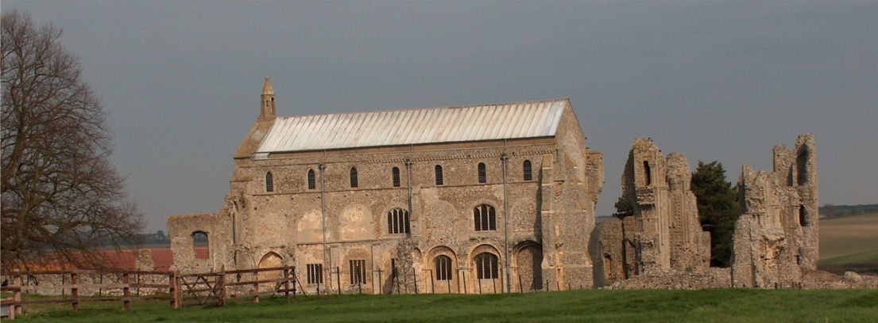
BINHAM PARISH COUNCIL
Parish Clerk – Sarah Hayden
53 Cromer Road, Lower Gresham
NR11 8RH
Tel: 01263 570223
Email: sarah352hayden@btinternet.com

Notice & Summons of Parish Council Meeting
Notice is given to the public and Members of the Council are summoned to attend a meeting of Binham Parish Council at the Memorial Hall, Binham
On Monday 11th September 2023 at 7.30pm
S. H. Hayden
Clerk
31st August 2023

The Public are welcome to attend this Parish Council meeting

AGENDA

1. To receive apologies for absence

2. Declarations of Interest and any dispensations of disclosable pecuniary interests

3. Approval of the Minutes of Parish Council Meeting held on 10th July 2023

4. Matters Arising from those Minutes
4.1 Closure of Blakeney Surgery
4.2 Any other matters arising

5. Reports
5.1 Norfolk County Council
5.2 North Norfolk District Council
5.3 Chair’s Report with SAM2 update
5.4 Clerk’s report on asset inspection

6. Planning
6.1 To discuss and make observations on any applications received after the date of this Agenda
6.2 Report from Planning Committee

7. Update on final plans for red telephone box

8. Finance and Regulatory
8.1 To receive budget, balance sheet and report on bank reconciliation
8.2 To approve list of payments

9. Allotments – to discuss plot boundaries and possible provision of further plot

10. Dog Bins – to review emptying frequency

11. To deal with any correspondence.

12. Items for Information Only or next Agenda

