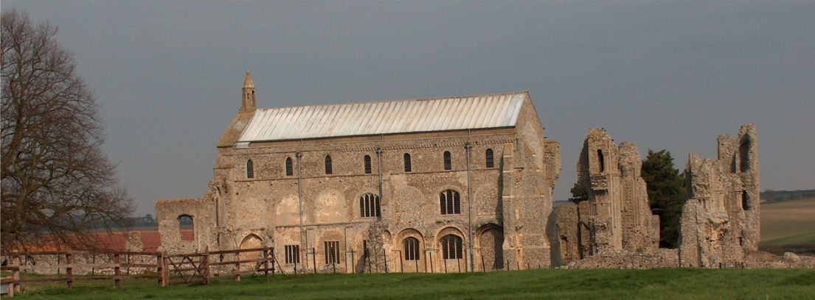
BINHAM PARISH COUNCIL
Parish Clerk – Sarah Hayden
53 Cromer Road, Lower Gresham
NR11 8RH
Tel: 01263 570223
Email: sarah352hayden@btinternet.com
https://binhampc.norfolkparishes.gov.uk

2023/7
DRAFT MINUTES OF PARISH COUNCIL MEETING 10th JULY 2023
AT THE MEMORIAL HALL, BINHAM

Those Present Cllr. L. Brady (Chair), Cllr. L. Brown (Vice Chair), Cllr. P. Alford, Cllr. P. Bailey, Cllr. L. Wynder
In Attendance Mrs. S. Hayden (Clerk)
County Cllr. M. Dalby

[Cllr. L. Wynder signed her Acceptance of Office, witnessed by the Clerk, before the meeting opened]
The Chair opened the meeting at 7.30pm

1. To receive apologies for absence
Cllr. K. Cooke had sent apologies
2. Declarations of Interest and any dispensations of disclosable pecuniary interests
None
3. Approval of Minutes of Parish Council Meeting held on 22nd May 2023
The minutes were approved and signed by the Chair
4. Matters Arising
1. The driver of the bus previously parked in Priory Crescent no longer lived in Binham
2. The Clerk confirmed there were no payments due following the VETS scheme being cancelled
3. Details for re-routing footpaths had been forwarded to the relevant landowner from NCC. Discussed.
4. Item 9.1 of minutes – bus frequency had been increased with additions in summer and re-routing in Fakenham.
5. All letter written to the King during the Coronation celebrations by the children, had been forwarded to his private secretary. 30 letters had been sent.

5. Reports
5.1 Norfolk County Council
County Cllr. Darby read out his report, which is annexed to these minutes.
5.2 North Norfolk District Council
Not received by the time of the meeting. [Received the following day and annexed to these minutes]
5.3 Chair’s Report and to receive SAM2 data
The Chair reported that there had been a shipping contained placed in the Green without permission. She had spent some time corresponding with the contractor responsible and also the owner of the property concerned and it should be removed shortly. In connection with trees on Priory Crescent, the Chair had met with the arboriculturalist by chance and learned that two trees would be removed, together with tree stumps which remained from previous felling. Following confirmation of Fibre Broadband being completed in Cockthorpe, she was aware of two residents who were planning to connect to it. Concerning the SAM2 data which had recently been collected at Cockthorpe, the figures remained very similar to the previous year. It would be interesting to note if the new 30mph roundels painted on the roads would slow traffic down compared to previous data and the SAM2 would be moved shortly to Front Street and Hindringham Road.

6. Planning
6.1 To discuss and make observations on any application received after the date of this agenda
No new applications had been received

2023/8

6.2 Report from Planning Committee
Cllr. Alford had circulated her report prior to the meeting. She reported that there had been two new applications since the last meeting as follows.
New Applications
PF/23/1093 Raising of lean-to shed and insertion of woodburner flue to approved annexe (previouisly approved in planning application PF/21/3473), change to existing brick and flint coping details and erection of garden wall - Westgate Old Farmhouse, Warham Road, Binham, NR21 0DQ – The Parish Council supported this application and it was now pending a decision from NNDC
PF/23/1152 Installation of solar PV panels on rear (south-facing) roof slop – The Long House, The Street, Cockthorpe, NR23 1QS – The Parish Council supported this application and it had been approved by NNDC

Pending since last meeting
PF/22/1714 – The Cattle Shed, Binham Road, Wighton – The Parish Council had objected to the application. There was a pending s. 106 Unilateral Agreement to be completed before an NNDC decision could be made. The Clerk was asked to contact District Cllr. Sarah Butikofer for an update.
RV/22/1522 – Variation of conditions 2 (approved plans) and 6 (bat mitigation and enhancement measures) and removal of condition 11 (code Level 3 for sustainable homes) to allow for change to roof finish from thatch to tile, internal layout alterations, amend windows to elevations, including new window positions and insert roof lights, change all window and door materials from timber to aluminium and revised bat mitigation and enhancement measure of planning ref: PF/13/1192 (Conversion of two-storey barn to residential and erection of three bay cart shed garage)- The Cattle Shed, Binham Road, Wighton – The Parish Council had objected – Decision pending by NNDC – linked to above application

Applications decided since last meeting
LA/23/0862 Replace metal 1950s ground floor windows on front of house on south side of front door with hard wood double glazed windows – 1 Front Street, Binham, NR21 0AN – The Parish Council supported this application and it had now been approved by NNDC

7. Maintenance
Update on telephone box plans
The telephone box was now watertight and the shelves could be fitted. The Chairman offered to deal with moving that forward.

8. Finance and Regulatory
8.1 To receive Budget against Actuals, Balance Sheet and report on Bank Reconciliation
The Budget and Balance Sheet were received with no comments and Cllr. Bailey reported that the Bank Reconciliation was correct.
8.2 To agree donations
Proposed and resolved to donate £100 to the Lynx and (later in the year) £20 to the British Legion for the Memorial Day wreath
8.3 To approve list of payments
The invoice for June grass cutting had not been received and was moved to “Payments anticipated”. The List was then approved and signed by the Chair and Clerk
8.4 To review Standing Orders
The Standing Orders amended by the Clerk had been circulated prior to the meeting. Proposed and agreed to approve and adopt the amended draft.

9. Update on Jubilee bench for Green and agree installation and any further costs
The Jubilee bench base had been completed by Cllrs. Cooke and Bailey. Arrangement were made for the bench to be collected and put in place. Cllr. Bailey to let the Clerk have any receipt for final fittings.

10. To consider Binham PC actions to contribute to conserve and enhance biodiversity as required by the Environment Act 2021
Discussed and agreed that the following actions by the Parish Council would contribute:

2023/9
1. Dark skies would continue to be a priority in observations on planning applications
2. Ownership of the flower boxes in the village, although provided and maintained by a village group (Cllr. Brown being a member), had been transferred to the Parish Council
3. The verge from the Priory to Abbey House was left to flower and was only cut annually
4. Cllr. Bailey spent some time litter picking in the village and surrounding area
5. The Parish Council had an awareness of local schemes and areas conserving and enhancing biodiversity, e.g. farm schemes, River Stiffkey current Langham Road scheme, AONB, hedges, etc.

11. To agree guidelines for approval of headstones and tablets in the Cemetery
Discussed and agreed to continue as at present, i.e. approval is delegated to the Clerk who could refer to the Parish Council for any decision if necessary.

12. To consider Parish Council social media
The Clerk reminded the Parish Council that NALC issued advice on social media. Discussed and agreed not to proceed with any social media accounts at present.

13. To deal with any correspondence
1. Letter/invitation to consultation on the closure of Blakeney Surgery. Cllrs. Brady and Alford would attend
2. Parish Partnership details for 2023-24

14. Items for information only or next Agenda
There would be a meeting with allotment tenants within the next couple of weeks to confirm plot boundaries.
Contact details to update the website and village noticeboards were agreed

There being no further business the meeting closed at 9.35pm. The approved cheques were signed.

The next meeting would be on Monday 11th September 2023

