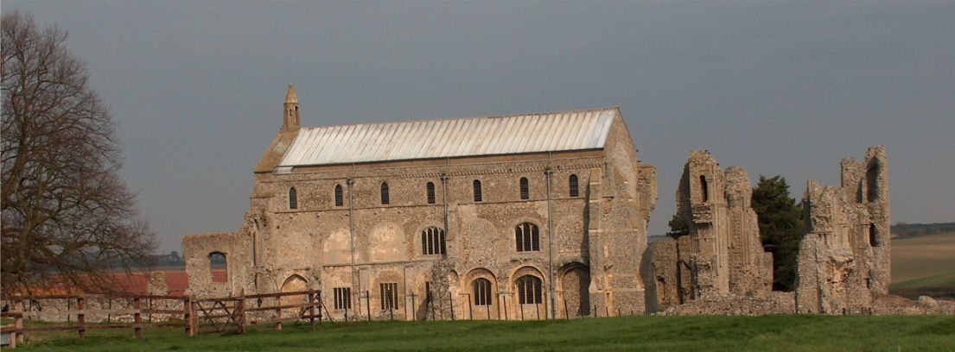
BINHAM PARISH COUNCIL
Parish Clerk – Sarah Hayden
53 Cromer Road, Lower Gresham
NR11 8RH
Tel: 01263 570223
Email: sarah352hayden@btinternet.com

Notice & Summons of Parish Council Meeting
Notice is given to the public and Members of the Council are summoned to attend a meeting of Binham Parish Council at the Memorial Hall, Binham
On Monday 10th July 2023 at 7.30pm
S. H. Hayden
Clerk
30th June 2023
The Public are welcome to attend this Parish Council meeting

AGENDA

1. To receive apologies for absence

2. Declarations of Interest and any dispensations of disclosable pecuniary interests

3. Approval of the Minutes of Parish Council Meeting held on 22nd May 2023

4. Matters Arising from those Minutes

5. Reports
5.1 Norfolk County Council
5.2 North Norfolk District Council
5.3 Chair’s Report with SAM2 update

6. Planning
6.1 To discuss and make observations on any applications received after the date of this Agenda
6.2 Report from Planning Committee

7 Update on red telephone box plans

8. Finance and Regulatory
8.1 To receive budget, balance sheet and report on bank reconciliation
8.2 To agree donations
8.3 To approve list of payments
8.4 To review Standing Orders

9. Update on installation of Jubilee bench and agree any further costs

10. To consider Binham PC actions to contribute to conserve and enhance biodiversity as required by the Environment Act 2021

11. To agreed guidelines for approval of headstones and tablets in the Cemetery

12. To consider Parish Council social media

13. To deal with any correspondence.

14. Items for Information Only or next Agenda

