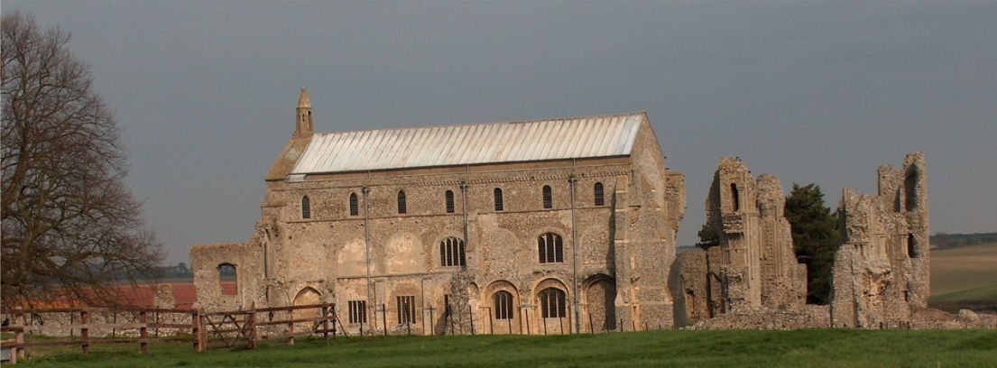
BINHAM PARISH COUNCIL
Parish Clerk – Sarah Hayden
53 Cromer Road, Lower Gresham
NR11 8RH
Tel: 01263 570223
Email: sarah352hayden@btinternet.com
https://binhampc.norfolkparishes.gov.uk

2023/4
DRAFT MINUTES OF ANNUAL PARISH COUNCIL MEETING 22nd MAY 2023 AT THE MEMORIAL HALL, BINHAM

Those Present Cllr. L. Brady (Chair), Cllr. L. Brown (Vice Chair), Cllr. P. Alford, Cllr. P. Bailey and Cllr. K. Cooke
In Attendance Mrs. S. Hayden (Clerk)
County Councillor Michael Darby

The Chair opened the meeting at 7.35pm

1. To elect a Chairman of the Council followed by signing of Acceptance of Office
Proposed and seconded Cllr Brady. Resolved unanimously. The Acceptance of Office was signed by Cllr. Brady and witnessed by the Clerk
2. To elect a Vice Chairman
Proposed and seconded Cllr Brown. Resolved unanimously.
3. Signing of Acceptance of Office by all elected parish councillors
All Acceptances of Office were signed and witnessed
4. To receive apologies for absence
Cllr. Lotte Wynder
5. To Co-Opt Parish Councillor/s followed by signing of Acceptance of Office
Proposed, seconded and resolved to co-opt Kevin Cooke, who signed his Acceptance of Office, witnessed by the Clerk. The Chairman expressed her thanks to Helen Owen (who had not stood for election) for all her work over the time she was a parish councillor.
6. Declarations of Interest and any dispensations of disclosable pecuniary interests
None
7. Approval of Minutes of Parish Council Meeting held on 9th January 2023
Approved and signed by the Chair
8. Matters Arising
None

9. Reports
9.1 Norfolk County Council
A report had been received and circulated, and is annexed to these minutes. Cllr. Darby reported that Kay Mason Billig had been elected new leader of Norfolk County Council and cabinet, which remained largely the same. There would be two cabinet members for Adult Social Services which would be more efficient as one was stretched with all the work required. One councillor has replaced three in another position. Bus travel fares would remain at £2 until 31st October 2023, then rise to £2.50, which is part of help for households through the Cost of Living funding. Bus frequency was discussed, together with a bus parking on Priory Crescent which it was agreed, was unsuitable, before Cllr. Darby was thanked and left the meeting. The Clerk was asked to write to Sanders in connection with bus parking.
9.2 North Norfolk District Council
District Councillor Butikofer had sent her contact details to parish councillors and expressed her willingness to help with anything she could
9.3. Chair’s Report
The Chair confirmed that she and Cllr. Alford had met with Richard Kershaw (who had not stood for election) to thank him for all his help whilst District Councillor. It was agreed to write formally to thank him. The
2023/5

Chair had been reading through old copies of the Lynx from 1998 and found it interesting that some problems were still the same today, including dog fouling, speeding and the telephone box. On the planning side for the Parish Council, some problems were resolving themselves and Cllr. Alford would update the Parish Council on that during the next item. The Coronation events on the Sunday, she felt, had been “just right”. The Songs of Praise was reasonably well attended and enjoyable. The afternoon event was attended by 70 to 80 people, with the cricket going well, as did the Tug of War. The Memorial Hall was well decorated with a lovely crown in the window and the children wrote letters to the King. The Chair would be forwarding these shortly. She felt that the events were enjoyed and had been good fun.

10. Planning
10.1 To discuss and make observations on any application received after the date of this agenda
None
10.2 Report from Planning Committee
The report had been circulated prior to the meeting
New applications
LA/23/0862 – replace metal 1950s ground floor windows on front of house on south side of front door with hard wood double glazed windows – Cllr. Alford advised that, as this was a listed building, planning permission was needed for windows. The Parish Council had supported this application which was in context with previous applications to replace old windows.
Pending applications since the last meeting
PF/22/1714 Construction of detached three bay carport and domestic store with annexe on first floor – The Cattle Shed, Binham Road, Wighton, NR23 1NX- Cllrs Brady and Alford had met with District Cllr. R. Kershaw who referred this application to the legal department as they were concerned at what had happened in the past. There was currently a pending S.106 Unilateral Undertaking relating to The Cattle Shed.
. RV/22/1522 – Variation of conditions 2 (approved plans) and 6 (bat mitigation and enhancement measures) and removal of condition 11 (code Level 3 for sustainable homes) to allow for change to roof finish from thatch to tile, internal layout alterations, amend windows to elevations, including new window positions and insert roof lights, change all window and door materials from timber to aluminium and revised bat mitigation and enhancement measure of planning ref: PF/13/1192 (Conversion of two-storey barn to residential and erection of three bay cart shed garage)The Cattle Shed, Binham Road, Wighton – The Parish Council had objected – Decision pending by NNDC and new revised plan submitted and on planning portal.
Applications decided since last meeting
PF/23/0339 Westgate Old Farmhouse, Warham Road, Binham NR21 0DQ- Construction of 1.6m high flint wall on part of eastern boundary to replace existing fence – Approved by NNDC

Cllr. Alford noted that an item of interest was the result of an appeal for a property in Cley, the subject of much publicity and an example of NNDC’s benchmark on planning. It was a contemporary property built outside of the approved plans and would now have to be demolished following a dismissal by the Planning Inspector on appeal.

11. Finance and Regulatory
[All documents in this item had been previously circulated]
11.1 To receive Actuals against Budget, Balance Sheet, Bank Reconciliation and Explanation of Variances to 31.3.23
Received with no comments. At this point, the Chair noted that the defibrillator costs this year would be less at £245 for the service element only, as the VETS system had not materialised and if the parish councillors were in agreement that subscription would not be renewed, saving £120. Agreed.
11.2 To consider and approve the Annual Governance and Accountability Return 2022-23
Proposed and resolved as follows:
To receive the Annual Internal Audit Report 2022-23 - Received
To approve section 1 Annual Governance Statement – Completed, approved and signed by the Chair and Clerk
To approve section 2 Accounting Statements – Approved and signed by the Chair
To complete the Certificate of Exemption – signed by the Chair and Clerk
2023/6

11.3 To review the Parish Council’s insurance policy and approve payment of premium
The payment of the new premium of £359.74 was approved
11.4 To approve list of payments including approval of NALC increase in subscription
The Chair asked if the Parish Council would approve payment of her expenses for ink and envelopes in writing to residents notifying of the Coronation events. Envelopes £49.76 and ink £16.49. Proposed and agreed. The Clerk asked the parish councillors to note that the subscription and website payments for NALC had increased by approximately 38.5%. Discussed and agreed to continue at present, but write to NALC explaining this would be reviewed in November when the budget would be agreed to set the precept.
The List was then amended, approved and signed by the Chair and Clerk.
11.5 To review all policies and risk assessments for Binham Parish Council
The Clerk was reviewing Standing Orders, which would be dealt with at the next meeting.
11.6 Resolution to confirm Binham Parish Council meets the eligibility criteria for adoption of the General Power of Competence and to adopt the General Power of Competence
Proposed and resolved resolution as Agenda item to adopt General Power of Competence

12. Maintenance
12.1 Update on Telephone Box
Cllr. Bailey hoped the box was waterproof after he had spent some 2 ½ hours sealing it. Although James Cooke had repainted the sanded down door, he had not returned to re-seal the box. There was vegetation growth around the box and also ivy growing inside. Clerk to liaise with landowner on weed control. Cllrs. Cooke and Bailey to liaise on fixing shelves.
12.2 Update on Jubilee bench
The type of hard standing was discussed, with Cllr. Cooke having the materials available and planning to go ahead with that shortly.
12.3 Review of allotments
The Chair and Clerk would visit to review the allotments following a complaint. Clerk to send the Chair a template of the agreements.

13. To discuss permission for plaques as memorials being placed in the cemetery
The Clerk outlined a request for memorial plaques to be placed in the cemetery. Discussed and agreed there was no suitable place due to the nature of the cemetery. Proposed and seconded that regrettably permission could not be given for memorial plaques. Resolved unanimously.
14. Items for information only or next Agenda
Information:
1. A complaint had been received that Footpath FP6 was not being reinstated following farming operations. It was suggested it may be easier if it were diverted. The Clerk as asked to contact the farm.
2. New bright lights had been placed on a property at the junction of Walsingham Road and Front Street. To be monitored.
3. All lights at Leeder’s Pightle had been removed
4. Information had been received that there may be an illegal party at the Memorial Hall the following Saturday
Next Agenda:
Review Standing Orders
15. To fix the times and dates for ordinary meetings
Agreed to continue on the second Monday of the month, bi-monthly from July

There being no further business the meeting closed at 10.20pm. The approved cheques were signed.
The next meeting would be on Monday 10th July 2023

