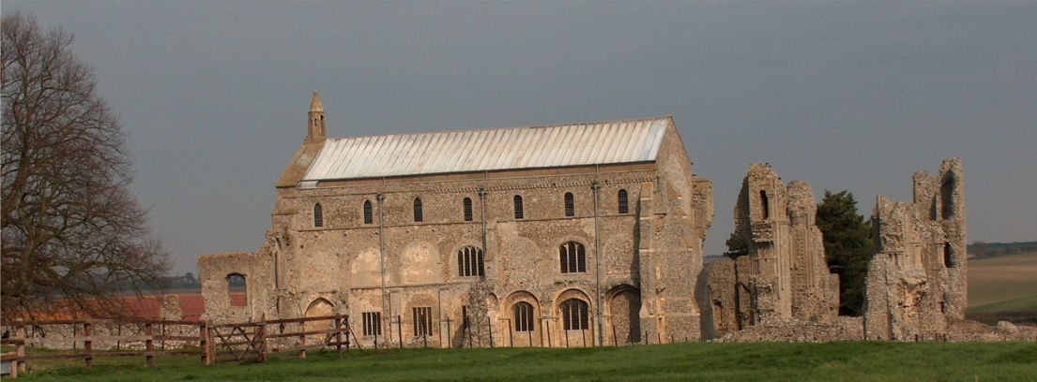
BINHAM PARISH COUNCIL
Parish Clerk – Sarah Hayden
53 Cromer Road, Lower Gresham
NR11 8RH
Tel: 01263 570223
Email: sarah352hayden@btinternet.com

Notice & Summons of Annual Parish Council Meeting
Notice is given to the public and Members of the Council are summoned to attend the Annual Meeting of Binham Parish Council at the Memorial Hall, Binham
On Monday 22nd May 2023 at 7.30pm
S. H. Hayden
Clerk
16th May 2023
The Public are welcome to attend this Parish Council meeting

AGENDA
1. To elect a Chairman of the Council followed by signing of Acceptance of Office
2. To elect a Vice Chairman
3. Signing of Acceptance of Office by all elected parish councillors
4. To receive apologies for absence
5. To co-opt parish councillor/s followed by signing of Acceptance of Office
6. Declarations of Interest and any dispensations of disclosable pecuniary interests
7. Approval of the Minutes of Parish Council Meeting held 9th January 2023
8. Matters Arising from those Minutes
9. Reports
9.1 Norfolk County Council
9.2 North Norfolk District Council
9.3 Chair’s Report re: SAMS
10. Planning
10.1 To discuss and make observations on any applications received after the date of this Agenda
10.2 Report from Planning Committee
11. Finance and Regulatory
11.1 To receive list of actuals against budget, balance sheet, bank reconciliation and explanation of variances to 31.3.22
11.2 To consider and approve the Annual Governance and Accountability Return as follows:
To receive the Annual Internal Audit Report 2022-23
To approve section 1 Annual Governance Statement
To approve section 2 Accounting Statements
To complete the Certificate of Exemption
11.3 To review the Parish Council’s insurance policy and approve payment of premium
11.4 To approve list of payments including approval of NALC increase in subscription
11.5 To review all policies and risk assessments for Binham Parish Council.
11.6 Resolution to confirm Binham Parish Council meets the eligibility criteria for adoption of the General Power of Competence and to adopt the General Power of Competence
12 Maintenance
12.1 Update on telephone box
12.2 Update on Jubilee bench
12.3 Review of allotments
13. To discuss permission for plaques as memorials being placed in the cemetery.
14. Items for Information Only or next Agenda
15. To fix the times and dates for ordinary meetings of the Council for the ensuing year

