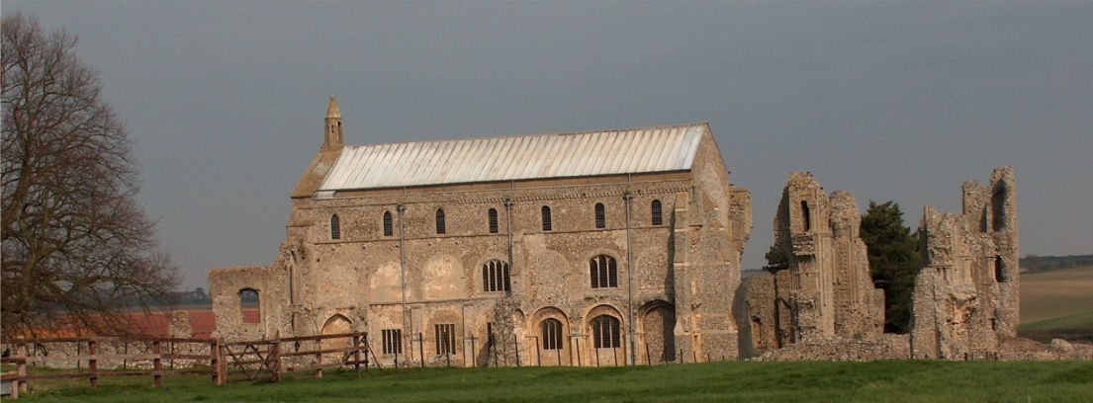
BINHAM PARISH COUNCIL
Parish Clerk – Sarah Hayden
53 Cromer Road, Lower Gresham
NR11 8RH
Tel: 01263 570223
Email: sarah352hayden@btinternet.com
https://binhampc.norfolkparishes.gov.uk

2023/1
DRAFT MINUTES OF PARISH COUNCIL MEETING 9th JANUARY 2023
AT THE MEMORIAL HALL, BINHAM

Those Present Cllr. L. Brady (Chair), Cllr. L. Brown (Vice Chair), Cllr. P. Alford, Cllr. P. Bailey, Cllr. K. Cooke, Cllr. L. Wynder
In Attendance Mrs. S. Hayden (Clerk)
District Cllr. Richard Kershaw
1 member of the public

The Chair opened the meeting at 7.22pm

1. To receive apologies for absence
Cllr. H. Owen had sent apologies
County Councillor Darby was hoping to attend but would be late
2. Declarations of Interest and any dispensations of disclosable pecuniary interests
None
3. Approval of Minutes of Parish Council Meeting held on 22nd November 2022
The minutes were approved and signed by the Chair
4. Matters Arising
1. LPG gas tanks at Priory Crescent – locks had been fitted
2. Front Street – bush had been cut back
3. An email circulation list of local farmers had been drawn up for Road Closure Notices
4. The telephone pole situation at Cockthorpe had been resolved satisfactorily
5. District Cllr. Kershaw reported that Serco had apologised for delays in waste collection and the service did appear to be improving. Cllr. Alford reported that she and her neighbours are still being missed. Cllr. Kershaw offered to assist if she could provide details by email to him.
6. Parking of Sanders coach – Clerk apologised for not writing to Sanders, but would do so - Cllr. Bailey offered to check if the coach was still being parked on Priory Crescent.
7. The Chair updated the situation regarding grass cutting over winter.

5. Reports
5.1 Norfolk County Council
A report from County Cllr. Darby had been received and is annexed to these minutes. The Clerk read out his report to the meeting.
5.2 North Norfolk District Council
District Councillor Kershaw reported that the budget situation was not good and although it was hoped to increase council tax by only 1%, as the Government would not be paying a New Homes Bonus this would effectively cost £900,000. Levelling up funds would also be less in the next financial year. However, NNDC were in a better position than other councils (Norfolk County Council had a £2m hole in their budget) and they would not be reducing services. The budget would be finalised in February. The Governance, Risk and Audit Committee would be looking at a leadership scheme on Friday. He was aware that there was currently 48% inflation on building projects. £14m was to be spent on coastal defences, funded by the Environment Agency and Balfour Beatty would be running that scheme. Businesses in the area were struggling and some in Fakenham had closed. North Walsham had drawn in new businesses due to the work being carried out in the town. Local elections would be held on 4th May and 21st March would be the start of the “pre-election period” when politics could not be discussed by councillors. A question was raised on the situation
2023/2

regarding Shannocks in Sheringham and Cllr. Kershaw confirmed a CPO had been served. The site would be developed and final negotiations were taking place, with funds secured.

Cllr. Kershaw made his apologies and left the meeting

5.3 Chair’s Report and to receive SAM2 data
The Chair reported that she would continue sending out a short newsletter in the village. She had not had a response on the need for a warm hub but at least it had been considered. She had attended the Police SNAP meeting at Wells although there had been only one other person attending. One priority set was scams targeting young people rather than adults. There had been anti-social behaviour in Wells, in particular skateboarding. Marine crime was also a priority. The Chair has asked if there happened to be a car in the area of Binham, would it be possible for an officer to spend half an hour in the village liaising with people.

The SAM2 data had been circulated and is annexed to these minutes. The camera had been moved to Hindringham Road during Road Safety Week when Hindringham Speedwatch Team were out regularly. The Camera Safety Partnership had also been sent the SAM2 data which had coincided with the date they had collected. However, they had stated they considered speeds in Binham were not sufficiently problematic to warrant Police attention. The Chair had been liaising with the Highways Engineer and requested speed roundels on the Hindringham, Langham and Warham roads and this had been agreed. She had also requested the “slow” signs be repainted and the repeater signs refreshed, as well as an extra grit bin for Warham Road. She had also requested that the grit bin on Priory Crescent be moved slightly. The siting of the SAM2 sign on Langham Road was discussed.

County Councillor Darby had arrived during the Chair’s report and was asked if he would like to speak at this point. He agreed and reported that an extraordinary meeting of the Council would be held the following week to discuss the proposal for a leader of the Council elected by the public. He explained that this would bring in £620m over the next 30 years. The final decision would be made by Cabinet, with a public consultation planned following that. Cllr. Darby was firmly against the proposal and felt it would result in less local power. The details could be found on the County Council website. Cllr. Darby was thanked and he left the meeting.

6. Planning
6.1 To discuss and make observations on any application received after the date of this agenda
No new applications had been received since the November meeting.
6.2 Report from Planning Committee
Cllr. Alford had circulated her report prior to the meeting. She commented that since the November meeting, four applications had been decided and two were still pending. Both pending applications were for The Cattle Shed and on PF/22/1714 here was a new plan moving the proposed building slightly due to the position of a right of way. Cllr. Alford also outlined the planning history of PF/22/1884, which had been refused planning permission. She had noted that during the past year there had been 13 planning applications in the parish. Four had been refused, eight approved and two were pending.
Pending since last meeting
RV/22/1522 – Variation of conditions 2 (approved plans) and 6 (bat mitigation and enhancement measures) and removal of condition 11 (code Level 3 for sustainable homes) to allow for change to roof finish from thatch to tile, internal layout alterations, amend windows to elevations, including new window positions and insert roof lights, change all window and door materials from timber to aluminium and revised bat mitigation and enhancement measure of planning ref: PF/13/1192 (Conversion of two-storey barn to residential and erection of three bay cartshed garage)The Cattle Shed, Binham Road, Wighton – The Parish Council had objected – Decision pending by NNDC
PF/22/1714 – The Cattle Shed, Binham Road, Wighton – The Parish Council had objected to the application. Pending NNDC decision

2023/3
Applications decided since last meeting
PF/22/1884 Conversion and extensions to detached garage to create 1 bedroom dwelling – land off Walsingham Road (land owned by 7 Front Street, Binham) – The Parish Council had objected to the application. Refused by NNDC
RV/22/1992 Variation of Condition 1 (Plans) of PF/18/2339 to amend external lighting details – land off Close and Walsingham Road, Binham – Refused by NNDC
PF/22/2335 Single storey side extension to dwelling – 45 Warham Road, Binham, NR21 0DQ – The Parish Council had submitted comments in support – pending NNDC decision
PF/22/2430 Single storey rear extension to dwelling, external alterations - The Barn House, Warham Road, Binham NR21 0DQ – The Parish Council had submitted comments in support – Approved by NNDC

7. Maintenance
7.1 Update on telephone box plans
Cllr. Wynder produced brackets for the shelving which would be screwed into the wooden back plate of the telephone box. She would circulate by email, details of the shelving. The Clerk was asked to chase waterproofing of the box following leaks from some windows. Discussion took place on the waterproofing materials. Cllrs. Bailey and Cooke to check Stiffkey box for the type used there. The sticking door had been sanded down by Clr. Bailey, which had resolved the problem.
7.2 Update on repairs to bus shelter and village sign base
Cllrs. Cooke and Bailey to check the bus shelter to decide which type of roofing would be suitable.

8. Finance and Regulatory
8.1 To receive Budget against Actuals, Balance Sheet and report on Bank Reconciliation
The Chair thanked the Clerk for reducing her hours paid for September to December. The Budget and Balance Sheet were received with no comments and Cllr. Bailey reported that the Bank Reconciliation was correct.
8.2 To approve list of payments
Approved and signed by the Chair and Clerk
8.3 To appoint internal auditor for 2022-23 accounts
Due to the existing internal auditor wishing to retire, it was proposed and resolved that Beryl Flood be appointed as internal auditor for 2022-23.

9. The Green
9.1 Update on signs for the Green and approve any further costs
Cllr. Brown confirmed that her husband was dealing with the signs.
9.2 Update on Jubilee bench for Green and agree installation and any further costs
The Jubilee bench was stored and would be installed in the Spring

10. To discuss arrangements for the celebration of the coronation of HM King Charles
The Memorial Hall Committee would be meeting the following week to discuss their plans. Agreed to hold an open meeting for any village organisations to attend and agree plans. It was hoped it would be held before the end of the month. Bank holiday dates were discussed.

11. To deal with any correspondence
The Chair noted a circulated email containing details of available funding for Village Halls and details of a meeting on community funding by Orsted
A complaint had been received about bins being left outside certain properties and a complaint had been received about an untidy area of the village. Chair agreed to speak to parties concerned.

12. Items for information only or next Agenda
Parking for the proposed new Farmer’s Market being held at the Memorial Hall was discussed
The Chair offered thanks for those who had put the Christmas tree up - it had looked very pretty.

There being no further business the meeting closed at 9.23pm. The approved cheques were signed.

The next meeting would be on Monday 13th March 2023

