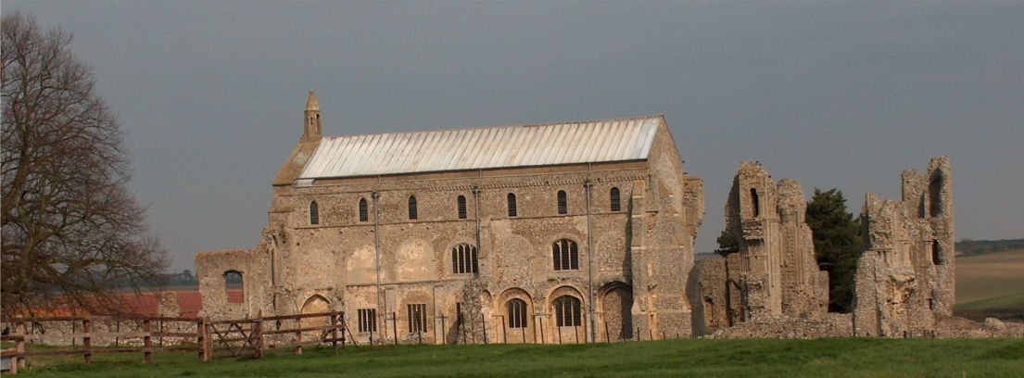
BINHAM PARISH COUNCIL
Parish Clerk – Sarah Hayden
53 Cromer Road, Lower Gresham
NR11 8RH
Tel: 01263 570223
Email: sarah352hayden@btinternet.com

Notice & Summons of Parish Council Meeting
Notice is given to the public and Members of the Council are summoned to attend a meeting of Binham Parish Council at the Memorial Hall, Binham
On Monday 9th January 2023 at 7.30pm
S. H. Hayden
Clerk
4th January 2023
The Public are welcome to attend this Parish Council meeting

AGENDA

1. To receive apologies for absence

2. Declarations of Interest and any dispensations of disclosable pecuniary interests

3. Approval of the Minutes of Parish Council Meeting held on 22nd November 2022

4. Matters Arising from those Minutes

5. Reports
5.1 Norfolk County Council
5.2 North Norfolk District Council
5.3 Chair’s Report

6. Planning
6.1 To discuss and make observations on any applications received after the date of this Agenda
6.2 Report from Planning Committee

7 Maintenance
7.1 Update on red telephone box plans
7.2 Update on repairs to bus shelter and village sign base

8. Finance and Regulatory
8.1 To receive budget against actuals, balance sheet and report on bank reconciliation
8.2 To approve list of payments
8.3 To appoint internal auditor for 2022-23 accounts

9. The Green
9.1 Update on signs for The Green and agree any further costs
9.2 Update on Jubilee bench for Green and agree installation and any further costs

10. To discuss arrangements for the celebration of the coronation of HM King Charles

11. To deal with any correspondence

12. Items for Information Only or next Agenda

