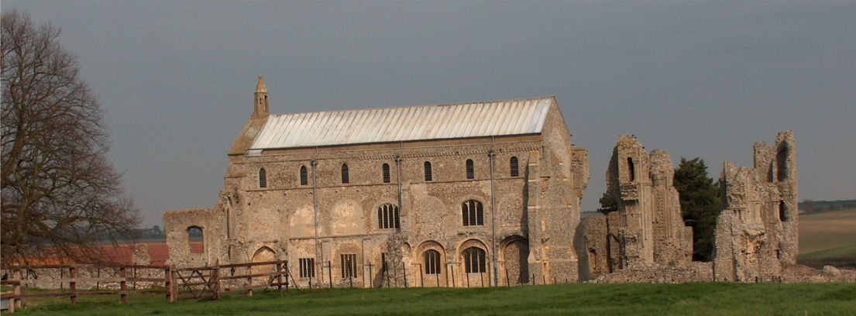
BINHAM PARISH COUNCIL
Parish Clerk – Sarah Hayden
53 Cromer Road, Lower Gresham
NR11 8RH
Tel: 01263 570223
Email: sarah352hayden@btinternet.com
https://binhampc.norfolkparishes.gov.uk

2022/18
DRAFT MINUTES OF PARISH COUNCIL MEETING 22nd NOVEMBER 2022
AT THE MEMORIAL HALL, BINHAM

Those Present Cllr. L. Brady (Chair), Cllr. L. Brown (Vice Chair), Cllr. P. Alford, Cllr. P. Bailey, Cllr. H. Owen, Cllr. L. Wynder
In Attendance Mrs. S. Hayden (Clerk)
District Cllr. Richard Kershaw
Two members of the public

The Chair opened the meeting at 7.28pm

1. To receive apologies for absence
Cllr. K. Cooke, County Cllr. M. Darby
2. Declarations of Interest and any dispensations of disclosable pecuniary interests
None
3. Approval of Minutes of Parish Council Meeting held on 10th October 2022
The minutes were approved and signed by the Chair
4. Matters Arising
1. Front Street – Clerk had asked owner to cut bush back further to aid visibility from Field Dalling, but this had not been done yet – Clerk to send reminder
2. LPG gas tanks at Priory Crescent – locks should have been fitted the day before the meeting and a compound had been suggested that would need a consultation with residents – Cllr. Bailey to check locks fitted
3. Cllr. Brown had removed the developer’s “Priory Mews” sign and also the old bin from the bus shelter.
5. Reports
5.1 Norfolk County Council
A short report from Cllr. Darby had been received and circulated, and is annexed to these minutes. The Clerk read out the report to the meeting.
5.2 North Norfolk District Council
District Councillor Kershaw reported that NNDC had not received replies yet on the applications for Levelling Up funding, Strategic Development Funding and Rural England Prosperity Funding. NNDC had held a Cost of Living Summit which was well attended by various groups and was available on the NNDC website. Foodbank visits had been up by 38% already, with an increase of the over 65s who find it difficult to accept help. NNDC were trying to broadcast helpful information on the website and in Outlook which had been published for those unable to access the website. A Jobs Fair had been held and 120 people had been successful in finding positions in hospitality and care. There was a business fuel cap of 0.22p/kw hr on new contracts. Cllr. Kershaw outlined measure being taken by businesses and the difficulties they were experiencing following his meetings with businesses in North Walsham the previous Friday. Norfolk had the highest number of Warm Spaces hubs. Pubs were joining in and the Little Theatre was opening as a Warm Space.
5.3 Chair’s Report and to receive SAM2 data
The Chair reported that the parish council had been busy with various matters and she would go through these as follows.
1. As reported at the October meeting there had been ongoing correspondence to resolve the problem with LPG tanks at Priory Crescent. See item 4 above.
2. Road Closure Legal Notices – a resident had asked for information concerning the Notices – these were normally received by the Parish Council in advance. The Clerk offered to circulate them to local farms who would benefit from prior notice.
3. Telegraph poles at Cockthorpe – a resident explained the difficulties with work that was in progress to lay fibre optic cables, which had been completed across their land. There were now plans to place six telegraph poles in the village which she felt would block sightlines for traffic passing through and were too close to the road to allow clear passage for large vehicles, such as farm traffic, buses, lorries, etc. Cllr. Kershaw explained the probable reason for telegraph poles rather than laying underground was to link with the properties with copper connection. The resident had contacted the Highways Authority and a meeting was expected the following day between Highways and Openreach. The Chair asked for an update following that meeting, so that the Parish Council could reply to any queries raised.
4. Dustbin emptying – there had been problems since 2nd week in September, with bins not being emptied in the village according to the schedule. District Cllr. Kershaw agreed there had been problems with various reasons. Serco had come to the Overview & Scrutiny Committee to give an explanation and the problems were now reducing. The leader of the Council, Tim Adams, had issued an apology and he hoped there would be an improvement in Binham.

Cllr. H. Owen made her apologies and left the meeting

5. Covid – we need to be mindful that Covid is still with us, with Christmas gathering approaching.
6. A Sanders Coach was regularly parked in Priory Crescent. Clerk to write asking the firm not to do so in a residential area
7. The village should probably start thinking about arrangements for the King’s Coronation on 5th May, with 7th May being a Bank Holiday.
8. The Jubilee bench had been delivered and was being stored until Spring. The circular memorial bench was being made.
9. The signs for the Green had been collected. Cllr. Brown to arrange placement.
10. SAM2 – The report had been circulated prior to the meeting and is annexed to these minutes. The data had been passed on to the Camera Safety Partnership who had placed their mobile SAM2 in the village. The Chair had compared their data to the village data, which was similar. The Camera Safety Partnership were not too concerned currently, but would “keep an eye” on Binham. The 30mph repeater signs in the village had faded and the “slow” signs needed repainting. Clerk to report.

6. Planning
6.1 To discuss and make observations on any application received after the date of this agenda
None
6.2 Report from Planning Committee
The report had been circulated prior to the meeting. Cllr. Alford commented as follows.

New applications
PF/22/1884 Conversion and extensions to detached garage to create 1 bedroom dwelling – land off Walsingham Road (land owned by 7 Front Street, Binham) – The Parish Council had objected to the application, which was pending a decision by NNDC.
RV/22/1992 Variation of Condition 1 (Plans) of PF/18/2339 to amend external lighting details – land off Close and Walsingham Road, Binham – Pending decision. Cllr. Kershaw advised that he was aware the application would be refused and the lights would be removed.
PF/22/2335 Single storey side extension to dwelling – 45 Warham Road, Binham, NR21 0DQ – The Parish Council had submitted comments in support – pending NNDC decision
PF/22/2430 Single storey rear extension to dwelling, external alterations - The Barn House, Warham Road, Binham NR21 0DQ – The Parish Council had submitted comments in support – pending NNDC decision

Pending since last meeting
RV/22/1522 – Variation of conditions 2 (approved plans) and 6 (bat mitigation and enhancement measures) and removal of condition 11 (code Level 3 for sustainable homes) to allow for change to roof finish from thatch to tile, internal layout alterations, amend windows to elevations, including new window positions and insert roof lights, change all window and door materials from timber to aluminium and revised bat mitigation and enhancement measure of planning ref: PF/13/1192 (Conversion of two-storey barn to residential and erection of three bay cartshed garage)The Cattle Shed, Binham Road, Wighton – The Parish Council had objected – Decision pending by NNDC
PF/22/1714 – The Cattle Shed, Binham Road, Wighton – The Parish Council had objected to the application. Pending NNDC decision
District Cllr. Kershaw advised that decisions had been made on the above two applications and would be available shortly.
PF/21/2926 Two storey side/rear extension to dwelling – 87 Warham Road, Binham, NR21 ODQ – Approved
District Cllr. Kershaw made his apologies and left the meeting

7. Maintenance
7.1 Update on telephone box plans
Cllr. Bailey explained that the door was sticking. Discussed. Clerk to ask painting contractor to sand back as original quote had included freeing the door. Cllr. Wynder had been offered used metal adjustable shelving by The Maltings. Agreed to accept their kind offer.
7.2 Update on repairs to bus shelter and village sign base
Held over until next meeting

8. Finance and Regulatory
8.1 To receive Balance Sheet and report on Bank Reconciliation
Budget and Balance Sheet received with no comments and Cllr. Brown reported that the Bank Reconciliation was correct.
8.2 To approve list of payments
Approved and signed by the Chair and Clerk

Cllr Wynder made her apologies and left the meeting

8.3 To agree Budget and set precept for 2023-4
Discussed in detail. Agreed to meet grass cutting contractors to cease grass cutting until frequency agreed due to reaching limit of budget for 2022-3. Proposed and resolved to set the precept at £8,400.
8.4 To appoint parish councillor to check bank reconciliations
The Clerk explained that as Cllr. Brown was a bank signatory it would be better practice to appoint another parish councillor. Proposed and resolved Cllr. Bailey would check bank reconciliations.
8.5 To adopt the Local Government Association Model Councillor Code of Conduct
Proposed and resolved to adopt the new Code

9. The Green
9.1 Update on signs for the Green and approve costs
As item 5.3 above. Metal poles would be required for fixing. Cllr. Brown to investigate.
9.2 Update on Jubilee bench for Green and agree installation and any further costs
As item 5.3 above

10. To deal with any correspondence
Sanders Bus Services – Clerk to answer survey request
Blakeney Parish Council – Clerk to write that Binham Parish Council were still in support of their endeavours to have medical services provided at the Surgery.
Duncan Baker MP – Projects and fundraising – noted

11. Items for information only or next Agenda
None

12. Resolution to close the meeting to the press and public under the Public Bodies (Admission to Meetings) Act 1960 to deal with item 13.
Proposed and resolved although no public present at this point

13. To consider request to purchase Exclusive Right to Burial in cemetery from non-resident
Discussed and sympathy expressed with this sensitive issue but rules had been made due to shortage of space in the Parish Council’s cemetery. Proposed and resolved to adhere to existing rules and not to allow exclusive rights to non-residents.

There being no further business the meeting closed at 10pm. The approved cheques were signed.

The next meeting would be on Monday 9th January 2023

