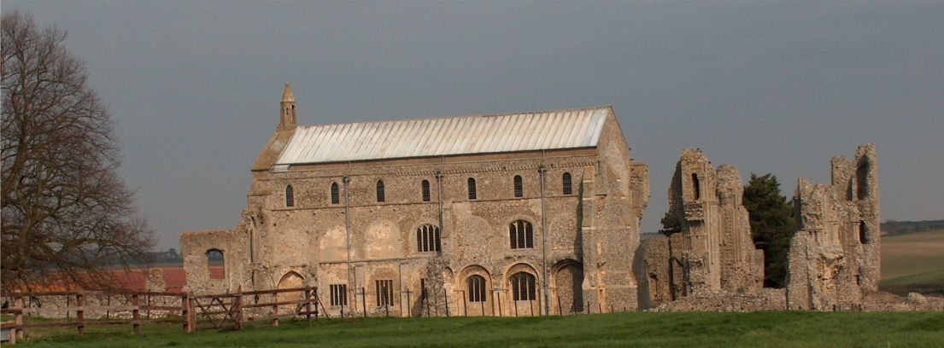
BINHAM PARISH COUNCIL
Locum Parish Clerk – Sarah Hayden
53 Cromer Road, Lower Gresham
NR11 8RH
Tel: 01263 570223
Email: sarah352hayden@btinternet.com

Notice & Summons of Parish Council Meeting
Notice is given to the public and Members of the Council are summoned to attend a meeting of Binham Parish Council at the Memorial Hall, Binham
On Tuesday 22nd November 2022 at 7.30pm
S. H. Hayden
Clerk
15th November 2022
The Public are welcome to attend this Parish Council meeting

AGENDA

1. To receive apologies for absence

2. Declarations of Interest and any dispensations of disclosable pecuniary interests

3. Approval of the Minutes of Parish Council Meeting held on 10th October 2022

4. Matters Arising from those Minutes

5. Reports
5.1 Norfolk County Council
5.2 North Norfolk District Council
5.3 Chair’s Report

6. Planning
6.1 To discuss and make observations on any applications received after the date of this Agenda
6.2 Report from Planning Committee

7 Maintenance
7.1 Update on red telephone box plans
7.2 Update on repairs to bus shelter and village sign base

8. Finance and Regulatory
8.1 To receive balance sheet, and report on bank reconciliation
8.2 To approve list of payments
8.3 To agree Budget and set precept for 2023-4
8.3 To appoint parish councillor to check bank reconciliations
8.4 To adapt the Local Government Association Model Councillor Code of Conduct 2020

9. The Green
9.1 Update on signs for The Green and agree any further costs
9.2 Update on Jubilee bench for Green and agree installation and any further costs

10. To deal with any correspondence

11. Items for Information Only or next Agenda

12. Resolution to close the meeting to the press and public under the Public Bodies (Admission to Meetings) Act 1960 to deal with item 13

13. To consider request to purchase Exclusive Right to Burial in cemetery from non resident

