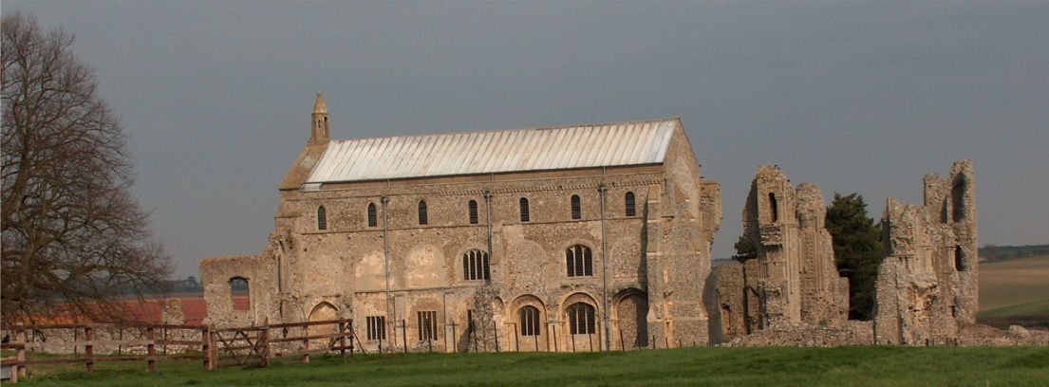
BINHAM PARISH COUNCIL
Parish Clerk – Sarah Hayden
53 Cromer Road, Lower Gresham
NR11 8RH
Tel: 01263 570223
Email: sarah352hayden@btinternet.com
https://binhampc.norfolkparishes.gov.uk

2022/15
DRAFT MINUTES OF PARISH COUNCIL MEETING 10th OCTOBER 2022 AT THE MEMORIAL HALL, BINHAM

Those Present Cllr. L. Brady (Chair), Cllr. L. Brown (Vice Chair), Cllr. P. Alford, Cllr. P. Bailey
In Attendance Mrs. S. Hayden (Clerk)
District Cllr. Richard Kershaw

The Chair opened the meeting at 7.35pm

1. To receive and accept apologies for absence
Cllr. H. Owen, Cllr. L. Wynder
2. Declarations of Interest and any dispensations of disclosable pecuniary interests
None
3. Approval of Minutes of Parish Council Meeting held on 11th July 2022
The minutes were approved and signed by the Chair
4. Matters Arising
1. The bin on Priory Crescent had been moved to the bus shelter as requested. Cllr. Brown to remove the existing bin
2. No answer had been received on extending the allotment plots
3. Agreed the Priory Mews Development sign to be removed. Cllr. Brown to action
4. Regarding registration of footpaths on the definitive map, the Clerk had attended a NCC webinar in connection with rights of way and heard that the 2026 deadline had been lifted. Clerk to check legislation.
5. The bush on the corner of Field Dalling Road had been cut back, improving visibility. Due to building work on Front Street however, with cars overtaking parked vehicles there, it was still difficult to emerge on to Front Street. Clerk to contact property owner and ask for it to be trimmed further if possible.

5. Reports
5.1 Norfolk County Council
A short report from Cllr. Darby (who was away) had been received and circulated, and is annexed to these minutes. The Clerk read out the report to the meeting.
5.2 North Norfolk District Council
District Councillor Kershaw reported that NNDC had a £640,000 surplus in their budget, although a 9% pay award was expected. Two levelling up bids had been applied for (one for Fakenham and one for Cromer) and the results should be known by the end of the month. Applications were being made for funding of 2.7m, divided into two parts, one directed at people and one at rural businesses. In connection with new economic zones, Cllr. Kershaw had attended a leader’s meeting on funding, although these zones were mainly Norwich Tech Park, Snetterton and Cambridge. NNDC would not benefit as they did not have this type of land and even if it did, developers would prefer other areas. There were potential film studios in the area with £4.2m investment to provide training. On nutrient neutrality, NNDC now had a calculator and hopefully by the end of the year applications affected will be moving and the Local Plan will be submitted by January. On Covid, fourth innoculations are being dealt with. Over the past two weeks, infections had increased by 4% during the first week and 14% the second week, although with no increase in admissions to Hospital.

2022/16
5.3 Chair’s Report and to receive SAM2 data
The Chair reported that during the public mourning period for the late Queen, the flag had been flown as required, a condolence book had been made available in the Church and provision made for flowers to be laid at the Village Sign on The Green. The messages with the flowers would be placed in the Condolence Book. Duncan Baker MP had visited the village but as the notice had been given a little late, no parish councillors had been available to meet him. The Parish Council had been dealing with ongoing and new planning applications. The Parish Council needed to be mindful of the energy price rises and be aware of people who may need help. Cllr Kershaw reported that NNDC had been encouraging people who did not need their winter fuel payment to donate it to charity and had appointed an energy officer. Discussion followed. The Chair had circulated SAM2 data, which is annexed to these minutes. She explained the figures and noted that traffic had decreased although a large amount of traffic was going through the village and the average speed was creeping up, with average speeding at 39mph. Speeding was discussed. The Chair reported that the highways rangers had visited and white lines had been painted and some signs replaced. The drains in the village seemed to be clear.

6. Planning
6.1 To discuss and make observations on any application received after the date of this agenda
None
6.2 Report from Planning Committee
The report had been circulated prior to the meeting.
New applications
RV/22/1763 Variation of condition 2 (approved plans) of planning permission PF/20/1954 (detached one and a half storey building to be used as self-contained holiday accommodation) to allow design changes - 49 Priory Crescent, Binham - Cllr. Alford outlined the comments that had been submitted objecting and the time spent on this application by the Parish Council. Cllr. Kershaw confirmed he had spoken with the applicant. The application had been refused by NNDC.
PF/22/1883 Removal of hedge to rear boundary and construction of boundary garden wall to rear boundary and part of west side boundary – Westgate Old Farmhouse, Warham Road, Binham, NR21 0DQ – Cllr. Alford outlined the supporting comments made by the Parish Council. This had been approved by NNDC with conditions.
RV/22/1522 and PF/22/1714 – The Cattle Shed, Binham Road, Wighton – Cllr. Alford explained that this had been difficult to comment upon due to a different property names being used to those on the ground, as well as a complicated planning history. The Parish Council had objected on both applications. She had spoken to the planning officer after submission of the comments and had raised a query on the gates to the development. District Cllr. Kershaw was still liaising on this application and had asked for some clarity. He would keep the Parish Council updated on any progress.
PF/21/2926 Two storey side/rear extension to dwelling – 87 Warham Road, Binham, NR21 ODQ – The Parish Council had supported this application. New plans had been submitted on 16.8.22. Cllr. Kershaw updated the meeting, confirming that there was now agreement between Conservation and Design and the applicant. Decision pending.
PF/22/1884 Conversion and extensions to detached garage to crate 1 bedroom dwelling – land off Walsingham Road (land owned by 7 Front Street, Binham) – Cllr. Alford explained the application was to create supplementary living accommodation. After checking the site and an old application, the Parish Council had objected, but asked that if it were approved, conditions for use as ancillary accommodation be attached. Discussed.
RV/22/1992 Variation of Condition 1 (Plans) of PF/18/2339 to amend external lighting details – land off Close and Walsingham Road, Binham – The Parish Council had objected to this application. The comments by the Highways Authority were read out by the Clerk. Discussed.
. Conditions on two other applications were noted by the Chair and she confirmed the Parish Council tried to be consistent in their comments on planning applications.

2022/17
Cllr. Kershaw made his apologies and left the meeting

7. Maintenance
7.1 To discuss ideas for future use of the telephone box
A resident had offered to run a micro library and book exchange. Discussed and agreed to accept the offer with thanks. The Chair would meet with the resident to discuss the details. Cllr. Bailey offered to investigate a report of water leaking into the telephone box and would also check other telephone boxes for ideas on shelves, etc. Cllr. Brown would investigate provision of shelving. Clerk to update resident who had offered to donate towards the cost of shelving.
7.2 To receive results of safety/asset check
The Clerk and Chair had checked the assets. There had been a pin missing from the grit bin at Priory Crescent. The bus shelter roof was leaking and needed to be a priority. The fence on the allotments needed repair. The base of the sign needed re-pointing. Cllr. Brown to investigate help with bus shelter repairs and re-pointing for sign.

8. Finance and Regulatory
8.1 To receive Actuals against Budget, Balance Sheet and report on Bank Reconciliation
Budget and Balance Sheet received with no comments and Cllr. Brown reported that the Bank Reconciliation was correct.
8.2 To approve list of payments
Approved and signed by the Chair and Clerk

9. The Green
9.1 To consider request for a memorial bench to be placed on The Green
The Jubilee bench had been received. The siting on the Green was discussed and agreed.
A request had been received to place a memorial bench on The Green. Agreed to give consent and the site was agreed. The Chair would contact the resident concerned.
9.2 To discuss signage re: no parking/driving and approve any costs
Discussed and agreed to provide post holes and aluminium signs, with three signs to be purchased from Stuart Signs, Fakenham whose charges were reasonable. Agreed to purchase three signs at a maximum cost of £100. Chair to circulate wording by email to parish councillors for agreement and then action.

10. To deal with any correspondence
NALC – invitation to nominate a representative –agreed to nominate Chair
LYNX – thank you for donation
SAAA – Option to opt out of central external auditor appointment – agreed not to opt out
Norfolk Parishes Movement for OTN – request to send letter to MP – agreed if still within date
Pension Regulator – Requirement to register which had been completed by the Clerk
NNDC Engagement Strategy consultation – Chair to complete
11. Items for information only or next Agenda
Cllr. Bailey outlined problems at the Priory Crescent site for LPG tanks where children had been reported playing around the tanks. These had no locks on the lids and reassurance was required by the residents that they were safe and could not cause accidents. Cllr. Bailey had written to Broadland HA himself but asked the Parish Council to also write for urgent reassurance or locks to be fitted. Agreed the Clerk would send letter.

There being no further business the meeting closed at 10.25pm. The approved cheques were signed.

The next meeting would be on Monday 28th November 2022

