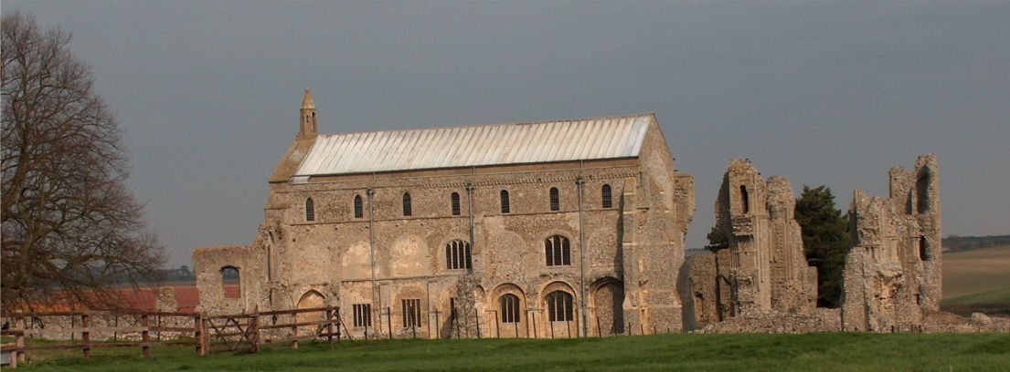
BINHAM PARISH COUNCIL
Parish Clerk – Sarah Hayden
53 Cromer Road, Lower Gresham
NR11 8RH
Tel: 01263 570223
Email: sarah352hayden@btinternet.com
https://binhampc.norfolkparishes.gov.uk

2022/11
DRAFT MINUTES OF PARISH COUNCIL MEETING 11th JULY 2022 AT THE MEMORIAL HALL, BINHAM

Those Present Cllr. L. Brady (Chair), Cllr. L. Brown (Vice Chair), Cllr. P. Alford, Cllr. P. Bailey, Cllr. K. Cooke, and Cllr. L. Wynder
In Attendance Mrs. S. Hayden (Clerk)
District Cllr. Richard Kershaw
County Councillor Michael Darby

The Chair opened the meeting at 7.32pm

1. To receive and accept apologies for absence
Cllr. H. Owen (Covid)

2. Declarations of Interest and any dispensations of disclosable pecuniary interests
None

3. Approval of Minutes of Parish Council Meeting held on 9th May 2022
The minutes were approved and signed by the Chair
4. Matters Arising
1. The Clerk reported that maintenance advice from an artist given to another parish council for their painted wooden sign for maintenance, was an annual coat of Danish oil and then a coat of beeswax.
2. No reply had been made yet to a request for an extension to the allotments site
3. Flagship had assured the Parish Council that herbicide would not be applied anywhere near trees (in connection with Priory Crescent). Monitoring on the provision of replacement trees would continue.
4. Tidying of the telephone box area had not been carried out yet, in accordance with the landowner’s request.
5. Prescriptions from Holt Surgery still needed 10 working days’ notice. District Councillors Kershaw advised that there was a countrywide shortage of pharmacists.
6. The lights at Priory Crescent remained off, in accordance with the Parish Council’s request
7. There was still a sign stating “Priory Mews” at the development although the road names were in place. District Cllr Kershaw offered to check it could be removed and that it did not apply to the development following completion and street naming.
8. Warmer Homes Initiative. The posters would go out on the noticeboards later in the year. There was a note on the website.

5. Reports
5.1 Norfolk County Council
A report from Cllr. Darby had been received and circulated, and is annexed to these minutes. The information regarding the new recycling centre was discussed

2022/12

5.2 North Norfolk District Council
District Councillor Kershaw reported that vaccinations for over 50s would be available in the autumn. On the nutrient neutrality requirements, six district councils would be getting together to create a nutrient neutrality calculator for housing. In connection with the Ukraine refugees, 80 properties in the district had received 100 adults and 65 children as guests. There had been a slowdown of people arriving and offers being made. There had been issues arising, such as safeguarding and lack of understanding of cultures. Cllr. Kershaw had written to Lord Harrington (Minister for Refugees) and our local MP on the problems. It was expected that there would be a dropping-off of the system as the refugees move on in their lives. NNDC were submitting two bids to the Levelling Up Fund, one for support for the creation of a swimming pool at Fakenham Sports Centre and one for the regeneration of the clifftop gardens and investments in the pier in Cromer. Cllr. Kershaw outlined the two schemes. There was a short run-in time of 6th July, but the Government website had not been working correctly when NNDC had tried to submit their bid. NNDC would also receive funding from the Strategic Recovery Fund for grant aid. The amount for year one was £150,000, year two £350,000 and year three £850,000. This was to be applied to help with the cost of living, poverty and skills, such as numeracy, etc, following the pandemic.

5.3 Chair’s Report and to receive SAM2 data
The Chair read out notes from Duncan Baker MP’s July News in connection with a proposal for a new dentistry school at the UEA and stated she was thinking of offering her services in connection with the project as it tied in closely with her career and work prior to retirement. The Parish Council had been quiet for the past two months although it continued to be consistent in areas such as planning. The Jubilee celebrations had been a fantastic success. They had commenced with about twenty volunteers being involved who had divided into groups and delivered on what they had set out to do. The cricket and tug of war were a great success, as was the tea and the barbecue at the pub. Sadly the concert had not been as successful, although the service on Sunday had been good. A great success had been the 700 metres of bunting, which had now been put away carefully for the next important event. The aims of engagement, fun and time with family and friends had been achieved. The picnic to jazz had sold 200 tickets plus children attending. The Chair gave thanks to everyone involved.

The SAM2 data is annexed to these minutes and Chair went through the figures. It was noted that speed signs in the village had faded and some covered by overgrown hedges, as well as “slow” signs on roads being faded. County Cllr. Darby would report the faded signs and the parish council would report “slow” signs.

6. Planning
6.1 To discuss and make observations on any application received after the date of this agenda
None
6.2 Report from Planning Committee
The report had been circulated prior to the meeting

New applications
None

Pending applications since the May meeting
RV/22/0690 Variation of Condition 2 (approved plans) of planning permission PF/20/1954 (detached one and a half storey building to be used a self-contained holiday accommodation) to allow for design changes including increased height of eaves, addition of dormer to north elevation, alterations to roof design, additional windows, increase in footprint and addition of first floor balcony – 49 Priory Crescent, Binham – Refused – there was a detailed Planning Officer’s Report on the NNDC website which explained their decision

2022/13

PF/21/3284 Single storey extensions to side and rear of dwelling following demolition of conservatory; two storey rear extension dormers to front and formation of two window openings at first floor on rear elevation alterations to access – 25 Front Street Binham, NR21 0AL – Approved with one slight change to the original plan relating to a front window

PF/21/2926 Two storey side/rear extension to dwelling – 87 Warham Road, Binham, NR21 ODQ – Pending Cllr. Kershaw offer to check the position.

Cllr. Kershaw and Cllr. Darby made their apologies and left the meeting

A resident arrived to address the meeting on item 10. The Chair offered to deal with item 10 at this point.

10. To consider possibilities for fibre broadband in the village
The resident introduced himself and explained that he worked from home and needed good Broadband speeds to enable him to do so. He had good speeds currently but there is a cabinet at the edge of the village and those further away from it may not have the same fast speeds. In a previous property he owned the speeds was so slow he had contacted BT and because of the low speeds, was able to arrange for fibre Broadband direct to the property without extra payment. He had since found that 75% of purchasers of property say fibre Broadband is critical and 70% can be put off a purchase is the speeds are slow. He explained that rural villages can get grants, BT can part fund and people could part fund to get fibre Broadband. He offered to leaflet drop and discuss the matter with anyone in the village who would be interested in getting together and funding faster speeds.

The matter was discussed and it was agreed to find out what current speeds are and what they would be if the proposal was taken up. An article in the Lynx was suggested for the information to be broadcast. Cllr. Cooke reported that he had upgraded his Broadband to fibre which went direct to his home and stated that he had nothing to pay other than the monthly payment package agreed. The resident was thanked for his information and offer of help.

7. Maintenance
7.1 To confirm approval of cost of Jubilee bench and site
The details of the new bench had been circulated prior to the meeting, with the suggestion that the remaining funds of the Covid grant (£318) be put towards the total cost of £660 including VAT and installation, with the remaining funds paid for by an anonymous donation. Resolved to agree the purchase and payment of £318. The site was discussed and it was agreed that the bench be placed on the Green. The base was yet to be finalised and advice would be sought from the manufacturer.

7.2 To discuss possible NCC Jubilee trees
A circular about help towards purchasing trees under a Norfolk County Council grant scheme had been circulated. Discussed but agreed that there was no suitable site in the village for such a scheme.

7.3 To discuss ideas for future use of the telephone box
The painting was due to take place on 23rd July 2022. Chair and Vice-Chair to liaise with the landowner on tidying around the box to enable this to take place. Use of box to be decided when refurbishment has taken place.

8. Finance and Regulatory
8.1 To receive Actuals against Budget, Balance Sheet and report on Bank Reconciliation
Budget and Balance Sheet received with no comments and Cllr. Brown reported that the Bank Reconciliation was correct.
8.2 To consider donation to the Lynx
Discussed and resolved to donate £100

2022/14

8.3 To approve list of payments
The figure for ground maintenance was added and the Clerk explained that there had been more grass cuts so far this year and the Parish Council needed to monitor those costs to keep them within the budget. Payments List approved and signed by the Chair and Clerk

9. Update on footpath registration
Cllr. Alford had produced a draft application to register the footpath which she handed to parish councillors. She explained the contents and asked the councillors to read it ready for when the application was ready for approval for submission. Statements would be taken shortly.

11. Items for information only or next Agenda
1. The Clerk had researched information on Binham and Cockthorpe crosses. The Parish Council were owners of the Binham cross, but more research was needed on the remains of the Cockthorpe cross.
2. An overgrown bush on the junction of Field Dalling Road and Front Street was blocking the “Give Way” sign and visibility at the junction. Agreed to write to the owners to request it be trimmed.
3. Dog bin at the Priory – other rubbish was being put in to the dog bin and also the garden waste bin. Currently the cost of purchasing a general rubbish bin, plus cost of emptying was too high for the Parish Council to fund. Signs to be placed on those bins asking people to take their rubbish home. To be discussed for the next financial year. Clerk to check rates for commercial emptying.
4. Could the rubbish bin in Priory Crescent be moved to the bus shelter as it was not needed where it was sited? Clerk to investigate and find out who is responsible for it.

12. Resolution to close the meeting to the public and press under the Public Bodies (Admission to Meetings Act 1960) to discuss item 13
Resolved although no public were present

13. To discuss and agree any action to prevent unauthorised driving and parking on/over the Green
Discussed title investigations so far and the problem areas. Agreed to write to property owners – clerk to draft. Signs considered.

There being no further business the meeting closed at 10pm. The approved cheques were signed.

The next meeting would be on Monday 12th September 2022

