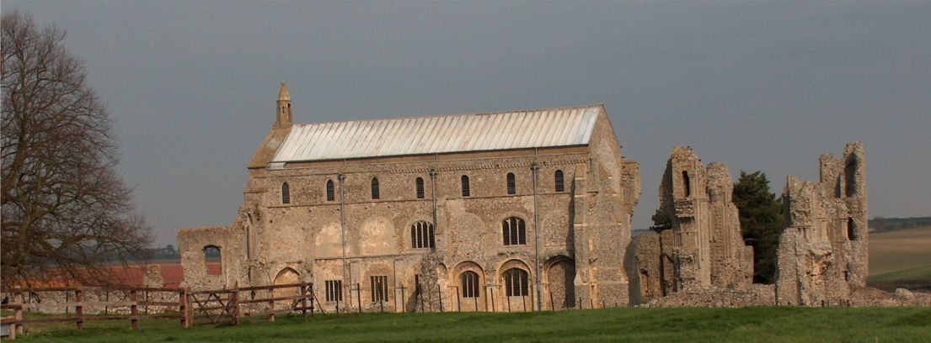
BINHAM PARISH COUNCIL
Parish Clerk – Sarah Hayden
53 Cromer Road, Lower Gresham
NR11 8RH
Tel: 01263 570223
Email: sarah352hayden@btinternet.com
https://binhampc.norfolkparishes.gov.uk

2022/4
DRAFT MINUTES OF ANNUAL PARISH COUNCIL MEETING 9th MAY 2022 AT THE MEMORIAL HALL, BINHAM

Those Present Cllr. L. Brady (Chair), Cllr. L. Brown (Vice Chair), Cllr. P. Alford, Cllr. P. Bailey, Cllr. K. Cooke, Cllr. H. Owen, and Cllr. L. Wynder
In Attendance Mrs. S. Hayden (Clerk)
District Cllr. Richard Kershaw
2 Members of the Public

The Chair opened the meeting at 7.30pm

1. To elect a Chairman of the Council followed by signing of Acceptance of Office
Proposed E. Brady. Resolved unanimously. The Acceptance of Office was signed by Cllr. Brady and witnessed by the Clerk

2. To elect a Vice Chairman
Proposed E. Brown. Resolved unanimously.

3. To receive and accept apologies for absence
County Councillor M. Darby had sent apologies

4. Declarations of Interest and any dispensations of disclosable pecuniary interests
None

5. Approval of Minutes of Parish Council Meeting held on 14th March 2022
Approved and signed by the Chair

6. Matters Arising
1. A reply had been received from Flagship Services re: cherry trees on Priory Crescent which had been circulated to councillors. The trees had been in rapid decline. Flagship looked to replace any tree and Cherry would be the likely replacement although these were not budgeted for in 2022. Discussed. The Clerk as asked to request Flagship did not spray around the base of the trees. The Parish Council would monitor and ask for replacement trees.
2. A reply had been received from Holt Surgery following our letter of support for Blakeney Parish Council, which had been circulated to parish councillors. Cllr. Alford outlined the changes at Holt Surgery and the current difficulties of obtaining medication.
3. Following our request to Broadland Housing Association, the lights in Priory Mews had been turned off.

7. Reports
7.1 Norfolk County Council
A report had been received and is annexed to these minutes. The Chair read the report in précis.
7.2 North Norfolk District Council
District Councillor Kershaw reported that Covid cases were dropping although there was no testing so the figures were less accurate and there were no daily updates. He gave the up to date figures, with two in ICU. NHS absences are high. There had been no announcement on further vaccination, but it would go through doctors’ surgeries and would be Moderna. NNDC had appointed an officer to deal specifically with Ukraine issues, who had lived in the UK for 11. They would have twice weekly meeting. There would be a nurse vaccinations for measles and Covid 19 available. 47 families had been welcomed although issues with visas were ongoing, as there was a limit of four, so that families of five were not able to get visas. Links with schools were established. Regarding nutrient neutrality, Cllr. Kershaw explained the problems, which were manifold as it would affect the 5 year supply of housing in the Local Plan. Seen councils had instructed a QC asking for planning presumption to be lifted for a period. Regarding energy rebates, those who paid by direct debit would shortly be refunded £150 and the Council would be writing to those who pay by other means.
7.3. Chair’s Report
The Chair had circulated the SAM2 data, which is annexed to these minutes. She explained the analysis of the data.
7.4 Chair’s Report
The Chair thanked Cllrs. Cooke and Bailey for erecting the refurbished Village Sign and the Memorial Hall Committee and History Group for sponsoring the refurbishment. The Jubilee celebration plans had been finalised and it was hoped they engaged both Binham and Cockthorpe residents of all ages. There were 15 to 16 people working together to arrange the events at no cost to the village, except for a small charge for adults attending the concert on the Saturday evening, as it was part of the normal concert run. Poster had been done with a map included. 200/300 metres of bunting had been prepared with more to come. There was £350 left from the Covid19 grant and it had been proposed that it be used for the events if needed. However, a commemorative bench was now proposed. The possibility of a commemorative tree in the autumn was discussed, but a site was needed.

The SAM2 data had been circulated to parish councillors and is annexed to these minutes. The Chair outlined the data to the meeting – only three weeks of date had been collected in March due to holidays/Covid, so the figures were less than usual.

8. Planning
8.1 To discuss and make observations on any application received after the date of this agenda
None
8.2 Report from Planning Committee
The report had been circulated prior to the meeting

New applications
RV/22/0690 Variation of Condition 2 (approved plans) of planning permission PF/20/1954 (detached one and a half storey building to be used a self-contained holiday accommodation) to allow for design changes including increased height of eaves, addition of dormer to north elevation, alterations to roof design, additional windows, increase in footprint and addition of first floor balcony – 49 Priory Crescent, Binham – The Parish Council had objected to this application. They had been approached by the applicant following the submission of their observations, but reiterated they were unable to support the application.

Pending applications since the March meeting
PF/21/2926 Two storey side/rear extension to dwelling – 87 Warham Road, Binham, NR21 ODQ – Pending Cllr. Kershaw offer to check the position.

PF/21/3284 Single storey extensions to side and rear of dwelling following demolition of conservatory; two storey rear extension dormers to front and formation of two window openings at first floor on rear elevation alterations to access – 25 Front Street Binham, NR21 0AL – Still pending

LA/21/3038 Works to remove paint from brickwork to the north wing of the Pottery House and its replacement with lime render and lime wash finish – The Pottery House, 41 Front Street, Binham NR21 0AL – Approved

PF/22/0563 Installation of window to ground floor in east elevation – Westgate Old Farmhouse, Warham Road, Binham, NR21 0DQ – Approved

PF/22/0190 Change of use of land to camping site and associated development including amenity block and access track. Binham Parish Council are not consultees as this is outside the boundary of the parish. The application reduced the number of pitches from 45 to 25. Field Dalling Parish Council had objected.

PF/22/0353 River restoration and the creation of an Integrated Constructed Wetland – field to the south Langham Sewage Treatment Works, Binham Road, Langham - Binham Parish Council were not consultees in this application. Langham Parish Council had objected due to lack of detail in the Impact Assessment. They would also like to see a permissive public footpath on the site.

PF/22/0196 Two storey detached dwelling (previously approved under application PF/19/0002) (Plot 1 only) 10 Walsingham Road, Binham, NR21 0AP – Approved

PF/22/0036 Installation of new UPVC frame window in rear elevation t ground floor rear new UPVC framed French doors in side elevation – Apple Garth, Langham Road, Binham, NR21 0DN – Approved

Cllr. Kershaw make his apologies and left the meeting

9. Finance and Regulatory
[All documents in this item had been previously circulated]
9.1 To receive Actuals against Budget, Balance Sheet, Bank Reconciliation and Explanation of Variances to 31.3.22
Received with no comments
9.2 To consider and approve the Annual Governance and Accountability Return
Proposed and resolved as follows:
To complete the Certificate of Exemption – signed by the Chair and Clerk
To receive the Annual Internal Audit Report 2021-22 - Received
To approve section 1 Annual Governance Statement – Approved and signed by the Chair and Clerk
To approve section 2 Accounting Statements – Approved and signed by the Chair
9.3 To approve list of payments
Approved and signed by the Chair and Clerk
9.4 To review all policies and risk assessments for Binham Parish Council

9.5 To review the Parish Council’s insurance policy and approve payment of premium
The payment of the new premium of £343.59 was approved

10. Maintenance
10.1 Update on Village Sign painting
The sign is now in place and it was agreed, had been done very well. Maintenance was discussed- clerk to investigate.
10.2 To discuss ideas for future use of the telephone box maintenance
The area around it needs weeding. Cllr. Brown offered to find someone to liaise with the owner and tidy up the area. Clerk to ask the contractor when it would be painted

11. Update and discussion on footpath registration
Statements to be taken shortly

12. To discuss consent for tree celebrating the Queen’s Platinum Jubilee
As 7.4 above

13. To agree cessation of VETS scheme in support of defibrillator use
Payment was due for this telephone scheme to support use of the defibrillator and a year’s notice should be given for cessation. The scheme had not been fully put into place and there was a lack of volunteers. It was agreed to pay for another year and try to set the scheme up again.

14. Items for information only or next Agenda
1. Warm Homes Initiative – Cllr. Alford will be putting notices up in the village and co-ordinating the scheme
2. Digital Poverty – Grants were available to assist in digital access
3. NNDC Textile Scheme offer received. Confirmed there was one on the Memorial Hall car park.
4. A letter had been received asking if it was possible for the allotments to be extended as one had been requested and there were no vacancies currently.
Next Agenda: Repair of allotment fence and bus shelter

15. To fix the times and dates for ordinary meetings
Agreed to continue on the second Monday of the month, bi-monthly

16. Resolution to close the meeting to the public and press under the Public Bodies (Admission to Meetings Act 1960) to discuss item 16
Resolved – public left the meeting

17. To discuss and agree any action to prevent unauthorised driving and parking on/over the Green
Discussed problem areas. Agreed to investigate details of any prescriptive rights

There being no further business the meeting closed at 10.30pm. The approved cheques were signed.
The next meeting would be on Monday 11th July 2022

