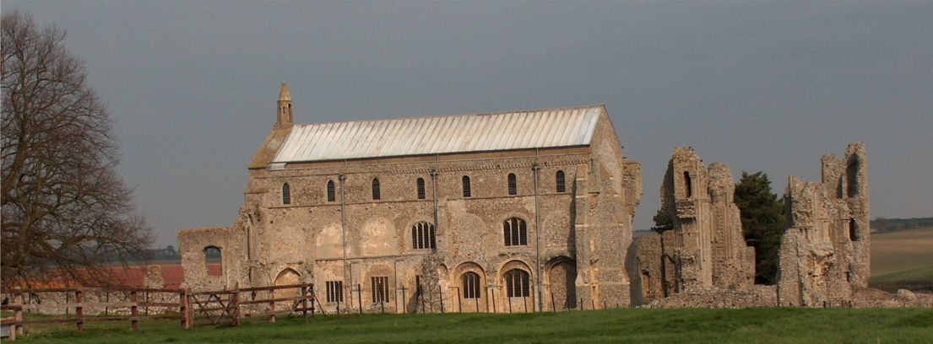
BINHAM PARISH COUNCIL
Locum Parish Clerk – Sarah Hayden
53 Cromer Road, Lower Gresham
NR11 8RH
Tel: 01263 570223
Email: sarah352hayden@btinternet.com

Parish Council Annual Meeting
Members of the Council
You are summoned to attend the annual meeting of Binham Parish Council at the Memorial Hall, Binham
On Monday 9th May 2022 at 7.30pm
S. H. Hayden
Clerk
4th May 2022
The Public are welcome to attend this Parish Council meeting

AGENDA

1. To elect a Chairman of the Council followed by signing of Acceptance of Office
2. To elect a Vice Chairman
3. To receive and accept apologies for absence
4. To Receive Declarations of Interest
5. Approval of the Minutes of Parish Council Meeting held 14th March 2022
6. Matters Arising from those Minutes
7. Reports
7.1 Norfolk County Council
7.2 North Norfolk District Council
7.3 Chair’s Report re: SAMS
8. Planning
8.1 To discuss and make observations on any applications received after the date of this Agenda
8.2 Report from Planning Committee
9. Finance and Regulatory
9.1 To receive list of actuals against budget, balance sheet, bank reconciliation and explanation of variances to 31.3.22
9.2 To consider and approve the Annual Governance and Accountability Return as follows:
To complete the Certificate of Exemption
To receive the Annual Internal Audit Report 2021-22
To approve section 1 Annual Governance Statement
To approve section 2 Accounting Statements
9.3 To approve list of payments
9.4 To review all policies and risk assessments for Binham Parish Council.
9.5 To review the Parish Council’s insurance policy and approve payment of premium
10 Maintenance
10.1 Update on Village Sign painting
10.2 To discuss ideas for future use of the telephone box maintenance
11. Update on footpath registration
12 To discuss consent for tree celebrating the Queen’s Platinum Jubilee
13 To agree cessation of VETS scheme in support of defibrillator use
14. Items for Information Only or next Agenda
15. To fix the times and dates for ordinary meetings of the Council for the ensuing year
16. Resolution to close the meeting to the public and press under the Public Bodies (Admission to Meetings Act 1960) to discuss item 16
17. To discuss and agree any action to prevent unauthorised driving and parking on/over the Green

