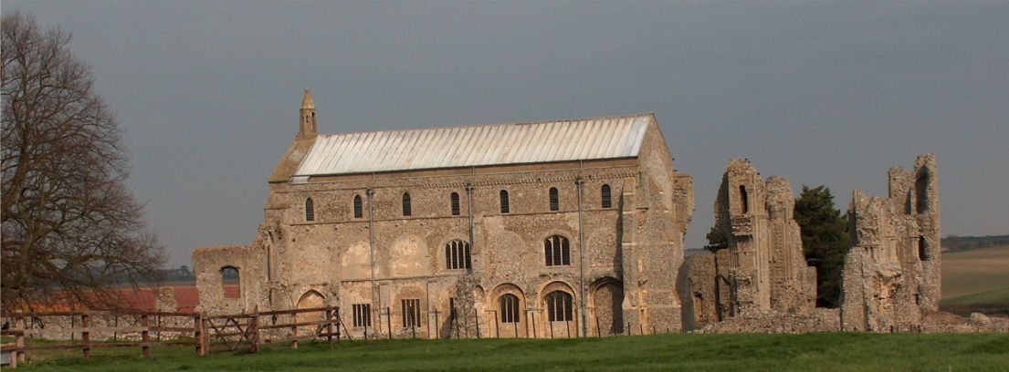
BINHAM PARISH COUNCIL
Parish Clerk – Sarah Hayden
53 Cromer Road, Lower Gresham
NR11 8RH
Tel: 01263 570223
Email: sarah352hayden@btinternet.com
https://binhampc.norfolkparishes.gov.uk

2022/4
DRAFT MINUTES OF THE PARISH COUNCIL MEETING 14th MARCH 2022 AT THE MEMORIAL HALL, BINHAM

Those Present Cllr. L. Brady (Chair), Cllr. L. Brown (Vice Chair), Cllr. K. Cooke, Cllr. H. Evans, and Cllr. P. Bailey.
In Attendance Mrs. S. Hayden (Clerk)
District Cllr. Richard Kershaw
5 Members of the Public

The Chair opened the meeting at 7.30pm

1. To receive and accept apologies for absence
Apologies received and accepted from Cllr. P. Alford (ill health). [Cllr. L. Wynder’s apologies were received following the meeting]
2. Declarations of Interest and any dispensations of disclosable pecuniary interests
Cllr. P. Bailey declared an interest in item 9 as a resident of Leeder’s Pightle.
3. Approval of Minutes of Parish Council Meeting held on 10th January 2022
Approved and signed by the Chair
4. Matters Arising
None
5. Reports
5.1 Norfolk County Council
No report had been received
5.2 North Norfolk District Council
District Councillor Kershaw was not in attendance at this point – see below. He had sent a report which was read out by the Clerk and is annexed to these minutes.
5.3. SAM2 Report
The Chair had circulated the SAM2 data, which is annexed to these minutes. She explained the analysis of the data.
5.4 Chair’s Report
The Chair reported the Covid numbers and advised that we still had to be mindful of the virus. Regarding planning, it was hoped that the issues with 2 The Green will shortly be over and the Green had been repaired and seeded. The Parish Council had made comment to the owner and would keep an eye on progress. Currently the footpath was blocked by pallets. The Parish Council still had to look at signs to remind people not to drive or park on the Green. There would be a meeting shortly in connection with the Jubilee celebrations. There was something proposed for each day, i.e. Thursday, Friday, Saturday and Sunday. There would be a concert and a special service at the Church. The Art Group would be producing special postcards and would have a Royal painting theme on display in the Memorial Hall. The organising committee were keen to use all spaces in the village and involve the younger element. They were keen to hold a village lunch and tea party. Finally, the parish council share of the Council Tax showed an increase, but it had been necessary to keep providing services.

5.2 District Councillor Kershaw had arrived and gave his further report
He reported that a development company called Zarah was planning to build exception housing in Field Dalling and was also trying in Thursford. He had checked the company at Companies House, but the figures
2022/5

there did not tie in with the capital they had stated they had. He had attended a Covid Engagement Board meeting, which would probably be the last one. The Covid figures were rising, but not in the ICUs.

6. Planning
6.1 To discuss and make observations on any application received after the date of this agenda
PF/22/0563 Installation of window to ground floor in east elevation – Westgate Old Farmhouse, Warham Road, Binham, NR21 0DQ – Discussed and agreed there were no objections.
6.2 Report from Planning Committee
The report had been circulated prior to the meeting.
New applications:
PF/22/0196 Two storey detached dwelling (previously approved under application PF/19/0002) (Plot 1 only) 10 Walsingham Road, Binham, NR21 0AP – The Parish Council had submitted comments in support
PF/22/0036 Installation of new UPVC frame window in rear elevation t ground floor rear new UPVC framed French doors in side elevation – Apple Garth, Langham Road, Binham, NR21 0DN – The Parish Council had submitted comments in support.
Pending applications since the January meeting
LA/21/3038 Works to remove paint from brickwork to the north wing of the Pottery House and its replacement with lime render and lime wash finish – The Pottery House, 41 Front Street, Binham NR21 0AL – Pending
PF/21/2926 Two storey side/rear extension to dwelling – 87 Warham Road, Binham, NR21 ODQ – Pending
PF/21/3284 Single storey extensions to side and rear of dwelling following demolition of conservatory; two storey rear extension dormers to front and formation of two window openings at first floor on rear elevation alterations to access – 25 Front Street Binham, NR21 0AL – Pending
Applications decided since November meeting
PF/21/0913 Single-storey extension; open porch to front; roof alterations, detached shed; new vehicular access and gates, boundary walls to replace hedge and fence – 5 The Green, Binham, NR21 0DD – Approved
PF/21/1262 & LA/21/1263 Construction of single storey extension to form garden room, internal alterations to create kitchen/breakfast room and installation of replacement staircase to serve the second floor - 2 Field Dalling Road, Binham - PF/21/1262 – Withdrawn LA/21/1263 - Approved
PF/21/3473 Extension and external alterations to detached garage to form annexe to serve as ancillary space to main house – Westgate Old Farmhouse, Warham Road, Binham, NR21 0DQ – Approved subject to condition “The annexe accommodation hereby approved shall be incidental to the use of the main dwelling and shall not be occupied at any time as a separate and un-associated unit of accommodation”

District Councillor Kershaw confirmed that the new Local Plan had been submitted, which triggered Regulation 19 so that it would now carry more weight. Building regulations would become stricter in June.

7. Finance and Regulatory
[All documents in this item had been previously circulated]
7.1 To approve List of Payments
As income over the budget had been received, a payment of £48 (including VAT) to the Clerk was agreed for attendance at a NALC Cemeteries Course. The List of Payments was then approved and signed by the Chair and Clerk
7.2 To receive the Budget, Balance Sheet and report on Bank Reconciliation
Balance Sheet and Budget received with no comments. Cllr. Brown reported that the bank reconciliation was correct.

8. To discuss support of Blakeney Parish Council in reopening of Blakeney Surgery
Discussed and agreed to ask for the face to face clinics to be reinstated as well as the continuance of medication collection.

9. To discuss bollard lighting at Leeders Pightle and agree any action
Cllr. Bailey stated that the lighting appeared not to be part of the planning application for the development, was not necessary as there were no steps or raised pavements and they interfered with dark skies. He had sent out a survey on behalf of the parish council, to 36 households. He had received 7 unqualified responses
2022/6

saying they did not want the lights, 2 qualified responses saying they don’t want the lights, but if they are to be retained, then they should be less bright and only lit until 11pm and 3 qualified responses saying that they do want them, but that they should be less bright and only lit until 11pm. 24 did not reply. A member of the public lived next to 8 incredibly bright lights on one side and 7 on the other side, although not all 7 were working. Her neighbours were also affected and there had been no discussion or consultation. Cllr. Bailey had been informed that Broadland Housing Association didn’t request the lights and Drakes (the electrical contractors) had said BHA had asked for them. They had been switched on on 17.2.22. Currently BHA had asked for those not working to be repaired. It had been confirmed the lights could all be turned off from a main switch. Norfolk Coastal Partnership had been contacted by a resident objecting to the lights and they had offered help under their Dark Skies Initiative. Discussed removal of lights, but considered the work would be considerable. Proposed and resolved that the Parish Council ask Broadland Housing Association not to repair those not working, but to turn the lights off and if they were not turned off to write to the NNDC enforcement team. Agreed Cllr. Bailey to draft letter to BHA and Clerk to draft letter to Enforcement Team.

10. Update and discussion on footpath registration
Cllr. Alford not in attendance, so this was postponed to the next meeting

11. Maintenance
11.1 Update on Village Sign painting
The sign had been collected for painting and painting was currently in progress.
11.2 To discuss ideas for future use of the telephone box maintenance
Postponed to the next meeting.

12. Correspondence
NNDC – Update on the outcome of the Binham-Hindringham Community Governance Review. The Bungalow, Foxburrow Farm had been re-designated into Hindringham parish from Binham.

13. Items for information only or next Agenda
Footpath and telephone box
The felling of cherry trees on Priory Crescent was discussed and a letter would be sent asking Victory Housing asking if they would be replaced. Parking on verges at Priory Crescent was discussed – clerk to add a request for a lay-by opposite the bungalows to the letter.
A member of the public asked if anyone other than the farm had right of way with vehicles on the footpath from the Buttlands to Walsingham. It was felt that the occupants of properties on Priory Crescent may do, but it was not known.

There being no further business the meeting closed at 9.05pm. There no cheques to sign.
The next meeting would be on Monday 9th May 2022

