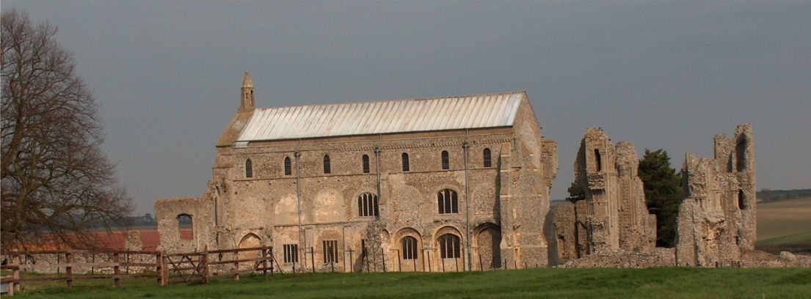
BINHAM PARISH COUNCIL
Clerk – Sarah Hayden
53 Cromer Road, Lower Gresham
NR11 8RH
Tel: 01263 570223
Email: sarah352hayden@btinternet.com
https://binhampc.norfolkparishes.gov.uk

Binham Parish Council Meeting
Members of the Council
You are summoned to attend a meeting of Binham Parish Council at the Memorial Hall, Binham
on Monday 14th March 2022 at 7.30pm
S. H. Hayden
Clerk
8th March 2022
The Public are welcome to attend this Parish Council meeting
Covid 19 precautions will be in place - please wear masks until seated and use hand sanitiser provided

AGENDA

1. To receive and accept apologies for absence
2. Declarations of Interest and any dispensations of disclosable pecuniary interests
3. Approval of the Minutes of Parish Council Meetings held on 9th November 2021
4. Matters Arising

5. Reports
5.1 Norfolk County Council
5.2 North Norfolk District Council
5.3 SAM2 Report
5.4 Chair’s Report

6. Planning
6.1 To discuss and make observations on any applications received after the date of this Agenda
6.2 Report from Planning Committee

7. Finance and Regulatory
7.1 To approve List of Payments
7.2 To receive balance sheet, Budget and report on Bank Reconciliation

8. To discuss support of Blakeney Parish Council in reopening of Blakeney Surgery

9. To discuss bollard lighting at Leeders Pyghtle and agree any action

10. Update on footpath registration

11. Maintenance
11.1 Update on Village sign painting
11.2 To discuss ideas for future use of telephone box

12. Correspondence

13. Items for Information Only or next Agenda

The next meeting will be on Monday 9th May 2022

