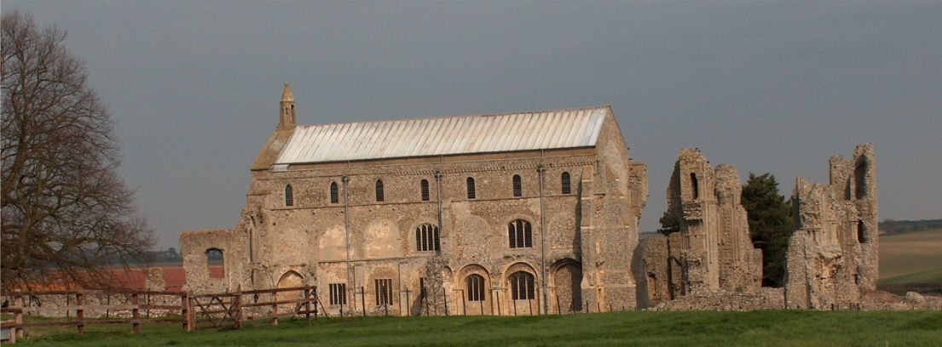
BINHAM PARISH COUNCIL
Parish Clerk – Sarah Hayden
53 Cromer Road, Lower Gresham
NR11 8RH
Tel: 01263 570223
Email: sarah352hayden@btinternet.com
https://binhampc.norfolkparishes.gov.uk

2022/1
MINUTES OF THE PARISH COUNCIL MEETING HELD ON
Tuesday 10th January 2022 AT THE MEMORIAL HALL, BINHAM

Those Present Cllr. L. Brady (Chair), Cllr. L. Brown (Vice Chair), Cllr. P. Alford, Cllr. P. Bailey, Cllr. L. Wynder
In Attendance Mrs. S. Hayden (Clerk)
County Councillor Dalby
District Cllr. Richard Kershaw
3 Members of the Public

The Chair opened the meeting at 7.30pm

1. To receive and accept apologies for absence
Apologies received and accepted from Cllr. H. Owen. County Councillor Dalby had sent apologies as he would be arriving late.
2. Declarations of Interest and any dispensations of disclosable pecuniary interests
None
3. Approval of Minutes of Parish Council Meeting held on 9th November 2021
Approved and signed by the Chair
4. Matters Arising
There would shortly be a meeting between the PCC, Memorial Hall Committee and Parish Council to discuss Jubilee arrangements. There had been a notification by email that funding available.
5. Reports
5.1 Norfolk County Council
Cllr. Dalby was not in attendance at this point – see below
5.2 North Norfolk District Council
District Councillor Kershaw was not in attendance at this point – see below
5.3 Chair’s Report
The Chair reported that regarding Covid, cases had increased from 850 – 1599/100,000 in N. Norfolk. In the whole of Norfolk there were 1513/100,000 and in Wells/Blakeney, cases had increased from 999/100,000 to 1,500. The message was to continue to take care. On other matters, there were vehicles driving across the Green in connection with building work. The Chair asked if there were any objections to signs being put up to ask the offenders not to drive on the Green. Agreed there were no objections. A Covid Memorial Plaque had been presented to the village at the Christmas supper and the Chair showed this and explained it would be put up in the foyer of the Memorial Hall, together with a framed card explaining why it had been presented.
5.2 District Councillor Kershaw had arrived and gave his report
He reported that The Reef visitors were up by 80% on the previous Splash and was very well used over Christmas. On Covid, he had attended a recent Covid Engagement Board meeting for Norfolk & Waveney. Norfolk and Waveney Health & Care Partnership had declared a critical incident. However, they were top of the table for the numbers of vaccination achieved. Cromer vaccination centre had closed as had Kelling and North Walsham. Castle Quarter had moved to City Hall. There was a shortage of tests and processing and critical care workers had been prioritised. Vaccinations for 5 – 11 years old were starting in two weeks. There were 244 cases in Hospitals with 5 in ICU. Those admitted had not had vaccinations.

2022/2

There were issues with some patients in Hospital not being able to leave as Adult Social Services did not have capacity to accommodate them. Virtual wards were running and will be expanded. General data shows that Omicron will start to decline by March and become endemic.

6. Planning
6.1 Report from Planning Committee
The report had been circulated prior to the meeting.
New applications:
PF/21/3284 Single storey extensions to side and rear of dwelling following demolition of conservatory; two storey rear extension dormers to front and formation of two window openings at first floor on rear elevation alterations to access – 25 Front Street Binham, NR21 0AL – Cllrs. Alford reported that she and Cllr. Brady had visited the property and she outlined the application generally. The only concern was the distance of the extension to the first two houses in Priory Crescent, which had small gardens although one has a side garden. The Clerk read out an email from the applicant on this. The application would not affect the other properties in Priory Crescent as 25 Front Street has a large garden. The other point noted was that one of the old pillars to the drive was being removed to allow better access. The applicant had spoken to all those affected. Cllr. Alford would compile comments and circulate to parish councillors for approval.
PF/21/3473 Extension and external alterations to detached garage to form annexe to serve as ancillary space to main house – Westgate Old Farmhouse, Warham Road, Binham, NR21 0DQ – Cllr. Alford explained this application was to convert an the garage into an annexe. The property had been completely remodelled in 2012, with a new garage being built. The application was discussed. Cllr. Alford would compile comments to be circulated for approval to parish councillors.
Pending applications since the November meeting
PF/21/0913 Single-storey extension; open porch to front; roof alterations, detached shed; new vehicular access and gates, boundary walls to replace hedge and fence – 5 The Green, Binham, NR21 0DD – Cllr. Kershaw had checked progress and on 23rd December, it was in a position to be finalised. The Conservation Officer was happy with the wall and with the extension if built with the same materials. There would be a condition to plant four new trees and roof tiles had been specified. The churning of the Green by the skip was discussed and it was noted that all grass had been worn from the footpath at the side. Cllr. Kershaw felt it would be approved.
LA/21/3038 Works to remove paint from brickwork to the north wing of the Pottery House and its replacement with lime render and lime wash finish – The Pottery House, 41 Front Street, Binham NR21 0AL – Pending
PF/21/2926 Two storey side/rear extension to dwelling – 87 Warham Road, Binham, NR21 ODQ – Pending
PF/21/1262 & LA/21/1263 Construction of single storey extension to form garden room, internal alterations to create kitchen/breakfast room and installation of replacement staircase to serve the second floor - 2 Field Dalling Road, Binham - Pending
Applications decided since November meeting:
PF/21/2145 Formation of additional window openings at first floor level in east elevation – Westgate Old Farmhouse, Warham Road, Binham – Approved
6.2 To discuss and make observations on any applications received after the date of this Agenda
Dealt with under item 7.1 above

5.1 County Councillor Michael Dalby had arrived by this point and gave his report in précis, which had been previously circulated and is annexed to these minutes. Cllr. Dalby then answered questions on vaccinations and highways matters, including obscured signage, potholes, drainage and mud on roads, which he agreed to assist with.

Cllr. Dalby then made his apologies and left the meeting.

7. Finance and Regulatory
[All documents in this item had been previously circulated]

2022/3

7.1 To approve List of Payments
The List of Payments was approved and signed by the Chair and Clerk
7.2 To receive the Balance Sheet and report on Bank Reconciliation
Balance Sheet received with no comments. Cllr. Brown reported that the bank reconciliation was correct.

8. Speeding in Binham
8.1 To receive the latest SAM2 data
The figures had been circulated, but appeared to be incorrect and would be checked and circulated after the meeting.
8.2 To discuss Speedwatch Community Team in co-operation with Hindringham and Langham parishes
Discussed in detail, including the effect of SAM2 signs in comparison with Speedwatch. There had been a request for volunteers in the Lynx, but no-one had come forward. A member of the public asked what was involved and this was explained. Agreed, as there were no volunteers, the situation would be reviewed in a year. Agreed to ask Hindringham Parish Council if they could give the dates of Speedwatch at Moorgate, so the SAM2 data could be used to check any effect on speeds on the Hindringham Road into the village.

9. Update and discussion on footpath registration
Cllr. Alford would progress the matter shortly.

10. Maintenance
10.1 Update on Village Sign painting
The sign had been repaired and was awaiting collection for painting. The bill for repair had been paid by the History Group
10.2 Update on telephone box maintenance and discuss ideas for future use
A village resident had kindly offered to contribute to the preparation of any work needed for the use of the telephone box. She wished to retain a low profile and the details would be kept on file for when the painting had been completed in the summer and a decision had been made for its use.

11. Correspondence
A Christmas Card had been received from County Councillor Dalby
A resident of Leeder Pightle was having problems with bright lights on the footpaths shining into her property, but Broadland Housing Association were now dealing with it. Cllr. Bailey agreed they were very bright, with 360 degree light. He suggested black tape on one side to deflect some light.

12. Items for information only or next Agenda
A member of the public was thanked for organising the Christmas lights on the Green.

There being no further business the meeting closed at 8.50pm. There no cheques to sign.

The next meeting would be on Monday 14th March 2022

