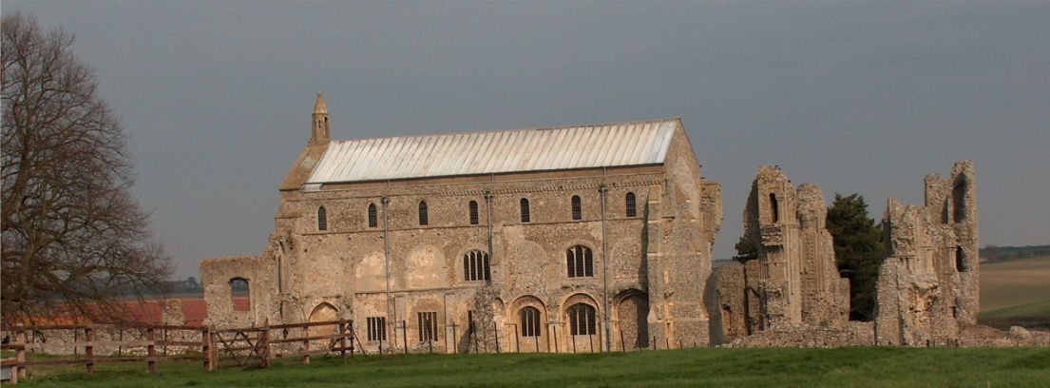
BINHAM PARISH COUNCIL
Clerk – Sarah Hayden
53 Cromer Road, Lower Gresham
NR11 8RH
Tel: 01263 570223
Email: sarah352hayden@btinternet.com
https://binhampc.norfolkparishes.gov.uk

Binham Parish Council Meeting
Members of the Council
You are summoned to attend a meeting of Binham Parish Council at the Memorial Hall, Binham
On Monday 10th January 2022 at 7.30pm
S. H. Hayden
Clerk
4th January 2022
The Public are welcome to attend this Parish Council meeting
Covid 19 precautions will be in place - please wear masks until seated and use hand sanitiser provided

AGENDA

1. To receive and accept apologies for absence
2. Declarations of Interest and any dispensations of disclosable pecuniary interests
3. Approval of the Minutes of Parish Council Meetings held on 9th November 2021
4. Matters Arising

5. Reports
5.1 Norfolk County Council
5.2 North Norfolk District Council
5.3 Chair’s Report

6. Planning
6.1 Report from Planning Committee
6.2 To discuss and make observations on any applications received after the date of this Agenda

7. Finance and Regulatory
7.1 To approve List of Payments
7.2 To receive balance sheet and report on Bank Reconciliation
7.3 To appoint internal auditor for 2020-21 accounts

8. Speeding in Binham
8.1 To receive latest SAM2 data
8.2 To discuss Speedwatch Community Team in co-operation with Hindringham and Langham parishes

9. Update on footpath registration

10. Maintenance
10.1 Update on Village sign painting
10.2 Update on Telephone Box maintenance and discuss ideas for future use

11. Correspondence
12. Items for Information Only or next Agenda

The next meeting will be on Monday 14th March 2022

