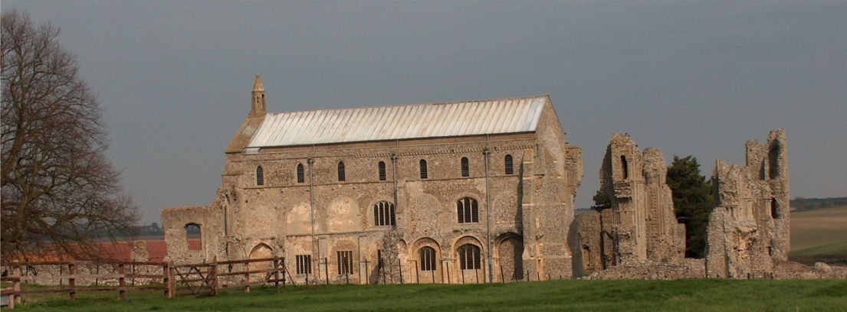
BINHAM PARISH COUNCIL
Parish Clerk – Sarah Hayden
53 Cromer Road, Lower Gresham
NR11 8RH
Tel: 01263 570223
Email: sarah352hayden@btinternet.com
https://binhampc.norfolkparishes.gov.uk

2021/19
MINUTES OF THE PARISH COUNCIL MEETING HELD ON
Tuesday 9th NOVEMBER 2021 AT THE MEMORIAL HALL, BINHAM

Those Present Cllr. L. Brady (Chair), Cllr. L. Brown (Vice Chair), Cllr. P. Alford, Cllr. P. Bailey and Cllr. K. Cooke
In Attendance Mrs. S. Hayden (Clerk)
District Cllr. Richard Kershaw
4 Members of the Public

The Chair opened the meeting at 7.35pm

1. To receive and accept apologies for absence
Apologies received and accepted from Cllr. l. Wynder (work training)
2. To co-opt Parish Councillor and signing of Acceptance of Office
Proposed and resolved to co-opt Paul Bailey to the Parish Council. He then signed an Acceptance of Office
3. To receive declarations of interest
None
4. Approval of Minutes of Parish Council Meeting held on 13th September 2021 and 16th August 2021
Both sets of minutes were approved and then signed by the Chair
5. Matters Arising
The grant application for Clerk training had been refused, but she would pay for the training on cemetery matters herself and attend a course next February. The Chair reported that the defibrillator training had gone very well and one session had been held. A collection for East Anglian Air Ambulance at the end of the session had raised £92.
6. Reports
6.1 Norfolk County Council
Cllr. Dalby was not in attendance
6.2 North Norfolk District Council
District Councillor Kershaw reported that he had attended a recent county board meeting on Covid 19 and there was some concern expressed at the figures. The roll out of vaccines for 12 – 15 yrs was slow, as the contract had been sent out for tender and was won by Herts CCG who were having trouble with the distance from the area. The figures for that age group were rising, which in turn was causing a rise in the over 60s due to family connections. Wells had started the booster vaccines. 80% of over 12’s had received their first dose and 78% their second dose. Last January there had been 800 in Hospital with Covid 19 and there were now 900 in Hospital but much lower numbers in intensive care. 94% of over 18s had received their first dose and 90% had received their second dose. Currently, 46% had received a booster vaccination and there would be a new booster vaccination centre at Kelling. The vaccination situation was confusing as people thought they would be called for a vaccine by their surgeries but that was incorrect and they had to actually book for their booster. Those in care homes should be fully vaccinated by the end of November. Norfolk schools were being advised to keep wearing masks. On other matters, a Director of Place, Martyn Fulcher, had been appointed to head up Sustainable Growth and Planning at NNDC. The handover of The Reef should be taking place on Thursday. This had been delayed to difficulties obtaining certain materials. There would be a soft opening through December and a full opening in January. There were three pools, a gym, a spin room and a café. It had been built with green credentials. Discussion followed on vaccinations, bookings and drop-in centres.

2021/20

The Chair agreed to discuss planning application PF/21/0913 - 5 The Green, Binham, at this point, while Cllr. Kershaw was present.

Cllr. Alford explained that the decision was still pending, although work was continuing on the property prior to approval. The Parish Council were concerned about the height of the wall and the level that the height measurements were taken from. The wall being built had blocked the view of the Green from the path to the Green from Front Street. There was also a small wall that had been built in the garden that was not on the application plans. Currently the architect had been asked to submit material details. As the property was in prominent position on the Green, these points were important. Cllr. Kershaw offered to bring the matter to the attention to Martyn Fulcher and this would be easier if Cllr. Alford could forward photos. The Chair explained that the Parish Council tried to be consistent with planning applications and proceeding with building work without approval did not send out a very good message, although it was acknowledged that approval had taken a considerable time. The current position outlined in an email to the Chair was that the requested materials details had been emailed to the Conservation Officer the day before, for his comments. Questions of enforcement were then discussed. Cllr. Kershaw also offered to check on the progress of PF/21/1263 - 2 Field Dalling Road, Binham, which had been “pending” for some time.

Cllr. Kershaw was then thanked for his help and he left the meeting

6.3 Chair’s Report re: SAM2
The Chair reported that, as in her article in the Lynx, it was important not to let our guard down regarding the spread of Covid 19. She understood that cases in Wells and Blakeney had risen by 50/75%, but the numbers were low prior to that. Norfolk cases are between 200/300 cases per 100,000 and we are at the lower end, but neighbouring areas with higher levels. Hopefully, children and the third booster vaccinations will be rolled out quickly. The Parish Council have been hugely busy on the planning side and are trying to be as careful and consistent as possible.

7. Planning
7.1 Report from Planning Committee
The report had been circulated prior to the meeting.
New applications:
There had been one new application since the September meeting.
PF/21/2926 Two storey side/rear extension to dwelling – 87 Warham Road, Binham, NR21 ODQ – This appeared to be the second application of the same type, although the first application had been approved. The differences were discussed and it was agreed that Cllr. Alford would draft comments and circulate them to the parish councillors for approval before they were submitted by the Clerk
Pending application since the September meeting
Three applications were still pending as follows:
PF/21/2145 Formation of additional window openings at first floor level in east elevation – Westgate Old Farmhouse, Warham Road, Binham – Pending, but there appears to also be a pre-application with no details supplied.
PF/21/0913 Single-storey extension; open porch to front; roof alterations, detached shed; new vehicular access and gates, boundary walls to replace hedge and fence – 5 The Green, Binham, NR21 0DD – See item 6.2 above
PF/21/1262 & LA/21/1263 Construction of single storey extension to form garden room, internal alterations to create kitchen/breakfast room and installation of replacement staircase to serve the second floor - 2 Field Dalling Road, Binham - Pending
Applications decided since September meeting
PF/21/1836 & LA/21/1850 Dormer to rear elevation, external alterations – 14 Front Street, Binham – Approved. The applicant had been working pro-actively with the Parish Council as work started and Cllr. Alford had been invited to visit the property, which helped when dealing with queries that arise.

2021/21

A member of the public asked if the Parish Council would support him planting fruit trees on the footpath from the Memorial Hall to Walsingham Road near to the new development. Cllr. Alford replied that the Parish Council could not give permission as such, but she would send a copy of the Ecology Report to him as that had included advice on the planting of the hedge on that footpath and suggested he should contact Norfolk County Council as they were responsible for the maintenance of rights of way. It was not known who owned the freehold.

It was noted that three cherry trees at Priory Crescent had been felled. Cllr. Owen had tried to contact Victory Housing to ask the reason and was told that one was dead, one in decline and one damaged. The tree stumps looked healthy. She had been informed that they would be replaced. Agreed the Chair would contact Victory Housing for a more detailed explanation.
7.2 To discuss and make observations on any applications received after the date of this Agenda
PF/21/2926 dealt with under item 7.1 above

8. Finance and Regulatory
[All documents in this item had been previously circulated]
8.1 To approve List of Payments
It was agreed to donate £25 to the British Legion for the wreath. List of Payments approved and signed by the Chair and Clerk
8.2 To receive the Balance Sheet and report on Bank Reconciliation
Balance Sheet received with no comments. Cllr. Brown reported that the bank reconciliation was correct.
8.3 To review the Budget and set precept for 2022-23
The draft Budget was discussed in detail and it was proposed and resolved to increase the precept to £7,500. It was noted that this would be a high percentage increase of 16% but it was necessary as otherwise the Parish Council would be severely underfunded. The following financial year should see a much lower percentage increase in line with recommended levels.
8.4 To approve Contract of Employment for Clerk
The draft Contract was approved and signed by the Chair.
8.5 To approve updated Data Protection Policy
Proposed and resolved to approve the amended Policy

9. Speeding in Binham
9.1 To receive the latest SAM2 data
The Chair explained the latest figures, giving an update on the most recent data
9.2 To discuss Speedwatch Community Team in co-operation with Hindringham and Langham parishes
The Chair explained that she had attended the preliminary meeting with representatives from Langham and Hindringham Parish Councils, to discuss the three villages joining forces to assist each other. Hindringham already had a Speedwatch Team. Langham were thinking of setting one up. Steve Dye, the Chair of Hindringham Parish Council then outlined the background to setting up the Hindringham Team. He explained that if there were 18 recorded vehicles speeding in 30 days, the County Team are obliged to attend and they could issue tickets. Vehicle speeds were recorded by the Speedwatch Team and sent to Police administration, with letters being sent out and in higher speeding cases, the Engagement Officer may speak to the offenders. Police had also attended in Hindringham following the Speedwatch Team reporting figures. Therefore, to get the Police County Team to attend, figures have to be provided. He would be happy to assist Hindringham and Langham to set up their Teams. He had discussed with the local inspector getting all 93 Teams in the County out on the same day to raise the profile of the problem of speeding. Discussion followed. Agreed the Parish Council would consider the matter and then decide. The Chair thanked Mr. Dye for his explanation and offer of help.

10. Update and discussion on footpath registration
Cllr. Alford apologised, but she had not progressed the matter, but would do so shortly.

2021/22

11. To discuss plans for Queens Jubilee in 2022
The Parish Council would arrange a meeting with the other organisations in the village, for a date before Christmas.

12. Maintenance
12.1 Update on Village Sign painting
12.2 Update on Telephone Box maintenance
Items 12.1 and 12.2 were dealt with together.

Quotes had been received for both projects. The cost of repairing the sign ready for painting would be £400 and the painting would be £700. The cost of repairing and painting the telephone box would be £1,500. The painter had repaired and painted the telephone box at Stiffkey. The History Group had kindly offered a donation in the region of £1,000 towards the costs and it had been proposed to try to obtain a grant for the balance of the costs. However, Cllr. Brown had asked most members of the Memorial Hall Committee if they would be prepared to contribute towards the cost of the work to the telephone box and had received supportive replies. This would be discussed at the next Committee meeting. It was agreed that the Committee input on the use of the Telephone Box would be welcomed. Agreed to await the decision of the Committee.

13. Correspondence
A “thank you” letter had been received from East Anglian Ambulance Service for the donation, following the defibrillator training session.

14. Items for information only or next Agenda
The Clerk and Chair had checked the Parish Council’s assets and the only items needing attention, apart from the village sign and telephone box, were the bus shelter repainting and replacement of rotten allotment fence posts. There was also a missing rod on the grit bin, which the Chair would deal with.

There being no further business the meeting closed at 10pm and the approved cheques were signed.

The next meeting would be on Monday 10th January 2022

