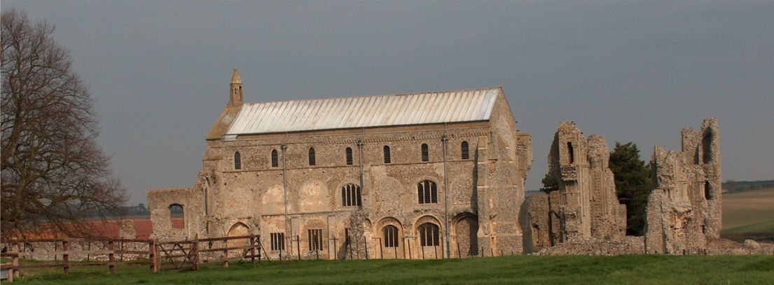
BINHAM PARISH COUNCIL
Clerk – Sarah Hayden
53 Cromer Road, Lower Gresham
NR11 8RH
Tel: 01263 570223
Email: sarah352hayden@btinternet.com
https://binhampc.norfolkparishes.gov.uk

Binham Parish Council Meeting
Members of the Council
You are summoned to attend a meeting of Binham Parish Council at the Memorial Hall, Binham
On Tuesday 9th November 2021 at 7.30pm
S. H. Hayden
Clerk
2nd November 2021
The Public are welcome to attend this Parish Council meeting
Covid 19 precautions will be in place - please wear masks until seated and use hand sanitiser provided

AGENDA

1. To receive and accept apologies for absence
2. To co-opt Parish Councillor and signing of Acceptance of Office
3. To Receive Declarations of Interest
4. Approval of the Minutes of Parish Council Meetings held on 13th September 2021
5. Matters Arising

6. Reports
6.1 Norfolk County Council
6.2 North Norfolk District Council
6.4 Chair’s Report

7. Planning
7.1 Report from Planning Committee
7.2 To discuss and make observations on any applications received after the date of this Agenda

8. Finance and Regulatory
8.1 To approve List of Payments
8.2 To receive balance sheet and report on Bank Reconciliation
8.3 To review Budget and set precept for 2022-23
8.4 To approve Contract of Employment for Clerk
8.5 To approve updated Data Protection Policy

9. Speeding in Binham
9.1 To receive latest SAM2 data
9.2 To discuss Speedwatch Community Team in co-operation with Hindringham and Langham parishes

10. Update on footpath registration
11. To discuss plan for Queens Jubilee in 2022

Maintenance
12.1 Update on Village sign painting
12.2 Update on Telephone Box maintenance and future use

13. Correspondence
14. Items for Information Only or next Agenda

The next meeting will be on Monday 13th January 2023

