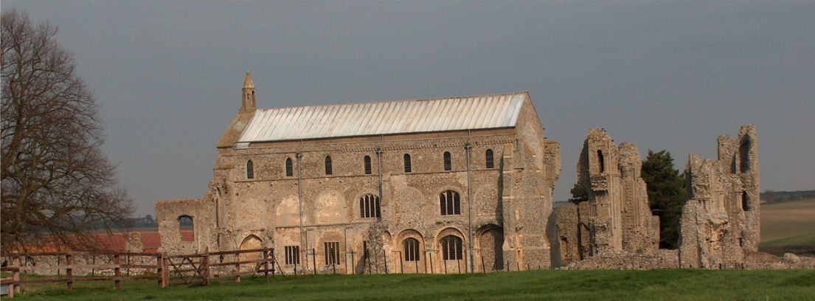
BINHAM PARISH COUNCIL
Parish Clerk – Sarah Hayden
53 Cromer Road, Lower Gresham
NR11 8RH
Tel: 01263 570223
Email: sarah352hayden@btinternet.com
binhampc.norfolkparishes.gov.uk

2021/15
MINUTES OF THE PARISH COUNCIL MEETING HELD ON
THURSDAY 13th SEPTEMBER 2021 AT THE MEMORIAL HALL, BINHAM

Those Present Cllr. L. Brady (Chair), Cllr. L. Brown (Vice Chair), Cllr. P. Alford and Cllr. L. Wynder
In Attendance Mrs. S. Hayden (Clerk)
District Cllr. Richard Kershaw
3 Members of the Public

The Chair opened the meeting at 7.32pm

1. To receive and accept apologies for absence
Cllr. H. Owen (meeting clash), Cllr. K. Cooke
2. To co-opt Parish Councillor and signing of Acceptance of Office
To be held over until the next meeting
3. To receive declarations of interest
None
4. Approval of Minutes of Parish Council Meeting held on 12th July 2021 and 16th August 2021
Both sets of minutes were approved and signed by the Chair
5. Matters Arising
None
6. Reports
6.1 Norfolk County Council
Cllr. Dalby was not in attendance
6.2 North Norfolk District Council
District Councillor Kershaw reported firstly, on Covid 19. The figures were low and numbers in ICU had decreased from 11 to 9 although it was expected there would be an increase now schools had returned. Leicester schools, who had returned earlier than Norfolk had been tracked, as well as figures from Latitude and Sundowner festivals, and all were lower than expected. 89% of people over 16 years old had been vaccinated and 83% with a second dose. 50% aged 16 – 18 years had been vaccinated. Those aged 12 – 15 years had the option of a single Pfizer vaccination. There had been no problems with the supply and delivery of doses. On other matters, it had been a busy tourist season, which had necessitated increased rubbish collections and increased toilet cleaning, with problems caused by too many motorhomes stopping overnight in car parks causing problems. Several had asked for stopping places on the roads as provided on the continent, but were told there were enough holiday parks to cater for them and that type of facility would not be provided in this area. Serco were in their first year of their waste management contract and NNDC had been pleased with their performance. The Reef was now nearing completion and should be open in a couple of weeks. The Government White Paper on planning had received criticism. The devolution matter had raised its head again with joint Norfolk and Suffolk council being proposed. There was a new “Director of Place”, Martin Fulcher, who was responsible for planning and performance improvements in that department should be taking place.

Cllr. Alford raised a question on sustainable growth in connection with the Egmere site and Cllr. Kershaw assured the meeting that despite Equinor having to relocate, there were other plans in the pipeline to fill the vacancy left.

2021/16
6.3 Chair’s Report re: SAM2
The Chair gave her report on the data gathered which is annexed to these Minutes. It was proposed to organise a meeting with Hindringham and Langham Parish Councils to co-ordinate a joint effort to tackle speeding. A joint Speedwatch group may be the way forward.
6.4 Chair’s Report
The Chair reported that the Parish Council had had a busy two months since the last meeting, mainly in connection with planning. She thanked Cllr. Kershaw for his help on various matters that had arisen. Continuing on planning, she confirmed that the Parish Council felt it was important to preserve the village conservation wise, while supporting modern living. It was also important to be consistent on all applications. On Covid, she felt that the vaccination programme had been stupendous. Cases were rising, but Cllr. Kershaw agreed, but said that the severity was not as bad. She advised that we still had to be careful and maybe continue lateral flow tests one or twice a week.

7. Planning
7.1 Report from Planning Committee
The report had been circulated prior to the meeting.
After reporting a quiet period at the July meeting, there had then been a very busy period with applications

New applications:
PF/21/1836 & LA/21/1850 Dormer to rear elevation, external alterations – 14 Front Street, Binham – The Parish Council had no objection to this application and commented that it is in very poor condition and as a Grade II listed building needed urgent sympathetic renovation and overall improvement to enhance its prominent position in the Conservation Area. Pending NNDC decision
RV/21/1857 Variation of Condition 2 (approved plans) of planning reference PF/20/1954 to allow revised loft layout, excavation to increase height of ground floor, repositioning of roof lights and insertion of window on north elevation - Land to rear of 49 Priory Crescent – The Parish Council had submitted comments with no objection – Approved by NNDC
PF/21/1751 Change of use of land from pasture for grazing for horses and sheep to a camping and caravan site, shower and toilet blocks and new site entrance – Manor Farm, Cockthorpe - The Parish Council had called an extraordinary meeting on 16th August to discuss this application in detail, with the applicants and interested parties present – see minutes of meeting for comments. The application had since been withdrawn. Cllr. Kershaw had spoken with the applicant.
PF/21/2145 Formation of additional window openings at first floor level in east elevation – Westgate Old Farmhouse, Warham Road, Binham – The Parish Council submitted no objection, with comments suggesting opaque windows for bathroom areas. Pending NNDC decision
PF/21/0913 Construction of single storey outbuilding to front of dwelling (retrospective) - 8 The Green, Binham – an application had been received. The Parish Council had no objections and the application had been approved by NNDC.

Applications pending since last meeting
PF/21/0913 Single-storey extension; open porch to front; roof alterations, detached shed; new vehicular access and gates, boundary walls to replace hedge and fence – 5 The Green, Binham, NR21 0DD – The Parish Council’s comments had been submitted with no objection to the extension, roof works, internal works, repositioning of driveway and new shed, but concern was expressed over the height of the new wall and gates. Concern had since been raised by the Parish Council, as the work had been commenced prior to approval and it was felt that some materials being used may not fit in the with local vernacular style within the Conservation Area. A new design for the wall had recently been submitted and the Parish Council had submitted their comments on that. The Conservation and Design Officer had asked for conditions to be placed on material submissions before approval is granted. Pending NNDC decision.
PF/21/1262 & LA/21/1263 Construction of single storey extension to form garden room, internal alterations to create kitchen/breakfast room and installation of replacement staircase to serve the second floor - 2 Field Dalling Road, Binham – This could not be seen from the road and therefore there was no objection, but the Parish Council did ask for traffic management and no parking on the Green conditions. Pending NNDC decision. Conservation and design officer does not support the application.

2021/17
7.2 To discuss and make observations on any applications received after the date of this Agenda
None

8. Finance and Regulatory
8.1 To approve List of Payments
The amount of £320 for grass cutting was added to the List, which was approved and signed by the Chair and Clerk
8.2 To receive the Balance Sheet and report on Bank Reconciliation
Balance Sheet received with no comments. Cllr. Brown reported that the bank reconciliation was correct.
8.3 To approve Contract of Employment for Clerk
To be held over to the next meeting

9. Update on adoption of red telephone box
The Clerk reported that purchase had gone through and the Parish Council now owned the telephone box.
The use of the box was discussed, including tourist information, seed exchange and book exchange. Cllr. Alford would be arranging for the electrics to be checked and a quote had been requested for the painting. It was agreed that the replacement windows would be clear glass and the painter could provide those. He would take all the glass out before painting and replacing it. The door needed easing and the Clerk would ask the painter if he could deal with that work. Clerk to ask the owner of the land if we could maintain the small area surrounding the box.

10. Update and discussion on footpath registration
Cllr. Alford circulated a report on the history of the path which appeared to be “no man’s land” and explained the reason the Parish Council should consider registering it. Resolved to go ahead with registration. Norfolk County Council had provided the paperwork/documents required to proceed. All agreed that there should be at least the twelve people willing to give the required statements confirming their use of the footpath over at least twenty years and Cllr. Alford would approach those she knew. Several offers to provide statements had already been received.

11. To discuss support for Norfolk parish movement for Offshore Transmission Network for Windfarms
Discussed and resolved to support the movement

12. To discuss plans for Queens Jubilee in 2022
Postponed to next meeting

13. Update on draft flood plan for village
The Chair reported that after investigations and inspections around the village, it had been concluded that there was no risk of flooding from the river and any flooding on the roads was due to blocked drains/gulleys. It was agreed that the parish councillors would regularly check these and report any that needed clearing. The Parish Council would also follow up comments submitted by farmers and see if any improvements could be made to ditches. Signs may be needed to warn of flooding across roads.

14. Update on Village Sign painting
The Clerk had made various enquiries and to date, a carpenter had agreed he could repair the sign in his workshop, but had not yet give a quote for the work. He would consider painting, but it was not his type of work. The person prepared to quote for painting the telephone box would also look at the sign and quote if he was able to deal with the painting.

15. Update on defibrillator training
Two training sessions had been arranged for 19th October 2021 in the Memorial Hall during mid-afternoon and early evening. There was a limit of twenty people for each session. The Chair and her husband would prepare the Notices and post them on the Noticeboards.

2021/18

15. Items for information only or next Agenda
1. Details had been submitted in connection with a Covid Memorial Token being distributed by NALC
2. The Clerk had submitted a grant application to fund a NALC cemetery training session
3. A check of highway signs would be done by all the parish councillors and results submitted to Highways
4. A “thank you” letter had been received from Lynx, which the Clerk read out.
5. A request had been received for the Parish Council to consider an electric charging point in the village. This had been discussed at a past meeting, but the cost of installing one had been considered too prohibitive, particularly as two types would be needed.

Next Agenda: Queens Jubilee (5th – 9th June) - An open meeting would be held involving all village organisations and residents

There being no further business the meeting closed at 9.30pm and the approved cheques were signed.

The next meeting would be on 9th November 2021 – NOTE THE MEETING WILL BE ON A TUESDAY NOT MONDAY

