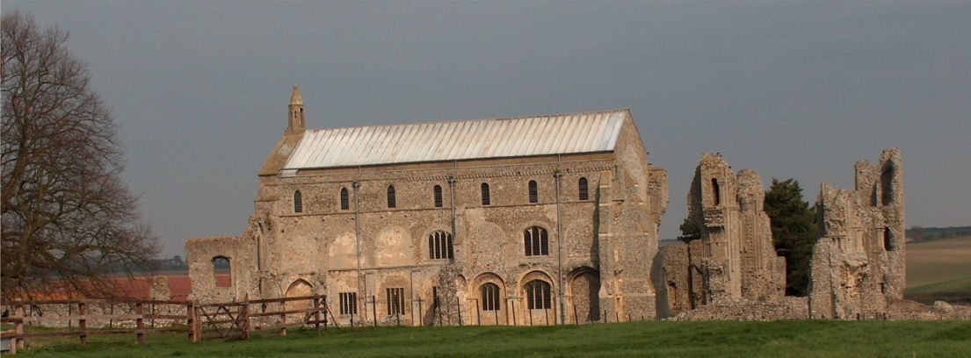
BINHAM PARISH COUNCIL
Clerk – Sarah Hayden
53 Cromer Road, Lower Gresham
NR11 8RH
Tel: 01263 570223
Email: sarah352hayden@btinternet.com
binhampc.norfolkparishes.gov.uk

Binham Parish Council Meeting
Members of the Council
You are summoned to attend a meeting of Binham Parish Council at the Memorial Hall, Binham
Monday 13th September 2021 at 7.30pm
S. H. Hayden
Clerk
4th September 2021
The Public are welcome to attend this Parish Council meeting
Covid 19 precautions will be in place - please wear masks until seated, use hand sanitiser provided and provide details for Track & Trace/QR code available

AGENDA

1. To receive and accept apologies for absence
2. To co-opt Parish Councillor and signing of Acceptance of Office
3. To Receive Declarations of Interest
4. Approval of the Minutes of Parish Council Meetings held on 12th July 2021 and 16th August 2021
5. Matters Arising

6. Reports
6.1 Norfolk County Council
6.2 North Norfolk District Council
6.3 Chair’s Report re: SAMS
6.4 Chair’s Report

7. Planning
7.1 Report from Planning Committee
7.2 To discuss and make observations on any applications received after the date of this Agenda

8. Finance and Regulatory
8.1 To approve List of Payments
8.2 To receive balance sheet and report on Bank Reconciliation
8.3 To approve Contract of Employment for Clerk

9. Update on adoption of red telephone box
10. Update and discussion on footpath registration
11 To discuss support for Norfolk parish movement for Offshore Transmission Network for Windfarms
12. To discuss plan for Queens Jubilee in 2022
13. Update on draft flood plan for village
14. Update on Village sign painting
15. Update on defibrillator training
16. Items for Information Only or next Agenda

The next meeting will be on Tuesday 9th November 2021 - PLEASE NOTE NOT MONDAY

