BINHAM PARISH COUNCIL
Coronavirus

It is 19th July 2021; the sun is shining showing off our wonderful landscape. The birds are still busy and constantly chattering as they go about their ‘daily routines’, the hedgerows and verges growing like topsy ready to be trimmed and tidied up, a job for the PC especially along the path on Warham road.

We have moved out of the National Lockdown today with all legal restrictions relaxed. BUT and a very big BUT we have been asked to remain cautious and take personal responsibility through informed choice to protect ourselves and neighbours alike as COVID cases continue to rise across the country including Norfolk.

As of July 19th, most legal restrictions to control COVID-19 have been lifted at Step 4 and summarised below.
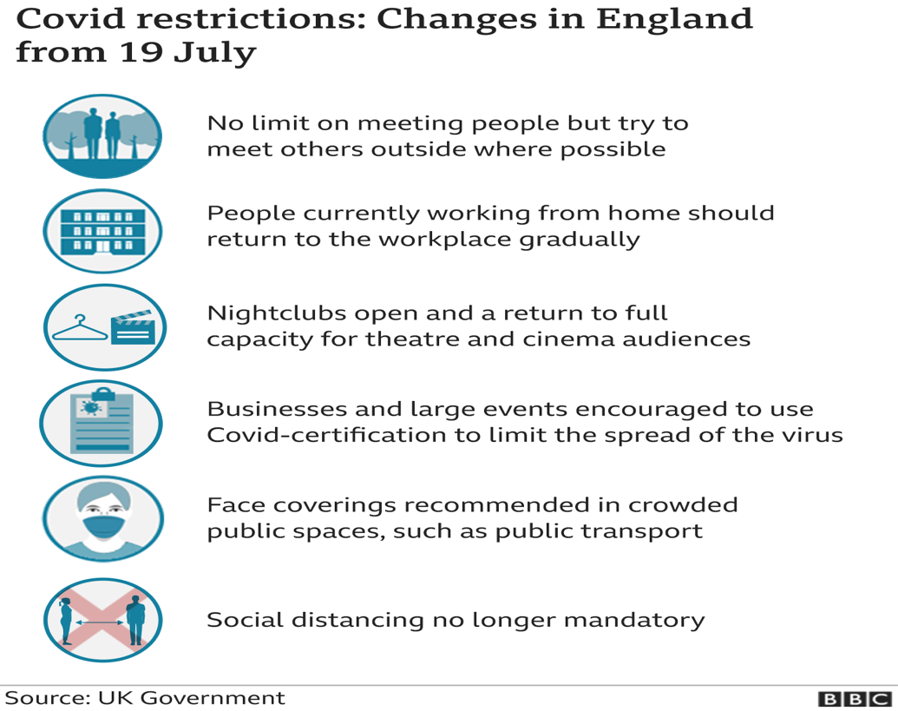

However, the GOVERNMENT is keeping in place key protections :
- testing when you have symptoms and targeted asymptomatic testing in education, high risk workplaces and to help people manage their personal risk.
- isolating when positive or when contacted by NHS Test and Trace.
- border quarantine: for all arriving from red list countries and for those people not fully vaccinated arriving from amber list countries.
(https://www.gov.uk/guidance/covid-19-coronavirus-restrictions-what-you-can-and-cannot-do)

Do please remember that COVID-19 has not gone away. It is really important to remember those actions we can take to keep ourselves and others safe. Collectively, we all need to continue to act carefully and remain cautious until the current surge has subsided, and a balance has been achieved to live with COVID.
All of the above reminds me that might still apply!
Village News:

‘Things’ are slowing returning to some sort of normality, but caution is off the essence when out and about and socialising for the foreseeable future.

The Priory Church of St Mary and the Holy Cross is open to the public from 10am to 5pm every day. A cautious approach is being taken to getting back to normality and we would ask visitors to respect the possible sensitivity of others and keep some distance when looking round.

In August there will be three services, all starting at 11am: Sunday 1st Holy Communion, Sunday 8th Morning Prayer and Sunday 15th Morning Prayer. On Sunday 29th at Gunthorpe, there will be a Group Communion Service starting at 10.30am.

On Saturday 7th August there will be two concerts of music by Bach and Handel performed by the Brook Street Band at 4pm and the programme repeated at 6.30pm. There will be limited seating for each, with clear separation. All seats must be pre-booked at £20 to include a glass of wine or fruit juice. Contact Maureen Frost 01328 830362 or davidfrost226@btinternet.com

ZOOM SERVICES - Zoom Evensong at 5pm on first Sunday of the month will continue (no service Sunday 1st August). Everyone is welcome! To participate please telephone Ian Newton on 01328 830947 or email iannewton46@gmail.com.

The Chequers Inn - The Chequers Inn will be open outside and in the gallery area throughout the summer on a Friday, Saturday, Sunday, Monday and Tuesday, from 12 until 9. Food and takeaways will be available 12 until 8. Booking is advisable either on 01328 830297 or via binhamchequersinn.co.uk. We look forward to seeing you soon.

Village Hall - The hall is now open for bookings and most of the usual groups, clubs etc are pleased to be able to meet up again. Although, we do ask people not to forget about the virus and still take care. Booking can be made by ringing Liz. 07435788221.

Some reminders to keep the village safe at all times during the summer

Speeding – We will soon be witnessing the summer harvest, and the holiday period is upon us which prompts me to remind all of us that there will be more farm, domestic, visitor and business traffic passing through the village, so more caution! I would remind everyone that the speed limit in the village is a maximum of 30mph. The Speed Monitoring Machine (SAM) has registered on some days 30% of cars speeding on entry to the village on the Hindringham road. SAM does not register who but only speed at a point in time. So caution and please keep your speed down.

Dog poo – notices will appear on the green as a reminder that dog poo should be picked up and disposed of safely in the dog poo bin or litter bins. So, please don’t forget to pick up after your dog(s).

Parking on and driving onto or across the Green is not permitted and we would ask that we please pay attention to this.

Have a wonderful cautious carefree summer with friends and family

Elizabeth S Brady, Chair Binham Parish Council

