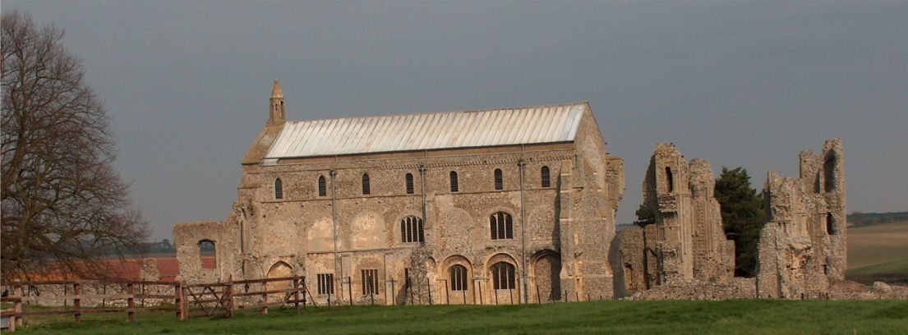
BINHAM PARISH COUNCIL
Parish Clerk – Sarah Hayden
53 Cromer Road, Lower Gresham
NR11 8RH
Tel: 01263 570223
Email: sarah352hayden@btinternet.com
binhampc.norfolkparishes.gov.uk

2021/15
MINUTES OF THE ANNUAL PARISH COUNCIL MEETING HELD ON
THURSDAY 16th August 2021 AT 8PM IN THE MEMORIAL HALL, BINHAM

Those Present Cllr. L. Brady (Chair), Cllr. L. Brown (Vice Chair), Cllr. P. Alford, Cllr. K. Cooke, Cllr. L. Wynder
In Attendance Mrs. S. Hayden (Clerk)
5 Members of the Public

The Chair opened the meeting at 8.04pm and explained the reason for calling the meeting

1. To receive and accept apologies for absence
Cllr. Owen had sent apologies that she may be late but hoped to attend
District Clr. R. Kershaw had sent apologies
[County Clr. M. Darby had sent apologies which were received following the meeting]

2. To receive declarations of interest
None

3. Planning
To discuss and make observations on planning application:
PF/21/1751 Change of use of the land from pasture for grazing to a camping and caravan site, shower and toilet blocks and a new site entrance – Manor Farm, The Street, Cockthorpe, Norfolk, R23 1QS

The Chair explained that she and Cllr. Alford (as Chair of the Planning Committee) would speak on the application and she would then ask members of the public to speak, followed by the parish councillors discussing and agreeing their observations to be made to the planning department of NNDC.

The Chair then outlined the importance of the various aspects of this application, including matters of environment, heritage, flora and fauna and the size of the village compared to the size of the site.

Cllr. Alford observed that it had been an unusual year and as a background, the Parish Council was aware of the planning rules surrounding pop-up camping sites following the lifting of Covid restrictions. This application was different in that it was for a permanent site. It was presently grazed by sheep and donkeys. The Parish Council were aware of the comments made by Historic England and the Norfolk Coast Partnership. It was a comprehensive application and our considerations would include the fact that it is within and AONB undeveloped area of north-west Norfolk, was an SSSI and that Cockthorpe was a small village.

The Chair asked if any member of the public would like to speak and one of the applicants accepted the offer.

2021/16

The applicants had looked at all options for a site, including five caravans allowed with a Caravan and Motorhome certified site, a pop-up camp site under this year’s planning regulations, but they would like a more permanent, well-kept site to be opened from May to September. The farm had to increasingly look at diversification for supporting their two families and this site was ideal, being close to home to fit in with child care, its proximity to an electricity supply and its convenience for visitors. The family had experience managing conservation areas and this would continue to be a beautiful place. They hoped to encourage walking and cycling to reduce traffic. They believed that there were no sites offering more than five pitches between Wells and Sheringham and this site would fulful a need.

Another member of the public with family in Cockthorpe then spoke and explained that they understood that farms had to diversify and they realised that this application was coming, although there had been no consultation. However there were some residents who were nervous of such a large site, although they had been assured that it would be landscaped. However, it is “on their doorstep” and they had concerns such as traffic, even though traffic through the village was already bad. Although there were concerns, the residents wished to retain a good relationship with the applicant. Discussion followed on the scale of the site and facilities.

The parish council then debated the following matters with the applicants helping with some queries:
Higher volume of traffic;
The entrance from the highway and road width at that point;
Cllr. Alford noted that the Norfolk Coast Partnership had objected stating the proposal was against policy in an AONB;
Number of pitches on the site;
Screening from North Side Cottages
Screening around shower/toilet block
Time scale for screening to be effective

As all comments had been received from the public and all queries answered from the applicants, the Chair asked the public if they would leave the meeting and allow the parish councillors to finalise their discussions, which they agreed to do and left the meeting.

It was agreed that Cllr. Alford would collate the comments to be submitted to NNDC planning department and the agreed points were summarised as follows.

1. The Parish Council supported farm diversification and an alternative site may have been considered more favourably
2. The number of pitches would overwhelm the village of 16 residents and could be reduced
3. If planning permission was granted more screening on the east side would benefit residents of the cottages and a screening hedge on the north side would mitigate the reduced hedge on the south side with the resulting interference with bats
4. As there is no infrastructure in Cockthorpe, traffic would be increased, with an average three car journeys per day to and from a narrow road, in particular traffic going to Stiffkey, on to the coast road
5. Under Policy EN10 new sites were not allowed in an AONB. An in depth impact assessment on the site within the AONB and next to the Church, should be carried out before a decision is made.
6. If planning permission was granted, the lighting impact should be minimised. (The Parish Council supports the dark skies initiative).
In conclusion the Parish Council objected to the application in its current form.

The meeting closed at 9.30pm

