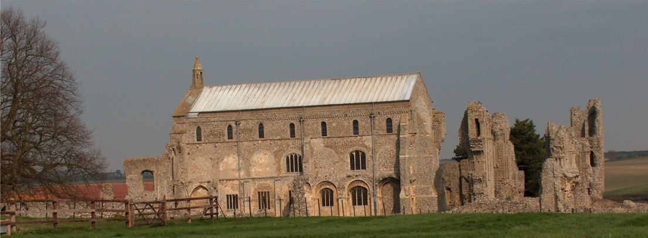
BINHAM PARISH COUNCIL
Clerk – Sarah Hayden
53 Cromer Road, Lower Gresham
NR11 8RH
Tel: 01263 570223
Email: sarah352hayden@btinternet.com
binhampc.norfolkparishes.gov.uk

Extraordinary Parish Council Meeting

Members of the Council
You are summoned to attend an extraordinary meeting of Binham Parish Council at the Memorial Hall, Binham on
Monday 16th August 2021 at 8pm
S. H. Hayden
Clerk
9th August 2021

The public are welcome to attend this Parish Council meeting and may speak at the discretion of the Chairman

Covid 19 precautions will be in place and we would ask that you please wear masks, use hand sanitiser provided and provide details for Track & Trace/QR code available

AGENDA

1. To receive and accept apologies for absence

2. To Receive Declarations of Interest

3. Planning

To discuss and make observations on planning application:
PF/21/1751 Change of use of the land from pasture for grazing to a camping and caravan site, shower and toilet blocks and a new site entrance – Manor Farm, The Street, Cockthorpe, Norfolk, R23 1QS

