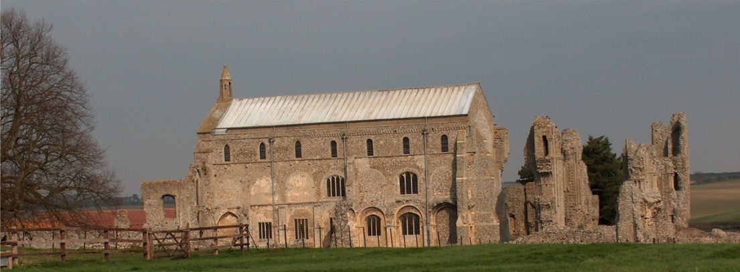
BINHAM PARISH COUNCIL
Parish Clerk – Sarah Hayden
53 Cromer Road, Lower Gresham
NR11 8RH
Tel: 01263 570223
Email: sarah352hayden@btinternet.com
binhampc.norfolkparishes.gov.uk

2021/11
MINUTES OF THE ANNUAL PARISH COUNCIL MEETING HELD ON
THURSDAY 12th JULY 2021 IN THE MEMORIAL HALL, BINHAM

Those Present Cllr. L. Brady (Chair), Cllr. L. Brown (Vice Chair), Cllr. P. Alford, Cllr. K. Cooke, Cllr. H. Owen, Cllr. L. Wynder
In Attendance Mrs. S. Hayden (Clerk)
County Councillor Michael Dalby
District Cllr. Richard Kershaw
4 Members of the Public

The Chair opened the meeting at 7.30pm

1. To receive and accept apologies for absence
No apologies. The Chair advised that Cllr. Hill had moved away from Binham and had therefore resigned from the Parish Council.
2. To receive declarations of interest
None
3. Approval of Minutes of Parish Council Meeting held on 6th May 2021
The minutes were approved and signed by the Chair
4. Matters Arising
Donations had been collected for Marie Strong’s retirement, flowers sent and the balance sent to Langham Parish Council who were co-ordinating donations for a Ward gift.

5. Reports
5.1 Norfolk County Council
Cllr. Dalby introduced himself as our new County Councillor and read out his report which is annexed to these minutes. The Chair thanked him for attending and he left for another parish council meeting.
5.2 North Norfolk District Council
District Councillor Kershaw would arrive later after attending another parish council meeting.
5.3 Chair’s Report re: SAM2
The Chair gave her report on the data gathered which is annexed to these Minutes.
5.4 Chair’s Report
The Chair reported that we would still need to take care despite Covid restrictions being lifted. She had received reports of driving on the Green, but by the time she arrived, there were no vehicles. She would put a comment in the Lynx. The Parish Council had been looking at archived documents in the Memorial Hall and will be recording what is there and archiving them at the Norfolk Records Office. Egmere Energy had contacted us in good time to let us know rye harvest dates, which had now passed. Thanks were given to them for the information which was very helpful. The maize harvest was currently planned for 13th September.

Councillor Kershaw had arrived and gave his report as follows.

He had attended two meetings in connection with the harvest traffic and had suggested speed limits and telephone numbers on trailers to contact if needed. In connection with Covid, at last Friday’s date, 82% of adults had received their 1st dose, which put the Council second out of 42 areas. 64% had received a second
2021/12

dose which put the Council fourth out of 42 areas. 90% over 40 had received their 1st dose and 83% had received their 2nd dose. Young people 18 to 24 years old, were coming forward to be vaccinated, but the next age group were more reluctant. Lateral flow tests had been distributed to businesses, which were then given stickers for their windows “Covid Safe”. Wardens had been employed to advise on social distancing and noise. Robert Jenrick had made it possible to have a pop-up campsite for 56 days without planning permission this year, so NNDC had no power to close them. In connection with Covid grants, the Council had issued £12m to 18,000 businesses which had put them on the Public Finance Awards shortlist. Finally, cases had been rising but are still low in N. Norfolk.

6. Planning
6.1 Report from Planning Committee
A report had been circulated prior the meeting.
Cllr. Alford reported that it had been a fairly quiet period.
New applications:
PF/21/0913 Single-storey extension; open porch to front; roof alterations, detached shed; new vehicular access and gates, boundary walls to replace hedge and fence – 5 The Green, Binham, NR21 0DD
The Parish Council planning committee had met at the property and agreed that the walls would be high and would affect the area. The application was supported generally, but high wall and solid gates would create a compound effect. Comments had been submitted.
PF/21/1262 & LA/21/1263 Construction of single storey extension to form garden room, internal alterations to create kitchen/breakfast room and installation of replacement staircase to serve the second floor - 2 Field Dalling Road, Binham – This could not be seen from the road and therefore there was no objection, but we did ask for traffic management and no parking on the Green.
Applications decided since last meeting
PF/20/2562 Mallards, Langham Road, Binham – Extension of garage roof and installation of PV panels; replacement fence to front boundary (part retrospective) – Approved
PF/21/0427 Installation of dormer window on east elevation at Priory Cottage, 8 Langham Road, Binham – Approved

6.2 To discuss and make observations on any applications received after the date of this Agenda
PF/21/1836 Dormer to rear elevation, external alterations – 14 Front Street, Binham, Norfolk, NR21 0AL – This application had only just received and would be dealt with under the Planning Protocol
Other Planning Matters
Land west of 49 Priory Crescent A member of the public outlined his proposed planning application which had not yet been received by the Parish Council. This was an application under which he planned to raise the roof from 4.9 to 6.2 metres. He asked for the Parish Council’s opinion. He confirmed that the electricity pole would be left as it is and this aspect was discussed. When the application was received the Parish Council would comment, but it was noted that the nearest house in the new builds was 9m high.
8 The Green, Binham – an application was expected shortly for retrospective permission for the replacement of a shed where the height had been raised necessitating an application.

6.3 To discuss and agree any action in connection with highway matters, planning matters and lorry movements in Langham Road and Field Dalling Road
The Chair outlined the complaints received surrounding the sand extraction on local farmland. She and Cllr. Owen had met with the farmer, who confirmed no material had been removed from the parish pit and the extraction material was for a farm road off the Field Dalling Road to access to a pop-up campsite. This had caused noisy lorry and plant movement, upsetting residents. If any similar work was proposed in the future the farmer had agreed to warn the Parish Council. All work carried out was within the General Permitted Development Order and the campsite was within current planning law.

Clr. Alford outlined her objections to the noise, lack of warning and continued movements which had been very upsetting.

2021/13

A member of the public asked to speak – he spoke on the necessity of larger machinery being used in farming operations.

Cllr. Kershaw, who had stayed for planning matters, made his apologies and left the meeting.

A member of the public asked to speak on item 5.3 and speeding in the parish. The Chair advised that there had been 4 complaints from Hindringham Road and one recently from Abbey House. The way forward was outlined by the Chair and it was agreed to ask the Highways Engineer to meet to see if there was anything that could be done to slow traffic in the village. The SAM2 rota was discussed.

7. Finance and Regulatory
7.1 To agree a donation to Lynx
Proposed and resolved to pay £100 donation to Lynx
7.2 To agree £12 contribution to Clerk attendance at NPTS seminar
The Clerk outlined the training sessions offered at the seminar. Proposed and resolved to contribute £12 to the cost of £60.
7.3 To approve List of Payments including approval of subscription to CAN
The subscription was discussed and it was agreed not to pay the subscription in this financial year and consider it next year. The List of Payments was approved and signed by the Chair and Clerk.
7.4 To receive Budget with Actuals, Balance Sheet and report on Bank Reconciliation
Budget to date and Balance Sheet received with no comments. Cllr. Brown reported that the bank reconciliation was correct.
7.5 To approve Contract of Employment for Clerk
To be held over to the next meeting

8. To discuss and agree adoption of Cold Calling Zones in Binham
Cllr. Alford had received no comments from the article published in Lynx. It was therefore agreed it could not be taken forward at the current time, but would be put on a “back burner”.

9. Update on adoption of red telephone box
The owner of the telephone box had been traced and had kindly consented to the Parish Council purchasing the telephone box. The Contract had been sent by BT and had been circulated to parish councillors prior to the meeting, with the obligations of maintenance being pointed out, in particular that the paint may be lead based and electrical testing. Proposed and resolved that the Contract be signed. Signed by the Chair and Cllr. Brown.

Cllr. Alford had checked the telephone box and noted that it needed painting, electrical testing and the small windows needed replacing. The History Group had offered funding and she handed over to a member of the public representing the Binham History Group to outline their offer. He reported that the History Group had, as we were aware, offered to pay for the Village Sign to be refurbished. They had capital from membership fees and talks which had not been earmarked for any specific use and which would be impossible to distribute to members in any fair way. They would like to offer £1000 to cover projects in the village, including the electrical testing of the telephone box, repainting and replacement of windows and the refurbishing of the WWII memorial bench on the Green. The Chair thanked him and Cllr. Alford for their offer which was gratefully accepted. The Clerk reported that the owner of the land on which the telephone box was placed was in support of the Parish Council and would like to be kept up to date on the plans for its use.

10. Update on Village Sign painting
This item was dealt with at this point following on from item 9. No progress had been made on the painting and it was agreed to obtain other quotes.

11. To discuss plan to support litter pick in Binham
The information on litter picking in Cllr. Darby’s report was noted. Agreed to leave this to the next meeting.

2021/14

12. To agree verge cutting on Warham Road in Autumn
Proposed and resolved that the Parish Council have the verge cut shortly

13. To agree area for interment of ashes in Cemetery and update of information
The Clerk, Chair and Cllr. Alford had visited the Cemetery and agreed a suitable area to be set aside for the interment of ashes as there was no separate area currently. Cllr. Alford was checking the information held on the plots against the names on the memorial stones and would liaise with the Clerk when completed. The plan of the Cemetery was passed to each parish councillor and it was agreed that the area was suitable.

14. Update on draft flood plan for village
A draft was being prepared, but not yet finished.

15. Items for information only or next Agenda
New terms and conditions for the bank account had been received – available from the Clerk.

There being no further business the meeting closed at 9.30pm and the approved cheques were signed.

The next meeting would be on 13th September 2021

