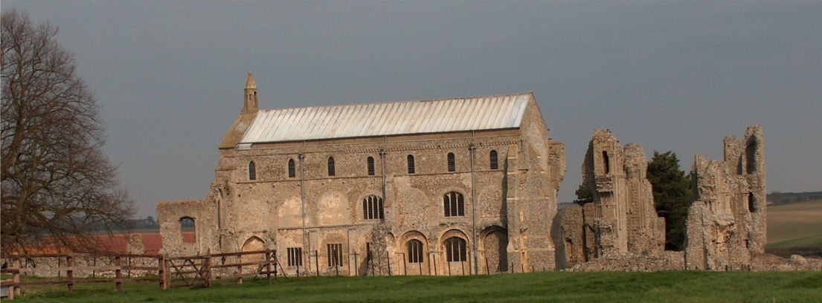
BINHAM PARISH COUNCIL
Clerk – Sarah Hayden
53 Cromer Road, Lower Gresham
NR11 8RH
Tel: 01263 570223
Email: sarah352hayden@btinternet.com

Parish Council Meeting
Members of the Council
You are summoned to attend a meeting of Binham Parish Council at the Memorial Hall, Binham
Monday 12th July 2021 at 7.30pm
S. H. Hayden
Clerk
6th July 2021
The Public are welcome to attend this Parish Council meeting
Covid 19 precautions will be in place
Please wear masks, use hand sanitiser provided and provide details for Track & Trace/QR code available

AGENDA

1. To receive and accept apologies for absence
2. To Receive Declarations of Interest
3. Approval of the Minutes of Parish Council Meeting held 6th May 2021
4. Matters Arising

5. Reports
5.1 Norfolk County Council
5.2 North Norfolk District Council
5.3 Chair’s Report re: SAMS
5.4 Chair’s Report

6. Planning
6.1 Report from Planning Committee
6.2 To discuss and make observations on any applications received after the date of this Agenda
6.3. To discuss and agree any action in connection with highways matters, planning matters and lorry movements in Langham Road and Field Dalling road

7. Finance and Regulatory
7.1. To agree donation to Lynx
7.2 To agree £12 contribution to Clerk attendance at NPTS seminar
7.3 To approve List of Payments including approval of subscription to CAN
7.4 To receive Budget with Actuals, balance sheet and report on Bank Reconciliation
7.5 To approve Contract of Employment for Clerk

8. To discuss and agree adoption of Cold Calling Zones in Binham
9. Update on adoption of red telephone box
10. To discuss plan to support litter pick in Binham
11. To agree verge cutting on Warham Road in Autumn
12. To agree area for interment of ashes in Cemetery and update of information
13. Update on draft flood plan for village
14. Update on Village sign painting
15. Items for Information Only or next Agenda

The next meeting will be on 13th September 2021

