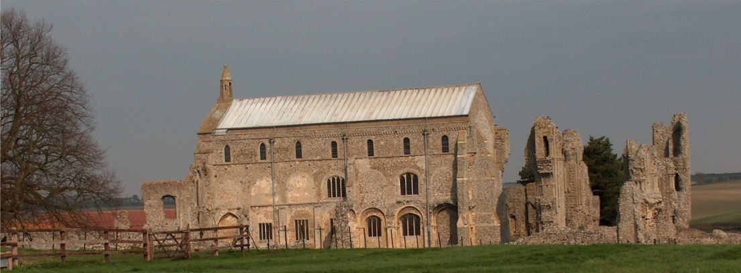
BINHAM PARISH COUNCIL
Parish Clerk – Sarah Hayden
53 Cromer Road, Lower Gresham
NR11 8RH
Tel: 01263 570223
Email: sarah352hayden@btinternet.com

2021/8
MINUTES OF THE ANNUAL PARISH COUNCIL MEETING HELD ON
THURSDAY 6th MAY 2021 VIA ZOOM

Those Present Cllr. L. Brady (Chair), Cllr. L. Brown (Vice Chair), Cllr. P. Alford, Cllr. H. Owen
In Attendance Mrs. S. Hayden (Clerk)
District Cllr. Richard Kershaw (NNDC)
1 Member of the Public

The Chair opened the meeting at 7.33pm,
All documents/cheques to be signed by the Chair or Clerk will be signed following the meeting

1. To elect a Chairman of the Council – Acceptance of Office to be signed following the meeting
Proposed: Cllr. E. Brady. Resolved
2. To elect a Vice Chairman
Proposed: Cllr. E. Brown. Resolved
3. To receive and accept apologies for absence
Apologies accepted from Cllr. K. Cooke, Cllr. L. Wynder (ill health), Cllr. J. Hill (travelling)
4. To receive declarations of interest
None
5. Approval of Minutes of Parish Council Meeting held on 8th March 2021
The minutes were approved and a copy was signed by the Chair, with the original to be signed by the Chair following the meeting
6. Matters Arising
Apologies were accepted from Cllr. P. Alford for the last meeting

7. Reports
7.1 Norfolk County Council
A “goodbye” report had been received from Cllr. Dr. M. Strong.
The Chair said she was sorry we could not elect Cllr. Strong if we had wished – she had been tireless in her efforts and it would be nice if we could personally donate to send a card and flowers to say “thank you”.
7.2 North Norfolk District Council
The Chair also thanked Cllr. Kershaw who always attends meetings and supports us.
Cllr. Kershaw reported on the Coronavirus vaccinations in the Norfolk & Waveney area. 70% of adults had received a first dose compared to 63% countrywide. 35% of adults had received their second dose compared to 28% countrywide. 95% of over 70s had received their second dose. There had been a total of 874,000 vaccinations since the start.
Cllr. Owen stated that the over 50s could not get vaccinated – she had tried very hard and found it difficult, before eventually succeeding. Cllr. Kershaw confirmed that so there had been a short period with no vaccines available, but more Astra Zenica vaccinations would be coming in at the end of the next week.
Continuing with the report, he confirmed that NNDC had appointed extra Covid wardens for the summer months and would continue with social distancing until they were instructed otherwise from the Government. They would be trying to keep car parking in the car parks, not blocking roads. NNDC were also giving out lateral flow tests for businesses who wanted them and they could then put stickers in their windows to highlight this. The “Track & Trace” results by officers had been excellent and they had worked very hard.
2021/9
7.3 Chair’s Report re: SAMS
The Chair had previously circulated her report [which is annexed to these minutes] and outlined the recent data since the SAM2 had been serviced, which was more accurate. A member of the public said that on the Hindringham Road 34 – 52% of 326/day (during lockdown) were speeding, which meant approximately 150 vehicles were speeding. He felt the gates were therefore not working and the 30mph sign might be more effective if it were moved to a site before the bend coming into Binham. The Clerk advised that Police traffic control had been carried out in Hindringham and the first stages of training had been undertaken by the volunteers in connection with Speedwatch. Discussion followed on signs. The Chair asked if anyone could suggest amendments to the method of displaying the data to make it easier to read.
7.4 Chair’s Report including any ongoing Covid 19 “Stay Secure” Provisions
The report was circulated prior to the meeting [annexed to these Minutes] and Clr. Kershaw had given us an update on vaccinations. The Chair felt it was a shame younger members are not being vaccinated yet. We still have to maintain social distancing to remain safe. The Chair would be sending a Covid 19 Newsletter out within a week, after more guidance from the Government on the further lifting of restrictions on 17th May. There were not enough funds in the Budget for a new bin at the bus shelter, so that would have to be held in abeyance for the future. There was a new resident in the village, who was very keen on litter picking and would like the Parish Council’s support. Could the parish council think about the nature verge along Warham Road, which was cut at the correct time by our contractor last autumn and who she felt should be asked to do the same in autumn this year.
8. Planning
8.1 Report from Planning Committee
A report had been circulated prior the meeting.
Cllr. Alford reported that it had been fairly quiet on the planning front since the last meeting.
New applications:
PF/21/0427 Installation of dormer window on east elevation at Priory Cottage, 8 Langham Road, Binham – the Parish Council’s comments had been submitted. Pending an NNDC decision

Applications decided since last meeting
PF/20/1954 Single storey detached dwelling with accommodation within part of roof space – Land west of 49 Priory Crescent, Binham – Cllrs. Alford and Brady had attended the Development Committee meeting and Cllr. Alford spoke at that meeting with the observations of the Parish Council. She thanked Cllr. Kershaw for his support. This application had gained consent, which seemed to be made easier when it was mentioned that the property would be used for holidays, which supported tourism. It had gained conditional approval and there was further work to be done on that.

Applications still pending since last meeting
PF/20/2562 Mallards, Langham Road, Binham – Extension of garage roof and installation of PV panels; replacement fence to front boundary (part retrospective) – Still pending a decision

Other Planning Matters
1. The Parish Council have asked NNDC to clarify whether demolition and rebuilding of an outbuilding at The Green requires planning permission. Awaiting a reply. Ref: ENF/21/0077
2. Updates on Tree applications were put on the report to the parish councillors – available on NNDC website
3. A parish councillor had raised a query in connection with tree work at the Reading Room site. There had been an application for a tree Order, an arboreal tree survey had been carried out and the case was reviews by the NNDC Tree Officer, so the work was in order.
8.2 To discuss and make observations on any applications received after the date of this Agenda
None

9. Finance and Regulatory
9.1 To receive list of actuals against budget, balance sheet, bank reconciliation and explanation of variances to 31.3.20
Received
9.2 To consider and approve the Annual Governance and Accountability Return as follows:
[The AGAR had been circulated to parish councillors prior to the meeting]
2021/10

To complete the Certificate of Exemption
Proposed and resolved that Binham Parish Council complete the Certificate of Exemption
To receive the Annual Internal Audit Report 2020-21
Received with no queries raised
To approve section 1 Annual Governance Statement
The Clerk read out each section of the Statement with the parish councillors replying. Proposed and resolved the Statement be signed by the Chair
To approve section 2 Accounting Statements
Proposed and resolved the Statements be approved.
9.3 To approve list of payments
Approved
9.4 To review all policies and risk assessments for Binham Parish Council
There were no amendments to be made
9.5 To review the Parish Council’s insurance policy and approve payment of premium
Cllr. Alford asked when we had last received alternative quotes which was 2011 and felt that further quotes should be obtained. Discussed and agreed that Clerk would ask Came & Co (brokers specialising in parish council insurance) to quote
9.6 To approve Clerk’s Contract of Employment
Agreed to hold over until next meeting

10. Update on draft flood plan for village
The Chair had circulated ideas for a flood plan and suggested warning signs might be a good idea after potholes not being seen in this year’s flooded roads Farmers had been very generous in advice as to flooding and drains in the area. The Highways Engineer thought there was a blockage further up Field Dalling Road from where the drain had been repaired and that was being investigated. Could the Chair have any comments on her outline suggestions and she would then prepare the policy.

11. Items for information only or next Agenda
1. Safer Neighbourhood – Cold Calling Zones – Cllr. Alford had circulated her report and said that Norfolk County Council operated the scheme and there were 12,000 homes on it. We could apply to NCC and Trading Standards to be on a scheme and we would need a local champion. She outlined recent incidents in the area. The Chair would put an article in Lynx asking for comments. Agreed to put on next Agenda
2. Purchase of Red Telephone Box – clerk to track down owner and councillors to find telephone number – agreed to put on next Agenda
3. Lynx donation request – for next Agenda
4. Litter collection was discussed as there was a new resident in the village keen to have the support of the parish council on this subject. Agreed to put on next Agenda
5. Verge cutting on Warham Road for next Agenda
6. Cemetery – area for interment of ashes and general updating of information – next Agenda
7. For information Cllr. Brown confirmed that a voluntary group in the village now had 22 flower boxes installed in the village and confirmed that these could now be taken over by the Parish Council as their assets. There were volunteers prepared to water and look after them.
8. Village sign – Cllr. Owen to enquire on the progress on repainting the Village Sign

12. To fix the times and dates for ordinary meetings of the Council for the ensuing year
The meetings would continue on the second Monday of the month bi-monthly and the next meeting would be in July.
The Parish Meeting would be held on 21st June 2021 on the same date as the Memorial Hall AGM

There being no further business the meeting closed at 9.25pm

